World War I (4) – Treaty of Versailles
Aim: | Date:
Key Words:

1.

2.
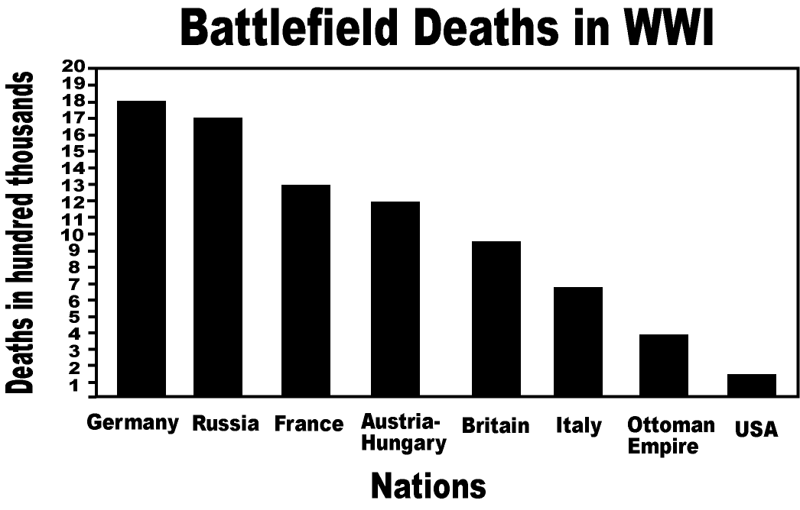
A. The End of the War
World War I started in 1914 and by 1918, the war had reached a stalemate (no side was winning). The two sides agreed to an armistice (an agreement to stop fighting). Both sides - the Triple Alliance (Austria-Hungary, Germany, and Italy) and the Triple Entente (Britain, France, and Russia) had a lot happen to them. Italy switch sides to the Triple Entente, the U.S. joined the Triple Entente in 1917 and Russia left the war in 1917. For a good portion of the war Germany was fighting on two fronts – against France and England on the West and against Russia on the East. There was even a Christmas Truce – In 1914, French, German, and British soldiers entered no man's land on Christmas Eve and Christmas Day where they held joint burial ceremonies, sang carols and played soccer.
Approximately how many soldiers died during WWI in the following countries:
a. France = b. USA =
How do you think the death totals would impact the goals of each country?

How did the geographic context of Germany impact the country?

B. The Paris Peace Conference
In January 1919, the victorious Allies gathered at the Palace of Versailles (outside of Paris, France) to work out the terms of peace in a treaty. However, each nation had different goals, which caused conflicts between them.
Read the agenda of each nation and describe their goals in your own words:
Country | Quote | Goals?
France  (Georges Clemenceau) | There are humans and then there are Germans. They must pay for their terrible crimes. We have to hurt them in their pride and take away their property
England (Prime Minister David Lloyd George) | Germany has to give away all imperialized colonies and pay reparations (war damages) for starting the war. But to follow France would be dangerous, as it would ruin Germany and prevent them from trading with us
Italy (Premier Vittrorio Orlando) | Italy’s main goal is to get the territory we were promised. The reason we entered the war was because we signed a secret treaty to get Austria-Hungary’s territory.”
United States (President Woodrow Wilson) | We must create peace in Europe. We must follow my plan, the Fourteen Points to create peace. This means having diplomacy (openly discussing problems), freedom, reducing weapons and dividing colonies equally. We must also create the League of Nations, an organization where all countries can discuss their problems

If you were at the Paris Peace conference, what recommendations would you make for the terms of the peace treaty?

C. The Treaty of Versailles
The results of the Paris Peace conference became known as the Treaty of Versailles in 1919.
Treaty of Versailles | How do you think this made Germans feel? Why?
The German military forces shall be demobilized (stop all military operations Germany cannot have a military larger than 100,000 soldiers
Germany must pay $32 Billion dollars in reparations (war damages) to the Allies
(32 billion German marks is roughly $400 billion in today's dollars)
Germany must give up its territories to France and Poland and other Allied countries
Germany accepts the responsibility of Germany and her allies for causing all the loss and damage…as a consequence of the war imposed upon them by the aggression of Germany and her allies.
A League of Nations is created to settle international disputes peacefully

From the Point of View, of Germany, is this treaty fair?

