**The Balkans**

|  |  |
| --- | --- |
| **Aim:** | **Date:** |
| **Key Words:**  **1.**  **2.** |  |

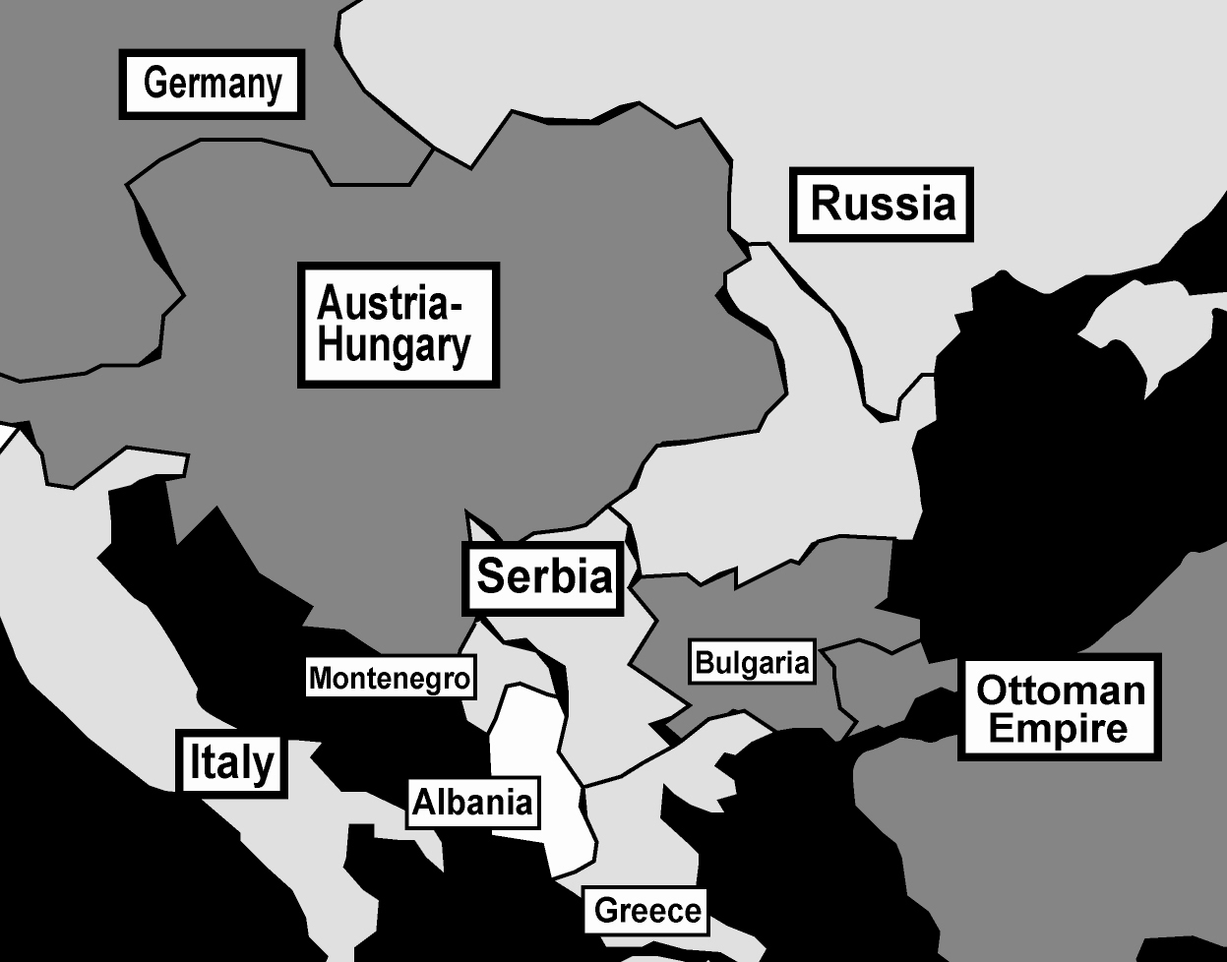

**A. The Balkans**

The Balkans is not a country, but rather it is an area in Eastern Europe, located between Asia and Europe. Many languages are spoken in the Balkans and there are people from many different countries who live there. The Ottoman Empire controlled all of the Balkans until the 20th century. By the 1900’s, the Empire became corrupt and inefficient. Little by little, the territories within the Ottoman Empire, such as Greece, Serbia, Romania and Montenegro declared their independence.

*How are the Balkans similar to New York City?*

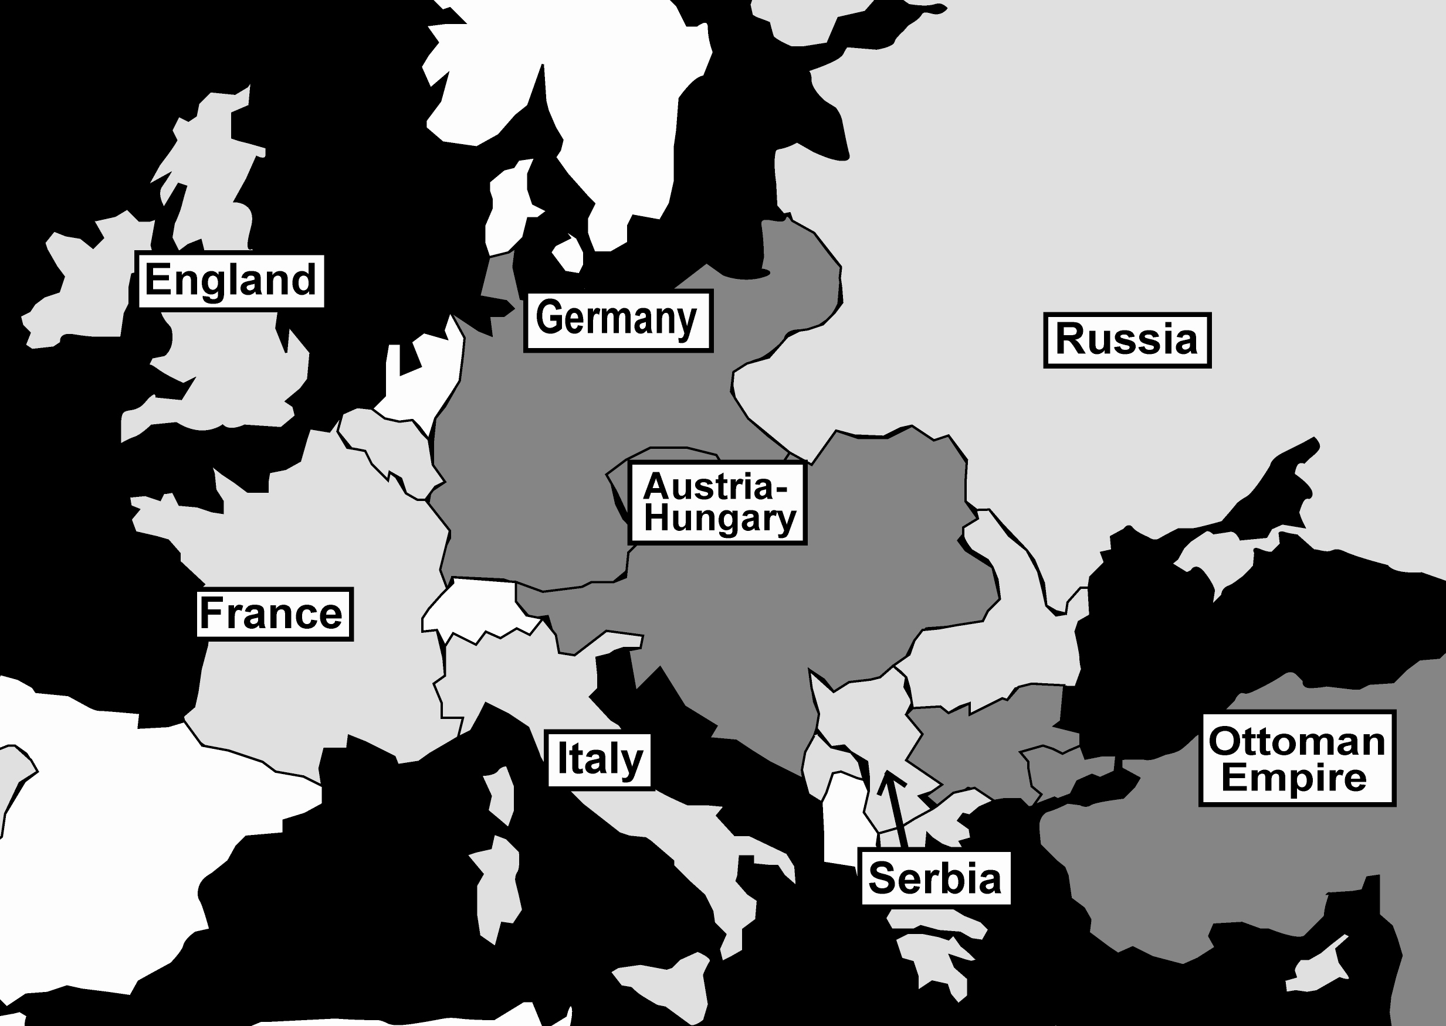

**B. The Problem in the Balkans**

Nationalism was very strong in the Balkans during the early 1900’s. People loved their nation so much they were willing to die for it.

- Serbia (a Balkan country) wanted all the Slavs (a kind of ethnic group that speak a Slavic language) in Europe to move from whatever country they were living in, to Serbia.

- There were Slavs in Austria-Hungary who wanted to move to Serbia. The Austro-Hungarian government didn’t want this. Austria-Hungary did not want Serbia to become stronger than they already were and were afraid that all the Slavs would fight back against them.

- Russia, a country with millions of Slavs, wanted to help Serbia. Russia did not like Austria-Hungary and wanted to see Austria-Hungary become weaker. They wanted to see a Slavic rebellion.

*TASK: Based on the reading above, fill in the three charts below.*

*Russia’s Goals*

*Austria-Hungary’s Goals*

*Serbia’s Goals*

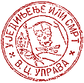**C. The Serbian Black Hand Society**

The Black Hand Society,also known as the “Union or Death” organization, was a group based in Serbia. They supported the idea that all Slavs living in Austria-Hungary should have a revolution against the Austro-Hungarian government and join Serbia. Below are some of the rules of membership:

Article 1: This organization has been created with the object of realizing the national ideal: The union of all Serbs. All Serbs without distinction of sex, religion, place of birth, and all who are devoted to this cause may become members.

Article 2: This organization prefers terrorist action to intellectual propaganda and for this reason must be kept secret from persons who do not belong in it.

Article 4: To accomplish this task, the organization: a. organizes revolutionary action in all territories inhabited by Serbs. b. Outside the frontiers of Serbia, uses every means available to fight the enemies of this idea. c. Maintain friendly relations with all states, peoples, organizations, and individuals who entertain feelings of friendship towards Serbia. d. Lends help and support in every way possible to all peoples and all organizations struggling for their national liberation and for their union.

Article 26: the members are known only by numbers. Only the Central Committee at Belgrade (city in Serbia) is to know their names.

Article 31: Anyone who enters the organization may never withdraw from it.

*What is the goal of the Serbian Black Hand Society?*

*How could this cause problems between the major European powers?*

**D. Assassination**

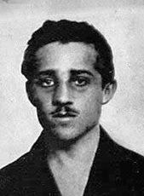The archduke of Austria-Hungary, Franz Ferdinand, and his wife Sophie visited Sarajevo in Bosnia, a Balkan country on June 28, 1914. This was to tour the country, after Austria-Hungary formally annexed Bosnia-Herzegovina in 1908 (they were given power over the area at the Berlin Conference but took it a step further and took total control). Franz Ferdinand was the heir to the Austro-Hungarian throne, the next in line to be the leader of Austria-Hungary. Gavrilo Princip (pictured right) was a 19-year-old Serbian and member of the Black Hand.

*According to the video, what action did the Black Hand Society take against Franz Ferdinand and his wife?*

*How is this a turning point?*