Name: _____________________________________________________________ Band: ________________

Edward R. Murrow H.S. Social Studies Department
Mr. Barge, Principal Global ICT
Global – Regents Review Project

If there is one thing you should hope to accomplish as a student in 10th grade global history, it should be to pass the Regents exam in June. The Global Regents exam includes everything from all 10th grade and is known to be one of the hardest exams you will take in high school. Both of your 10th grade semester projects will be based on the Regents and will help prepare you for this challenging exam. Each semester your project will focus on two particular topics from the Regents exam.
Content Goals  - Research and study world leaders and economic systems  - Build knowledge of world leaders and economic systems | Skill Goals  - Develop writing skills  - Develop active reading skills  - Develop citation skills

Part I – World Leaders (45 points – 15 points each)
A. Fill out the chart about different world leaders.
B. Read a primary source document and answer questions
C. Write a TEAL paragraph on two world leaders.

Part II –Economic Systems (45 points – 15 points each)
A. Fill out the chart about different economic systems.
B. Read a primary source document and answer questions
C. Write a TEAL paragraph on two economic systems.

Part III: Mechanics (10 points)
- You must demonstrate appropriate grammar usage in writing and mechanics of language
- YOUR PAPER MUST BE STAPLED OR SECURELY ATTACHED.
- LATE PAPERS: You will lose five points per day the project is late. This includes days we do not have school and days the band does not meet.
- Plagiarism (presenting someone else’s work or idea as your own) is unacceptable. If done you will fail for the project.
- You MUST Actively Read. This means you are annotating the reading – underling, highlighting, making notes in the margins.

What do I need to do for this project?
Everything you need for the project is included in this packet or is in the classroom. You have the information you need, the charts, and even the spaces to write your answers. Mostly, all you need to do is the thinking and writing. For the TEAL paragraph you will be required to use a textbook, which are in the classroom. When you are done answering each of three parts for BOTH topics (6 parts in all), you will carefully check over your work and submit this completed project packet back to your teacher.

Saying you “didn’t understand’ something or you “couldn’t find the answer” is NOT an excuse for leaving something blank or not turning in the project. Your teachers are here every day to help you and answer any questions you may have. It is YOUR responsibility to come and see your teachers if you need help and they will be happy to assist you.

THIS PROJECT WILL BE EVALUATED ACCORDING TO THE RUBRIC. READ THIS CLOSELY.
Part I - World Leaders Part I – Political Revolutions

A. World Leaders Chart (15 points)
Use the information on the information sheet to fill in the chart.

 | What country & time period did this leader exist in?  (Geographic Context) | What important changes did this ruler make?  (List 2) | Was the leader more positive OR negative overall for their country? Make a claim and use evidence.
1. Napoleon Bonaparte | Country?  Time Period? | -  -
2. Joseph Stalin | Country?  Time Period? | -  -
3. Mao Zedong | Country?  Time Period? | -  -
4. Mohandas Gandhi | Country?  Time Period? | -  -
5. Nelson Mandela | Country?  Time Period? | -  -
6. Aung San Suu Kyi | Country?  Time Period? | -  -
7.Pol Pot | Country?  Time Period? | -  -

B. Document Analysis (15 points)
Read the primary source document then answer the questions which follow.
“My father was one of the million victims who were killed by the Khmer Rouge genocide politics led by Pol Pot. Up to this today I cannot comprehend the reason for the execution of my father and other millions of my fellow country men. My father was not a man of politics nor was he a criminal by any means. As a far as I can remember, he was a family man like any other Cambodian men in the country. He was a loving and caring father. A great protector and provider for his family and for those worked in his shipping company. He was a patriotic man… According to this Khmer Rouge cadre, named Met Chan, who was personally involved with the interrogation of my father described ways which he and his comrades punished my father. From the time they took my father out of our hut, he was kicked, dragged and beaten all the way to the killing site. Before he was executed he was cuffed in chains along with three other men and was confined in a basement inside an abandoned temple. He went without food for several days because Khmer Rouge cadres knew that he was going to be killed anyway before they finally decided to take him to the grave. His face was swollen with bruises from the beating. His back and ribs were broken by the constant beating by the young Khmer Rouge Cadres. The beating was so severe that it paralyzed his speech and consciousness. By this time, he was just lying on the floor unable to move or ask for mercy. According to Met Chan, his last words were calling for his wife, son and daughter…Two days after the interrogation, they took him to the killing ground. He was hit with a metal rod three times at the back of the head…I am one of the many voices speaking out atrocity of the Khmer Rouge's genocide politics. There are millions of Cambodians who lost their immediate family members and loved ones. The Khmer Rouge regime not only traumatized millions of Cambodians' psychological function but it created a permanent scare in every Cambodian citizens. We lost so much. The greatest lost of all were those whose resources and capacities to advance our social development. A lot of talented individuals died because some defected semi- intellectuals such as Pol Pot were too incompetent to deal with social development.”
- Sisowath Doung Chanto (Story retold in 1990)
Describe the main idea of this passage. (Summarize without quotes.)

What is the historical context of this document? (Use the information packet.)

Is this document a reliable source?

C. World Leaders TEAL Paragraph (15 points)
Based on the information from the information sheet, pick two world leaders and write a 7-10 sentence paragraph response using the TEAL format to address the following task. For this part of the project you will need to look up a piece of information in the textbook and CITE and write it in a BIBLIOGRAPHY it in your paragraph. You will need to write the (author’s name, page number) at the end of a sentence. NO QUOTES!

- Identify two leaders
- Identify and define an enduring issue
- Explain how the enduring issue has continued to be an issue or changed over time in reference to the two leaders

Possible Enduring Issues to Write About:
Power Conflict Globalization Environment Scarcity Migration

Nationalism Response to Change Cultural Diffusion Technology Human Rights Violations

Bibliography:
(Format: Last Name, First Name. Book Title. City: Publisher, Year Published. Print.)

WORLD LEADERS INFORMATION SHEET

1. Napoleon Bonaparte
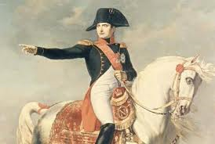Napoleon Bonaparte (1769-1821) was not only one of the greatest military commanders of all time, but he also became the emperor of France, as well as many other European countries after the French Revolution. France was in a chaotic state following the French Revolution. The French people had been executed mercilessly during the Reign of Terror by Robespierre. The people craved a return to a normal, peaceful lifestyle. Napoleon rose to fame during the French Revolution, as a respected military general. He was a respected commander, both by his troops and then, the people of France. After coming back from his military campaigns, he became a member of a three-person team of French rulers. He quickly pushed out his co-rulers and became the Ruler-for-Life in 1802 and then the Emperor in 1804. He waged military campaigns and attempted to conquer nations such as Italy, Sweden, Germany and Spain. During this time, in France, he instituted the Napoleonic Code. This was a set of laws that gave the people of France their first legal code – laws such as forbidding privileges based on birth, allowing freedom of religion. Napoleon also made everybody (not just the Third Estate) pay taxes. However, despite the success of the Napoleonic Code, his military campaign against Russia became a disaster – unprepared for the cold weather and large size of Russia, Napoleon suffered a terrible defeat. He was driven out of power soon after this loss, but even today, he remains one of the most fascinating and disputed historical figures of modern European history.

2. Joseph Stalin
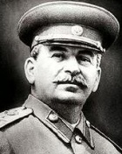Joseph Stalin (1879-1953) was a totalitarian dictator who became the second leader of the Soviet Union. Every aspect of people's lives was controlled by the government. Russia became a command economy, where government officials made all economic decisions. Stalin forced peasants to give up ownership of their land and live on government-owned farms called collectives. On a collective farm, all animals and equipment were owned by the state. The government controlled the prices paid to the farmers for their products, and forced them to fill quotas, or production goals. During the Great Purges, Stalin eliminated his opponents by sending them to do brutal physical labor in work camps (gulags), by assassinating them in large numbers, by putting them on public trials and using them as examples for the rest of the country. Stalin terrorized large segments of the Soviet population, especially rich farmers. He also ordered a massive famine in Ukraine, where around 5 million people died. About 20 million people died or disappeared because of Stalin’s actions. Russia successfully fought back against Germany’s armies during World War II. Stalin also tried to spur industrial production, hoping to catch up to the United States as a world superpower.

3. Mao Zedong
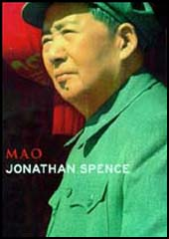Mao Zedong (1893-1976) was inspired by the ideas of the Russian Revolution and succeeded in bringing the revolution to the suffering peasants in China. As in Russia, the communist revolution in China was not one of workers vs. owners, but one of imperial government vs. poor starving peasants who felt that government had abandoned them. After years of civil war, China became a Communist nation in 1949. The newly communist China looked to the Soviet Union for leadership, but quickly turned in a different direction. Mao Zedong, the leader of the Communist Party, turned China from a farming, old-fashioned society into a modern industrial power. Mao undertook a number of programs in order to achieve his goal. He created communes, a Chinese version of the Russian collective, tried to renew Chinese culture. He also launched a series of agricultural and industrial production initiatives, and improved the social standing of women. He was well-known for the Cultural Revolution, which waged war on Western and democratic ideas in China. Foreign writings and influences were removed from China by his Red Guards, his army of student revolutionaries. Some of Mao's writings were copied into the handbook, The Quotations of Chairman Mao (also known as the Little Red Book) and given to every Chinese citizen and they were forced to memorize it.

4. Mohandas Gandhi
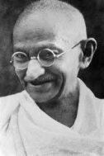Mohandas Gandhi (1869-1948) was a nationalist leader in India who called for ahimsa (non-violence) and civil disobedience (not following laws because they are immoral) to gain India’s freedom from the British empire. India had been controlled by the British Empire since the 1700s. Over time, nationalistic feelings grew among the Indian population and a movement was began to first rule themselves, and then achieve complete independence from the British. In 1885, Indian nationalists formed the Indian National Congress, of which Gandhi was the leader, to achieve these goals. Gandhi believed in using non-violent methods to peacefully protest the rule of the British. He organized the Salt March to protest the British Salt Tax, which made it illegal for workers to collect free salt from the seas and forcing them to buy salt they couldn’t afford. In 1947, India gained their independence from Great Britain, due in large part to the strong leadership of Mohandas Gandhi.
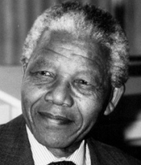5. Nelson Mandela
Nelson Mandela (1918-2013) was elected South Africa’s first black president in 1994. South Africa was ruled by European (British and Dutch) settlers for a long time. While, South Africa gained independence from Great Britain in the beginning of the 20th century, the country was still controlled by the white minority. Black South Africans lived under the policy of apartheid, which limited their rights severely. Under apartheid, black South Africans could only live in certain areas and were required to use separate trains, beaches, restaurants and schools and could not marry white South Africans. Nelson Mandela, a leader of the African National Congress, protested this treatment of black South Africans. The African National Congress, a group formed in protest of this policy, was eventually outlawed due to their violent tactics. Nelson Mandela was imprisoned for over 30 years due to his involvement in anti-apartheid demonstrations. Apartheid lasted until the early 1990s when white South African President, F. W. de Klerk ended apartheid and released Nelson Mandela from his imprisonment. In 1994, Nelson Mandela was elected as South Africa's first black president. One of the first things Mandela did as president was to rid the country of the awful policy of apartheid, creating equality amongst the races in South Africa.
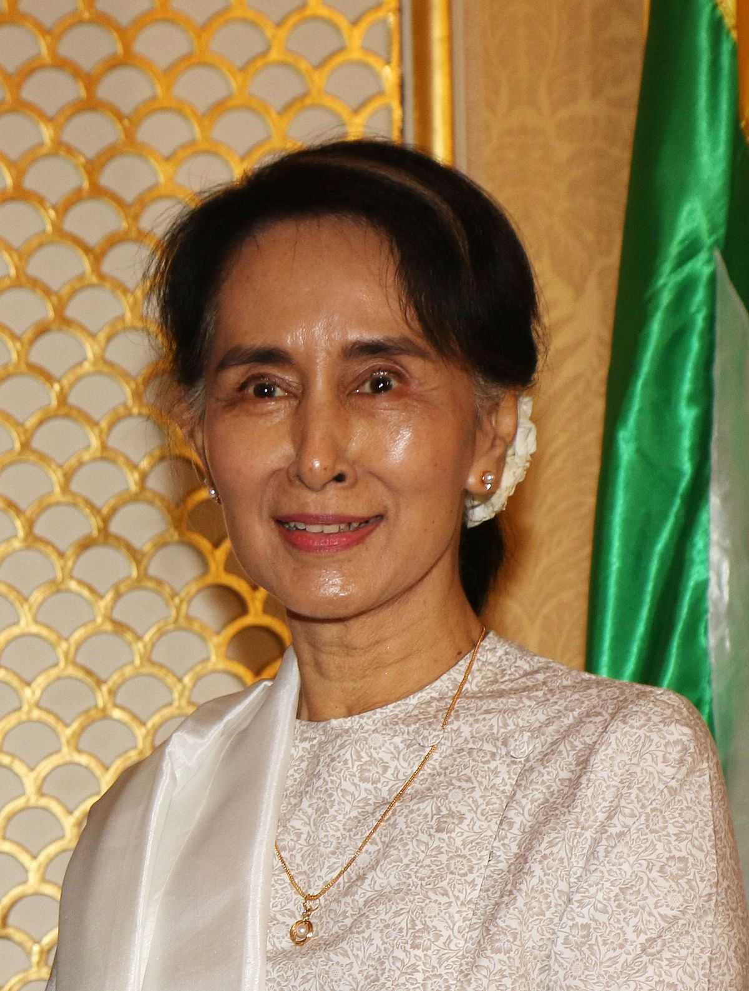6. Aung San Suu Kyi
Aung San Suu Kyi (1945-present) was born in Yangon, Myanmar, in 1945. After years of living and studying abroad, she returned home only to find widespread slaughter of protesters rallying against the brutal rule of dictator U Ne Win. She spoke out against him and initiated a nonviolent movement toward achieving democracy and human rights. However, in 1989, the government placed Suu Kyi under house arrest, and she spent 15 of the next 21 years in custody. In 1991, her ongoing efforts won her the Nobel Prize for Peace, and she was finally released from house arrest in November 2010 and subsequently held a seat in parliament for the National League for Democracy party until 2015. That November, the NLD won a landslide victory, giving them a majority control of parliament and allowing them to select the country's next president. It March 2016 Suu Kyi's adviser Htin Kyaw was selected for the post, and the following month Suu Kyi was named the state counsellor, a position above the presidency that allows her to direct the country's affairs. In September 2016, Myanmar’s military was accused of ethnic cleansing. Aung San Suu Kyi spoke out, however, she refused to denounce the military and their role in the controversy.

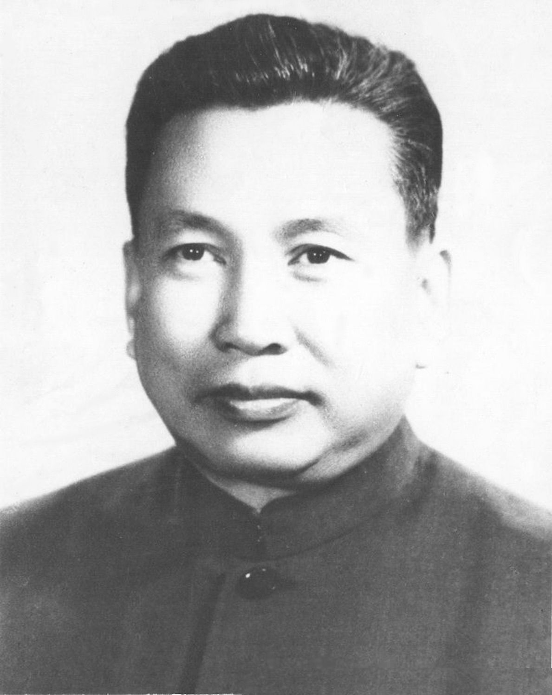7. Pol Pot
Pol Pot was born Saloth Sar on May 19, 1925, in Kompong Thom Province, Cambodia. He rose to power as leader of the Khmer Rouge, Cambodia’s Communist regime, which took control of the country with a large population living in poverty in 1975. Prior to this regime, Cambodia had a monarchy and then had a republic briefly, but the people were used to dictators. Setting the calendar to “Year Zero,” Pol Pot and the Khmer Rouge embarked on building what they considered to be the new Cambodia. The Khmer Rouge was one of the most brutal regimes of the 20th century. Pol Pot had been influenced and impressed by China’s Cultural Revolution under Mao Tse-tung, thus following that country’s lead in evacuating cities and forcing people into a rural, farming life. During its reign, which ended in 1979, Pol Pot oversaw the deaths of an estimated one to two million people from starvation, overwork or execution. With a recent history of border conflicts, Vietnam entered Cambodia by late 1978, deposing Pol Pot and the Khmer Rouge early the following year. As the country opened its borders to outsiders, the world became aware of the full horror of Pol Pot’s tenure as Cambodia’s leader. Mass graves, or "killing fields," provided evidence of the atrocities, and Pol Pot was found guilty of genocide by a tribunal though he was never imprisoned. He died in 1998.
Part II – Economic Systems
A. Economic Systems Chart (15 points)
Use the information on the information sheet to fill in the chart.

 | What type of government is this economic system associated with? | What are the defining characteristics (features) of this economic system?  (List 2 for each) | What is the historical context?
1.Traditional economy |  | -  - | Society (Location)?  Time Period (not years)?
2. Manorialism |  | -  - | Society (Location)?  Time Period (not years)?
3. Mercantilism |  | -  - | Society (Location)?  Time Period (not years)?
4. Capitalism  (also known as a market economy) |  | -  - | Society (Location)?  Time Period (not years)?
5. Communism  (also known as a command economy) |  | -  - | Society (Location)?  Time Period (not years)?
B. Document Analysis (15 points)
Read/Observe the primary source document then answer the questions which follow.
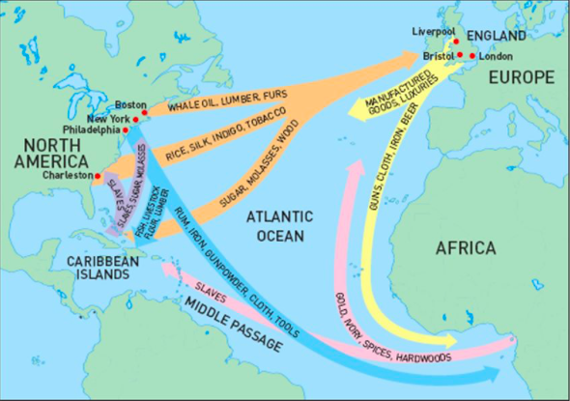
- Map of International Trade (1800s)
Describe the main idea of this map.

What is the historical context of this document? (Use the information packet.)

Is this document a reliable source?

C. Economic Systems TEAL Paragraph (15 points)
Based on the information from the information sheet, pick two economic systems and write a 7-10 sentence paragraph response using the TEAL format to address the following task. For this part of the project you will need to look up a piece of information in the textbook and CITE and write it in a BIBLIOGRAPHY it in your paragraph. You will need to write the (author’s name, page number) at the end of a sentence. NO QUOTES!
- Identify two economic systems
- Identify and define an enduring issue
- Explain how the enduring issue has continued to be an issue or changed over time in reference to the two economic systems

Possible Enduring Issues to Write About:
Power Conflict Globalization Environment Scarcity Human Rights

Nationalism Response to Change Cultural Diffusion Technology Migration

Bibliography:
(Format: Last Name, First Name. Book Title. City: Publisher, Year Published. Print.)

ECONOMIC SYSTEMS INFORMATION SHEET

An economy can be defined as the way in which people manage their resources. It also describes the way people use their environment to meet their needs. An economy in a country includes the making, selling or exchanging goods between groups of people. Does an economy rely on making money through growing crops (like in a traditional economy) or is an economy where money is made through making goods in factories (such as an industrial economy)? All of these systems attempt to answer the same questions. What should be produced? How much? How should goods be produced? And who controls the production of these goods? Some of the most common types of economies are found below:

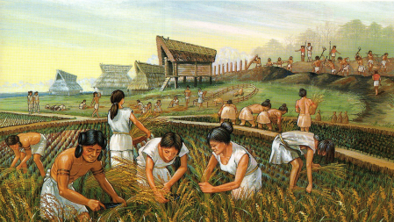1. Traditional Economy

Traditional governments are not associated with particular types of governments. The people decide how much is to be produced and in what manner, depending on their individual or community’s needs. Traditional economies began during the Neolithic Revolution, all over the world, including early river valley civilizations (such as Mesopotamia, the Egypt river valley, etc.) Traditional economies are based on agriculture (farming). They also rely on very simple barter trading (which involves exchanging certain goods for another type of good, without ever exchanging money). In a traditional economy, humans use the resources around them for food source, shelter, clothing, footwear or fuel. The entire family participated in the production of food and trading resources, and skills were handed down through the family. In a traditional society, most people would not have gone to school or learned a trade through a college, but would have learned traditional hunting, farming or trading skills that were passed down through the generations. There are still societies today that have traditional economies although industrialized nations like England have more modern types of economies. As humans’ knowledge of science increased and technology improved, we have shifted away from traditional economies.

2. Manorialism
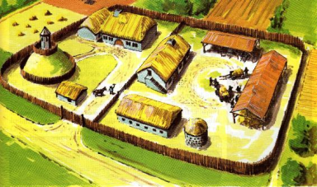
During the Middle Ages, a new form of government called feudalism appeared in response to increased invasions and limited resources. Manorialism was an economic system that went along with a feudal lifestyle. Feudalism (the government) required that political, social and economic life revolved around a manor (large unit of land). Everyone who lived on that manor had to perform some type of duty, whether it be growing crops, making goods by hand or protecting the lord of the manor. There were not many opportunities to leave the manor and people had to be self-sufficient (able to provide for themselves) on the manor. The resources needed to make food, clothing, furniture, fuel, etc. came entirely from the manor. Existing mostly in Japan and Europe, in manorialism there was very little trading, and people were generally tied to the manor. The lord controlled what resources were grown on the manor and how they were to be used. Because the lord was in charge of the land and could control the activities of people on it, there emerged a social class system where the lord was the highest and most powerful person in that society, followed by the Church, then the knights, merchants and artisans, and finally, the serfs (peasants). Serfs were not slaves, because they could not be bought or sold, but they could not easily leave the manor either.

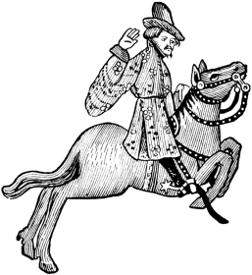3. Mercantilism

Mercantilism is an economic system which developed after manorialism and is associated with colonial types of government. Some countries that practiced mercantilism included Great Britain, Portugal and Spain. Mercantilism is when a country believes that the more wealth it stores up, the greater their government should be. So, mercantilist countries build up their nation’s wealth by exporting (selling) more goods than they import (buy from other countries). Countries needed to find places to sell their goods as well as to find places where to get natural resources. For this reason, they found and conquered colonies. Colonies supplied their Mother countries with the raw materials that were used to produce finished goods and then send those goods back to their colonies. Generally, merchants controlled what resources were to be produced and how they were to be used, sold or traded. However, monarchs (kings or queens) were often asked to provide protection or political privileges for monarchs.
In feudalism during the Middle Ages, merchants and traders did not have high social status or opportunities to sell their goods to a large market of people. However, because of mercantilism, merchants and traders became wealthier, starting to improve their social status and gain political power. The increase in trade is part of the Commercial Revolution , which helped end feudalism and manorialism. It also led to the beginning of the slave trade and the growth of banks and other large businesses.

4. Capitalism
Capitalist economies are associated with the democratic types of governments, and with countries such as the England. The capitalist economy is also known as a market economy. Capitalism is an economic system where individuals control businesses, instead of the government. Adam Smith developed the idea for capitalism in his 1776 book, The Wealth of Nations (during the Industrial Revolution). In capitalism, the types of resources used are determined by supply and demand. In other words, if a business owner thinks that there is demand for a particular kind of good, he will supply it. The price of that good depends on how much of the good is available in the market and how much demand there is for it. So the business owner (not the government) decides how many goods will be made, what resources are needed to make this resource and how much of the good will be sold. Then, he may keep the profits from his sales and produce more goods. According to capitalism, government should not interfere in the sale and free trade of goods. For this reason, capitalism goes along with democratic types of government, where people have many types of freedoms. A capitalist economy is usually tied with industrialization, where goods are made in factories (instead of by hand) to minimize the cost of producing those goods.

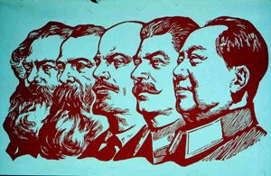5. Communism
Communism is associated with totalitarian governments of countries such as the Soviet Union, China and Cuba. Communism is also called a command economy. Communism is based on the idea of the thinker Karl Marx, who believed that everyone should share the money and resources in a society. Marx put his ideas in his book, The Communist Manifesto in 1848, after the height of the Industrial Revolution. He was against the very small and rich ruling class controlling the rest of society. He was against the idea of capitalism. Marx had the idea that people should share in the wealth of a country equally. There should be no rich or poor. However, he did not say who should control the economy and the resources of a country, so in Communist countries, very powerful dictators ended up taking over. Virtually every resource is controlled by the very strong government. In a Communist economy, there is a lot of attention paid to making industrial goods like machines and weapons. Very little attention, however, is paid to making food and consumer goods (like clothing or furniture or televisions). Thus, people in Communist countries often found it very hard to obtain food, consumer goods and make profits from their businesses.

 | Excellent | Good | Satisfactory | Needs Improvement | Points
Part IA – World Leaders Chart  (15 points) | (13-15 points)  The information chart was entirely completed, and all information was correct. | (8-12 points)  The information chart was mostly completed, and most information was correct. | (4-7 points)  The information chart was not completed, and/or some information was not correct. | (0-3 points)  Few, if any of the project instructions were followed.
Part IB – World Leaders Document Analysis  (15 points) | (13-15 points)  All questions are answered descriptively and analytically | (8-12 points)  Most answers are answered analytically and descriptively | (4-7 points)  Some questions are answered analytically and descriptively | (0-3 points)  Almost no answers are answered analytically and descriptively
Part IC – World Leaders TEAL  (15 points) | (13-15 points)  Body Paragraph formatting was followed correctly – Topic Sentence, Evidence, Analysis, Link. Many examples and details were given. All tasks were addressed. | (8-12 points)  Body Paragraph formatting was followed semi-correctly – Topic Sentence, Evidence, Analysis, Link. Some examples and details were given. Most tasks were addressed. | (4-7 points)  Body Paragraph formatting was followed correctly at parts – Topic Sentence, Evidence, Analysis, Link. Few examples and details were given. Few tasks were addressed. | (0-3 points)  Few, if any of the project instructions were followed.
Part IIA – Economic Systems Chart  (15 points) | (13-15 points)  The information chart was entirely completed, and all information was correct. | (8-12 points)  The information chart was mostly completed, and most information was correct. | (4-7 points)  The information chart was not completed and/or some information was not correct. | (0-3 points)  Few, if any of the project instructions were followed.
Part IIB – Economic Document Analysis  (15 points) | (13-15 points)  All questions are answered descriptively and analytically | (8-12 points)  Most answers are answered analytically and descriptively | (4-7 points)  Some questions are answered analytically and descriptively | (0-3 points)  Almost no answers are answered analytically and descriptively
Part IIC – Economic Systems TEAL  (15 points) | (13-15 points)  Body Paragraph formatting was followed correctly – Topic Sentence, Evidence, Analysis, Link. Many examples and details were given. All tasks were addressed.  Citations and bibliography | (8-12 points)  Body Paragraph formatting was followed semi-correctly – Topic Sentence, Evidence, Analysis, Link. Some examples and details were given. Most tasks were addressed.  Citations and bibliography | (4-7 points)  Body Paragraph formatting was followed correctly at parts – Topic Sentence, Evidence, Analysis, Link. Few examples and details were given. Few tasks were addressed.  Citations and bibliography | (0-3 points)  Few, if any of the project instructions were followed.  No citations and bibliography
Part V – Mechanics  (10 points) | (8 – 10 points)  Stapled/Attached  Almost entirely free of spelling, punctuation, and grammatical errors  Demonstrates appropriate grammar usage in writing and mechanics of language  Active Reading | (5 –7 points)  May contain a few spelling, punctuation, and grammatical errors  May demonstrate appropriate grammar usage in writing and mechanics of language  Active Reading | (3 – 4 points)  May contain several spelling, punctuation, and grammatical errors  Partially demonstrates appropriate grammar usage in writing and mechanics of language  Active Reading | (0-2 points)  Contain several spelling, punctuation, and grammatical errors  Does not demonstrate appropriate grammar usage in writing and mechanics of language
Next Steps: Total:

