99Name:

The Cold War
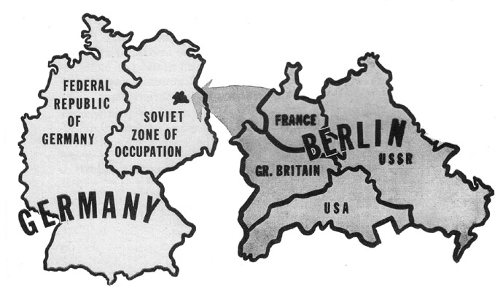
A. Germany (1945-1989)
Historical Context: After WWII, Germany had major problems: cities were reduced to rubble and large portions of the population were suffering from hunger and the loss of their homes. In order to help rebuild, the Allies would govern Germany through four occupation zones, one for each of the Four Powers--the United States, Britain, France, and the Soviet Union. Since the capital city, Berlin, was in the Soviet Sector, it was also decided that the capital (Berlin) should be divided into four parts.
The Berlin Blockade was the first “battle” of the Cold War. In June 1948, the Soviet Union blocked the three Western powers’ railroad and street access to the western sectors of Berlin that they had been controlling. (Although each country had a part of Berlin, the entire city existed within the Soviet Sector.) Their aim was to force the western powers to give the Soviets power over the whole city and spread communism. In response to the blockade, the United States and the other Western powers formed the Berlin Airlift to supply the city. The Soviets admitted defeat in May of 1949 and ended the blockade. However, the Soviets would not give up completely. At 2AM on August 13, 1961, a low, barbed-wire barrier was strung between East and West Berlin. A permanent wall was eventually built which effectively divided the city in half for decades and it was called the Berlin Wall. Anyone who tried to cross over to the U.S. side, would be shot and killed.

After the Cold War: The Berlin Wall remained in place until 1989. It wasn’t until 1990, that Berlin and Germany had its first free elections. Since reunification (which we will be covering in detail after the Layered Curriculum), Germany has taken a more active role in the European Union. In the 2005, Angela Merkel (she was re-elected in 2018) became the first female Chancellor of Germany. She is considered one of the most powerful people in the world and Germany has one of the strongest governments and economies in the world.
Questions | U.S. Answer | U.S.S.R. Answer
Which side did they support?
What was their goal?
How did they try to meet their goal? (What did they give to their side to help them win the war?)

As a result of this conflict, was communism contained or expanded?

Did the Cold War have a positive or negative effect on this country? Explain with evidence.

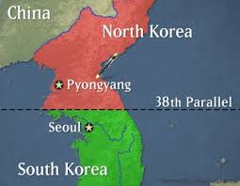
B. The Korean War (1950-1953)
The Korean War was a civil war between North Korea and South Korea. The conflict began on June 25, 1950 and fighting continued until an armistice (a truce) on July 27, 1953. Since no official peace treaty was signed, the war is still not technically over. The Soviet Union and China, seeking to expand the communism, aided the North Koreans (with weapons and other supplies), while forces representing the United Nations—led primarily by the United States with troops (soldiers) provided by 15 other nations, aided the South Koreans. Each side wanted to unite the Korean peninsula under its own political ideology (communism or capitalism). At the end of the conflict, Korea remained divided along the 38th parallel. The demilitarized zone (DMZ) between the two nations is still the most heavily fortified border in the world. There is a constant hope among the populations in both North and South that Korea will again be united under one flag.
Korea Today:
North Korea, is a one-party state, now led by Kim Jong Un. From 1993 – 2008, it is estimated that 240,000 to 420,000 people died due to famine and that there were 600,000 to 850,000 unnatural deaths (forced labor, executions, concentrations camps). In 2017, Kim Jong Un’s half-brother was assassinated (poisoned). As of 2019, North Korea continually tests missiles and threatens the world with nuclear attacks. In 2018, North Korean, South Korean and U.S. leaders met.
South Korea is a democracy with a capitalist market economy, which has grown enormously since the 1960s. As of 2019, of the top 100 female golfers in the world, 38 were Korean.In 2018, South Korea hosted the Winter Olympics.

Questions | U.S. Answer | U.S.S.R. Answer
Which side did they support?
What was their goal?
How did they try to meet their goal? (What did they give to their side to help them win the war?)

As a result of the Korean War, was communism contained or expanded?

Did the Cold War have a positive or negative effect on this country? Explain with evidence.

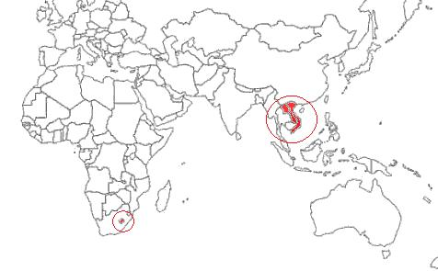
C. Vietnam War (1954-1975)
Historical Context: Prior to the war this area was called French Indochina. The area was conquered by the French during the 1800s (remember Imperialism!!!!) and Japan took over the area during WWII. Afterwards, the French tried to re-establish their control. In Vietnam, the French faced guerilla forces led by Ho Chi Minh who was a nationalist and communist and eventually the French gave him control of the country.
The Vietnam War was a civil war between North Vietnam (Viet Cong communist-led guerrillas) and South Vietnam (anti-communists). The communists of the North wanted to unify Vietnam into a single state that would be based on communist ideology. The USSR sent supplies and weapons to help the Viet Cong win the war. Motivated by a policy of containment, the United States pledged support for the anti-communist South Vietnam. The United States and its allies provided training and equipment and sent soldiers to South Vietnam. In 1975, South Vietnam surrendered to the North. Vietnam was unified as a communist state. The Vietnam War had disastrous effects. Vietnam’s infrastructure (buildings and roads) was destroyed, and farmland was polluted by American chemical warfare (Agent Orange). An estimated 2 million Vietnamese died and another 3 million were wounded. During the Vietnam War, 58,000 Americans died in Vietnam and the war cost the United States millions of dollars. Due to this, America abandoned the Truman Doctrine.
Vietnam Today: Vietnam’s current constitution, 2013 Constitution, states that the Communist Party of Vietnam has a central role in parts of the government. The General Secretary of the Communist Party controls many parts of the government. Collectivized farms (remember Stalin!!!) and factories are central to its economy, with millions of people working in government programs. There is high unemployment, a widening gap between rich and poor, and increases in bankruptcy, prostitution, and corruption.

Questions | U.S. Answer | U.S.S.R. Answer
Which side did they support?
What was their goal?
How did they try to meet their goal? (What did they give to their side to help them win the war?)

As a result of the Vietnam War, was communism contained or expanded?

Did the Cold War have a positive or negative effect on this country? Explain with evidence.

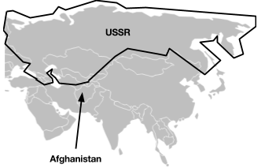
D. Soviet-Afghan War (1979-1989)
In April 1978, Afghanistan’s government was overthrown by military officers who supported communism. The new government had a close relationship with the Soviet Union but was greatly disliked by the devout Muslim and largely anticommunist population. Insurgencies [rebellions] rose against the new communist government. The insurgents or rebels were known as the mujahideen. In December 1979, the Soviet Union invaded Afghanistan to protect the communist government. Nearly 100,000 Soviet soldiers took control of major cities in Afghanistan. They bombed civilian areas where the mujahideen and its supporters were located. Motivated by a policy of containment, the United States and its European allies supported the mujahideen against the Soviets. The United States and allies provided weapons, military training, and funding to the mujahideen. The mujahideen were able to fight back against the Soviet forces using missiles supplied by the United States. By 1988, the Soviet Union agreed to withdraw its troops. By Feb. 15, 1989, Afghanistan returned to nonaligned status (was neutral – did not support U.S. or U.S.S.R.)
Afghanistan Today: In 1989, a civil war broke out in Afghanistan with the Taliban winning and staying in control until 2001. From 1989 until 2001, 400,000 Afghans died. After, the September 11 attacks, the U.S. government a demanded that the Taliban hand over Osama bin Laden (who was a mujahideen and was trained by the U.S.!!!) and mastermind of the attacks. After refusing to comply, the October 2001 Operation Enduring Freedom was launched. The Taliban government was overthrown and the new Afghan government was formed but Taliban forces began regrouping. The US war in Afghanistan officially ended in December 2014. Afghanistan remains one of the poorest countries in the world due to a lack of foreign investment, government corruption, and the Taliban insurgency.
Questions | U.S. Answer | U.S.S.R. Answer
Which side did they support?
What was their goal?
How did they try to meet their goal? (What did they give to their side to help them win the war?)

As a result of the Soviet-Afghan War, was communism contained or expanded?

Did the Cold War have a positive or negative effect on this country? Explain with evidence.

