**Napoleon 1**

|  |  |
| --- | --- |
| **Aim:** | **Date:** |
| **Key Words:**  **1.**  **2.** |  |

**A. The Directory**

As the violence of the Reign of Terror ended, Robespierre was executed because he had too much power. Matthew Arnold wrote that this time was a terrifying place, "caught between two worlds, one dead, the other struggling to be born." After the Reign of Terror, a new Constitution was written.The new constitution took effect on September 27, 1795. It created two branches of government. The first branch was the Council of Elders, which was an elected legislature. The second branch, was the Directory which was a group of 5 men who opposed (were against) the restoration of the Old Regime (old French government).

*What do you think Matthew Arnolds’ quote means?*

______________________________________________________________________________________________________________________________________________________________________________________________________________________________________________________________________________

*What were the goals of the Directory?*

______________________________________________________________________________________________________________________________________________________________________________________________________________________________________________________________________________



**B. Napoleon the General**

France was still at war with the rest of Europe. Due to the involvement in war, military generals began to gain power. Rising bread prices made people threat to riot. Into this dangerous situation stepped a brave military leader, Napoleon Bonaparte. He won many battles against the British and Austrians in war.

“On my return to Paris, I found .. that the Constitution was …destroyed … The people . . . prepared the resolution in which I will become the new and temporary law (leader) of the Republic. .. [I was] devoted to the Republic.

*Why does Napoleon think he would be a good leader for France?*



**C. The Consulate**

In 1799, Napoleon helped to overthrow the Directory in a coup d’etat (overthrow of government by military leaders). This established the Consulate which was a government with Napoleon at the head of it. However, he was not an emperor because there were other people below him in the government (Napoleon was called the 1st Consulate). This government was considered a military dictatorship since the military was in charge.

*What was the Consulate?*

______________________________________________________________________________________________________________________________________________________________________________________________________________________________________________________________________________

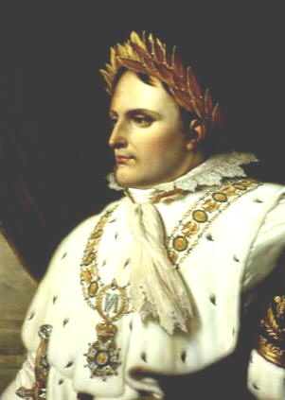**D. Napoleon the Emperor**

After the coup d’etat, Napoleon organized a new government and put himself in charge. In 1804, he took the title “Emperor of the French.” Napoleon now had absolute power. The French people, hoping for stability, supported Napoleon.

“What is a throne? — a bit of wood covered in gold and velvet. I am the state— I alone am here the representative of the people. France has more need of me than I of France.”

“In political administration (government), no problem is ever simple. It can never be reduced to the question whether a certain measure is good or not.”

*Based on the quote, what type of ruler do you think Napoleon will be?*

______________________________________________________________________________________________________________________________________________________________________________________________________________________________________________________________________________

**E. French Revolution Timeline**

*Based on this handout, add THREE more events to the timeline.*