Latin America 1

Aim: | Date:
Key Words:

1.

2.
A. Map of European Colonies
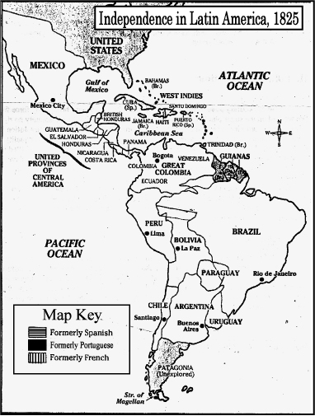
Use the information on the chart and color in the map. The map key will tell you which design to fill in each colony.

Social Class | Who are they?  What was their role in society?
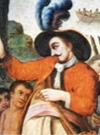
Peninsulares
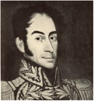
Creoles
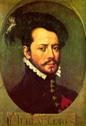
Mestizos
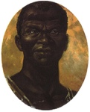
Slaves/Mulatto
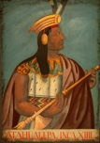
Indians
Portuguese  Colonies | Brazil
French Colonies | Guianas, Haiti
Spanish Colonies | Mexico, Cuba, Peru, Argentina, Bolivia, Ecuador, Chile, Paraguay, Uruguay, Colombia, Panama, Venezuela

B. Social, Political and Economic Conditions
Latin American colonial society was sharply divided into classes based on birth. At the top of Spanish American society were Peninsulares; men who had been born in Spain. Only Peninsulares could hold high office in Spanish colonial government. Creoles, Spaniards born in Latin America, ranked after Peninsulares. Creoles could not hold high political offices, but they could serve in colonial armies and become officers. Together, these two minority groups controlled wealth and power in the Spanish colonies. Below the Creoles came the Mestizos (persons of mixed European and Indian ancestry) who were the business owners. After the Mestizos came the African slaves and Mulattos. African slaves performed all of the hard labor for the colonists. Mulattos were people of African and Spanish descent. Last were the Indians. Unlike enslaved Africans, Indians were of little economic value to the Spaniards. As a result, they were more severely oppressed than any other group.

C. Social Unrest
Read each statement below and answer the following:
- Decide if a Peninsulare, a Creole, a Mestizo, an Indian, or an African slave said the statement.
- Describe the goals of that group.
- Explain at least one possible reason for these goals.

"I consider myself a Spanish American. My parents came from Spain, but I was born in this new land. I appreciate my Spanish heritage, but I believe the time has come to be free from ties with Spain!"

Who said it? | Goals of this group | Why do they have this goal?

"This is my land! My people lived here long before any others. Then conquerors came from beyond the sea. They seized the land and made my people work for them like animals. They took our gold and silver. We want our freedom once again."

Who said it? | Goals of this group | Why do they have this goal?

"My father came from across the sea. My mother is a native of this land. Though some people scorn me, I feel that I combine the best of two cultures. I will fight for freedom and respect!”

Who said it? | Goals of this group | Why do they have this goal?

"We bring our culture, our knowledge and our religion to this savage land. We will rule this land and we - will civilize its people."

Who said it? | Goals of this group | Why do they have this goal?

"I am ready to stand up against the rulers of this land. They brought me here, against my will. They made me work for them but gave me nothing in return. I know I shall never see my homeland again, so I am ready to fight t make my new land free!"

Who said it? | Goals of this group | Why do they have this goal?

