**Suffrage**

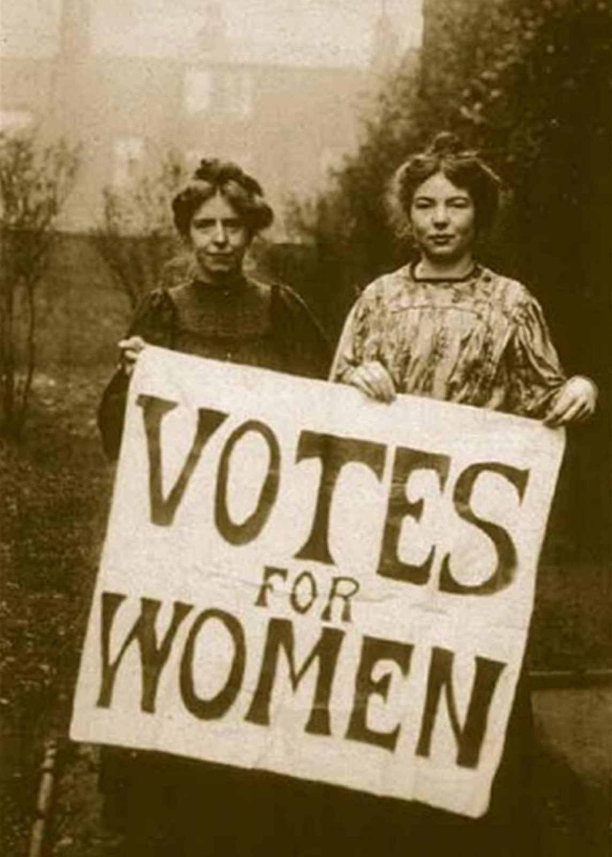

Beginnings: During the 1800s, a cult of domesticity idealized the middle-class woman as a mother who stayed at home taking care of her kids and husband. She did not have a role outside the home. Many middle-class women disliked these expectations and protested the restrictions on their lives.

Goal: Particularly, women wanted suffrage, or the

right to vote.

Opposition: British suffragists faced opposition. Some opposers believed that women were too emotional to vote responsibly, and others believed that women belonged at home, not in the government. Frustrated by this opposition, some women became more militant, or aggressive.

Strategies: In Great Britain women’s suffrage attracted attention when John Stuart Mill presented a petition in Parliament calling for inclusion of women's suffrage in the Reform Act of 1867, which was rejected. Later in the same year, Lydia Becker (1827 – 1890) founded the first women's suffrage committee, in Manchester. Other committees were quickly formed, and in 1897 they united as the National Union of Women's Suffrage Societies, with Millicent Garret Fawcett (1847 –1929) as president. Emmeline Pankhurst, assisted by her daughters Christabel and Sylvia, founded the Women's Social and Political Union (WSPU) in 1903. Her followers, called "suffragettes," heckled politicians, practiced civil disobedience, or refusal to obey certain laws, and were frequently arrested for causing riots.

Impact: In February 1918, women over the age of 30 received the right to vote. Suffrage rights for men and women were equalized in 1928.

Definitions: Suffrage, civil disobedience.

**Education**

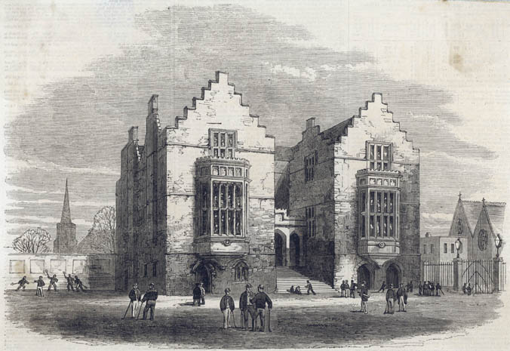Beginnings: Before the Industrial Revolution and reforms, education was scarce, expensive, and restricted to males. The only formal education provided to British children were religious schools. Reformers believed that they needed to have a literate workforce and that education should be available to even the poorest.

Goal: Mandatory free education for children. By the late 1800s, reformers fought to have the government set up public schools and require basic education for all children. In schools, students were taught discipline, patriotism, and work habits.

Opposition: Reformers faced opposition from factory owners, who wanted cheap labor and families who were dependent on the child’s wages.

Strategies: In 1839 [Thomas Guthrie](https://en.wikipedia.org/wiki/Thomas_Guthrie) wrote *Plea for Ragged Schools* and started a [ragged school](https://en.wikipedia.org/wiki/Ragged_school). In 1844 [Anthony Ashley-Cooper,](https://en.wikipedia.org/wiki/Anthony_Ashley-Cooper,_7th_Earl_of_Shaftesbury)  formed the 'Ragged School Union' dedicated to the free education of destitute children and over the next eight years over 200 free schools for poor children were established in Britain. This got the attention of the government.

Impact: In 1833, the government passed the Factory Act making two hours of education a day compulsory for children working in factories. The government also granted money to charities for schools for the first time. In 1844, the Ragged Schools Union was set up to give schooling to very poor children. In 1880, the Education Act made school attendance compulsory for children up to the age of 10. The 1902 Education Act established a system of secondary schools or high schools. Reforms also led to the opening of colleges and universities as well as libraries.

Definitions: literate, Factory Act of 1833

**Unions**

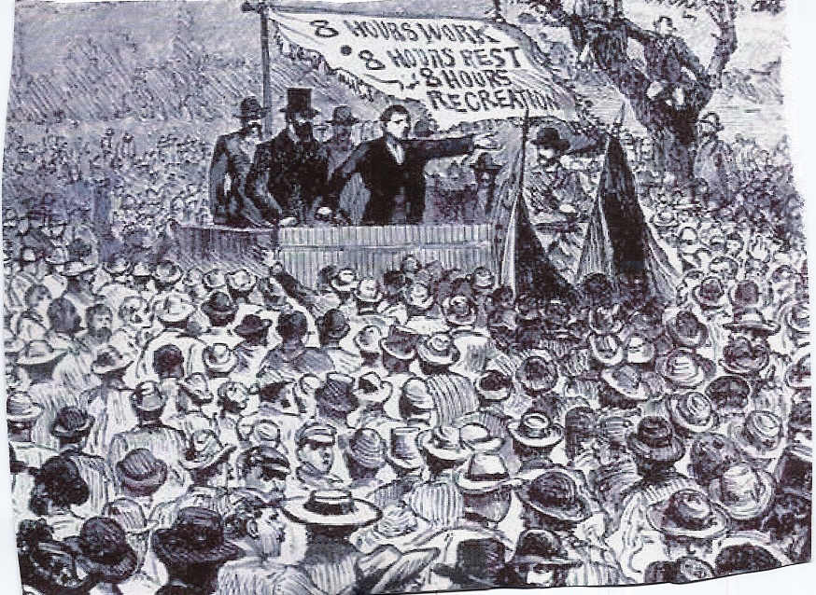

Beginnings: A union is an organized association of workers formed to protect and further their rights and interests such as fair wages, working hours, and working conditions. During the Industrial Revolution, workers were subjected to long hours, poor wages, and dangerous conditions.

Goal: Legalize unions.

Opposition: During the 18th century, when the Industrial Revolution prompted a wave of disputes between workers and factory owners, the government introduced measures to prevent unionization and striking. The Combination Acts, passed in 1799 and 1800, during the Napoleonic wars, made any sort of strike action illegal - and workmen could receive up to three months' imprisonment or two months' hard labor if they broke these new laws.

Strategies: Despite the Combination Acts, workers continued to press for better pay and working conditions during the early part of the 19th century, and trade unions grew rapidly in London and elsewhere. Parliament repealed the Combination Acts in 1824 and 1825. Trade unions could now no longer be ignored as a political force, though employers remained reluctant to treat workers' representatives as their equals. 'New unionism' reached out to the many unskilled workers in Britain who lacked union representation. The first women's 'trade societies' also began to emerge during this period. The strike by the female workers at the Bryant & May match factory, in the East End of London, in July 1888 highlighted the expanding boundaries of trade union activity in Britain.

Impact: By organizing into a labor union, workers could act together as a group. They could try, as a group, to get the employer to meet their demands. This process is called collective bargaining – bargaining as a group. With collective bargaining, workers were in a stronger position to win their demands such as:

1. Higher wages
2. Fewer working hours
3. Security against unemployment
4. Vacations with pay
5. Benefits: medical care, hospitalization costs, retirement pensions, etc.

Definitions: Collective Bargaining, union

**Sanitation**

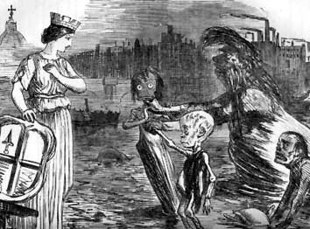

Beginnings: In an attempt to contain the disease, Health Boards were set up to establish better standards of sanitation. Local government officials were told to clean up the towns and cities. They were instructed to provide for the removal of solid waste heaps and other household wastes, to clean the streets (particularly of the large amounts of horse manure) and to whitewash houses wherever possible.

Goal: Proper removal of waste and clean drinking water.

Opposition: Many people did not believe there was a connection between polluted water and health problems.

Strategies: In 1854 Dr. Snow was able to demonstrate the link between cholera (deadly disease) and the water supply. During an outbreak of cholera in the Soho area of London, he noticed that many of the victims obtained their water from the same public water pump. When Dr. Snow removed the handle from the pump to prevent people from using it, the cholera fatalities in Soho fell dramatically. Despite overwhelming evidence, not everyone was convinced, and more time went by before effective action was taken against cholera. In fact, the disease struck again in 1866, but by this time new sewers and cleaner public water supplies had been installed in parts of London. It was noticeable that the epidemic was confined to those areas of the city which were still relying on old water supplies. Finally, the connection between cholera and polluted water was accepted.

Impact: As a result, improved sanitation and the provision of clean drinking water became an even greater priority. This, together with gradual improvements in housing, enabled cholera, along with other diseases associated with poor living conditions, to be eradicated.

Definitions: Cholera and epidemic

**Working Conditions**

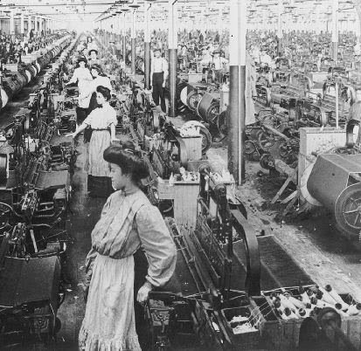

Beginnings: Some of the bosses hire thousands of men, women, and children. In the cotton-spinning trade, these people work fourteen hours a day. Workers were kept locked up, summer and winter, in a heat of 80 to 84 degrees. The door of the place where they work was locked. The workers were not allowed to leave their work station to get water. Even the rainwater was locked up by the master’s order. The accidents that occurred to the manufacturing population were very severe and numerous. Many accidents could be prevented if employers were not being too cheap to purchase safety guards for the machines. Many accidents occur when the machinery catches loose portions of dress or hair. These young women are dragged into the machine.

Goal: Safe working conditions.

Opposition: Improving working conditions would cost owners money since they would have to pay for improvements and pay workers who did dangerous jobs more. Some economists argued that increased costs would ruin the industry, which made a major contribution to the wealth of the country. (This was later found to be wrong as better fed, less tired workers produced more, not less.) Some people argued that the workers would only spend the extra time and money in drunkenness and crime. (This turned out to be wrong: better conditions led to less crime.) Finally: the government believed it was wrong to interfere in the free working of the economy (Laissez-faire).

Strategies: Robert Peel, a factory owner and British Prime minister, started pushing for reforms after seeing first-hand what was happening in factories.

Impact: In 1847, the Ten Hours Act was passed that limited the work day to ten hours, but it was ineffective. In 1878, the Factory and Workshop Act was passed that included laws on safety. This law included inspections and set money aside to hire inspectors.

Definitions: Laissez-faire, Ten Hours Act

**Child Labor**

Beginnings: During the Industrial Revolution poor children often worked full time jobs in order to help support their families. Children as young as four years old worked long hours in factories under dangerous conditions.

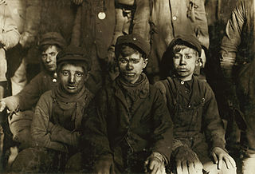

Goals: Regulate child labor.

Opposition: Children performed all sorts of jobs including working on machines in factories, selling newspapers on street corners, breaking up coal at the coal mines, and as chimney sweeps. Sometimes children were preferred to adults because they were small and could easily fit between machines and into small spaces.  Another reason that businesses liked to hire children workers was because they worked for little pay. In many cases, children weren't paid at all, but worked for their room and board. When they did earn wages, children often earned 10 to 20 percent of what an adult would earn for the same job, which saved owners money. Some families also needed the money their kids brought home.

Strategies: Michael Sadler, a member of Parliament, interviewed child factory workers and presented his findings to Parliament (English government). His report is called the Sadler Report.

Impact: The Health and Morals Act of 1802 limited the amount of work hours for children under 14 and said children under 9 could not work. The minimum (lowest) age of employment shall be nine years. The Factory Act of 1833 limited the amount of work hours for under 18 children.

Definitions: Child Labor, The Factory Act