Name:

Industrial Revolution – Constructed-Response Questions

Directions: For constructed-response questions, you will need to answer a total of four questions. Answer each question in at least 3 sentences using both document information and prior knowledge.

Document #1
Map of England during the Industrial Revolution.
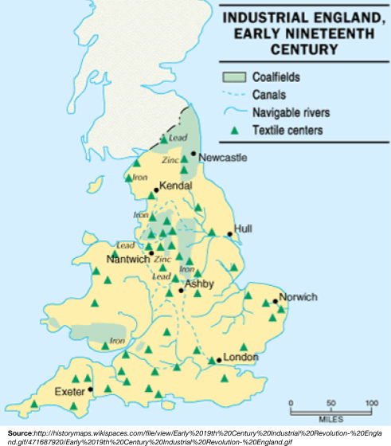

QUESTION 1 – You must answer this question!

Geographic Context—where this historical development is taking place, and why it is taking place there.

1. Using document 1, explain how the geographic context affected the beginning of the Industrial Revolution.

Document #2
Robert J. Southey was a British writer who was born during the Industrial Revolution.

“. . . A place more destitute of all interesting objects than Manchester, it is not easy to conceive. In size and population it is the second city in the kingdom, containing above fourscore thousand [80,000] inhabitants. Imagine this multitude crowded together in narrow streets, the houses all built of brick and blackened with smoke; frequent buildings among them as large as convents, without their antiquity, without their beauty, without their holiness; where you hear from within, as you pass along, the everlasting din of machinery; and where when the bell rings it is to call wretches to their work instead of their prayers, . . . ”
— Robert J. Southey, Letters from England, 1807

QUESTION 2 – You must answer this question!

2. Using document 2, identify the purpose of creating this document.

Document 1 Document 2
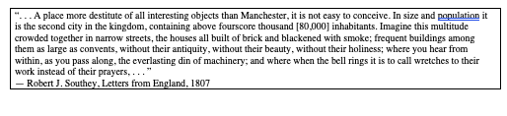
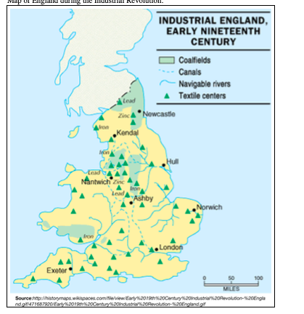

QUESTION 3 – You must answer both questions!
A turning point is a significant event, idea, or historical event that brings about change. It can be local, regional, national or global.

3a. Identify a turning point associated with the events or ideas in documents 1 and 2. (One Sentence)

3b. Explain a turning point associated with the events or ideas in documents 1 and 2. Be sure to use evidence from both documents 1 and 2 in your response.

Unsatisfactory (0) | Needs Improvement (5) | Satisfactory (10)
Either no attempt was made to answer the question, or an attempt was made that did not address the question properly. | A valid attempt to answer the question was made. However, there may be factual inaccuracies, vagueness, or missing relevant analysis. | The question was answered in a satisfactory manner. The appropriate evidence, analysis, and outside information was used.

Grades: Q1 Q2 Q3a Q3b

Total CRQ Grade

