Document 1

The Sadler Committee (1832)
In 1832 Michael Sadler secured a governmental investigation of conditions in the textile (cloth) factories and he sat as chairman on the committee. The evidence printed here is taken from the large body published in the committee's report. The questions are frequently leading; this reflects Sadler's knowledge of the sort of information that the committee was to hear and his purpose of bringing it out.

Document 1A  This is an excerpt from William Cooper’s testimony before the Sadler Committee in 1832. |  | Document 1B  This is an excerpt from the testimony of Joseph Hebergam to the Sadler Committee.
Sadler: When did you first begin to work in mills?  Cooper: When I was ten years of age.  Sadler: What were your usual hours of working?  Cooper: We began at five in the morning and stopped at nine in the night.  Sadler: What time did you have for meals?  Cooper: We had just one period of forty minutes in the sixteen hours. That was at noon. |  | Sadler: Do you know of any other children who died at the Mill?  Hebergam: There were about a dozen died during the two years and a half that I was there. At the Mill where I worked last, a boy was caught in a machine and had both his thigh bones broke and from his knee to his hip . . . . His sister, who ran to pull him off, had both her arms broke and her head bruised. The boy died. I do not know if the girl is dead, but she was not expected to live.  Sadler: Did the accident occur because the shaft was not covered?  Hebergam: Yes.  Sadler: What means were taken to keep you awake and attentive?  Cooper: At times we were frequently strapped. (beaten with a belt)  Sadler: When your hours were so long, did you have any time to attend a day school? Cooper: We had no time to go to day school.

Document 2
At Work in a Woollen Factory  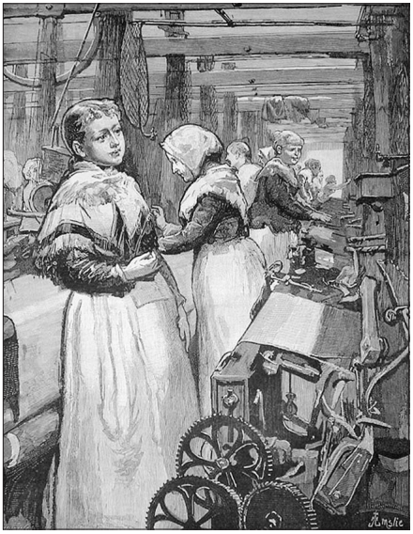  The Illustrated London News, August 25, 1883  Source: NYS Global History and Geography Regents Exam, June 2006. |  | 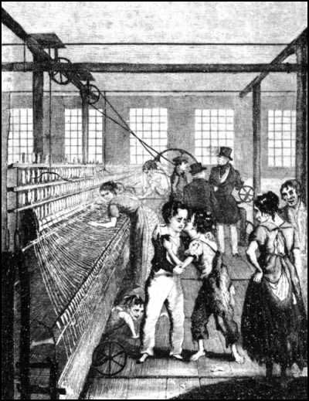  Illustration from Frances Trollope’s Michael Armstrong: Factory Boy (1840), a novel about a child laborer.

Document 3
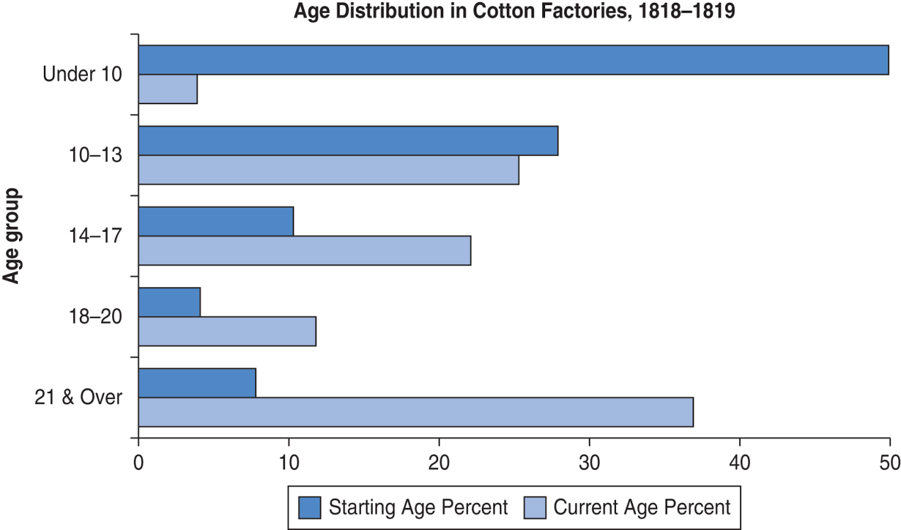
Source: Created for the New York State K–12 Social Studies Toolkit by Agate Publishing, Inc., 2015. Based on data from Wade Thatcher, Child Labor During the English Industrial Revolution. http://wathatcher.iweb.bsu.edu/childlabor/. British Parliamentary Papers (BPP) (1818) Minutes of Evidence on the Health and Morals of Apprentices and others employed in Cotton Mills and Factories. Sessional Papers, House of Lords, vol. 96, appendix. BPP (1919) Minute of Evidence on the State and Condition of the Children employed in Cotton Factories, Sessional Papers, House of Lords, vol. 110, appendix.
Document 3b
Child Employment in the United Kingdom in 1851
Mining |  |  | Textiles and Dyeing
Males under 15 | 37,300 |  | Males under 15 | 93,800
Females under 15 | 1,400 |  | Females under 15 | 147,700
Males 15-20 | 50,100 |  | Males 15-20 | 92,600
Females over 15 | 5,400 |  | Females over 15 | 780,900
Total under 15 as % of workforce | 13% |  | Total under 15 as % of workforce | 15%
Source: Booth, C. “On the Occupations of the People of the United Kingdom, 1801-81.” Journal of the Royal Statistical Society (J.S.S.) XLIX (1886): 314-436. Data retreived

Document 4
“. . . A place more poor of all interesting objects than Manchester, it is not easy to conceive. In size and population it is the second city in the kingdom, containing above fourscore thousand [80,000] inhabitants. Imagine this multitude crowded together in narrow streets, the houses all built of brick and blackened with smoke; where you hear from within, as you pass along, the everlasting noise of machinery; and where when the bell rings it is to call wretches to their work instead of their prayers, . . . ”
— Robert J. Southey, Letters from England, 1807
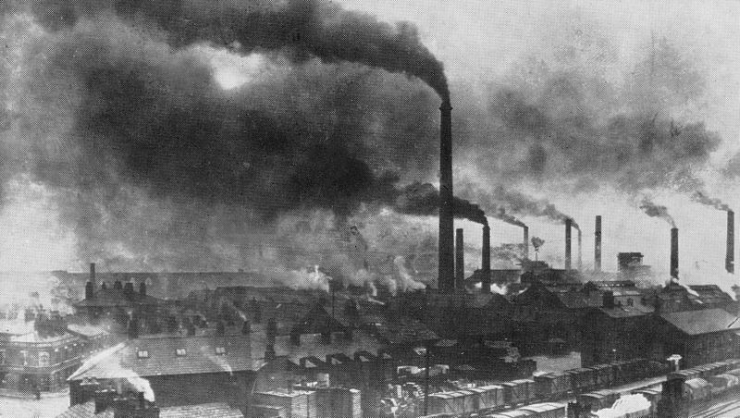
Photograph of Widnes, England in the late 19th century.
Source: https://commons.wikimedia.org/wiki/File:Widnes_Smoke.jpg

Document 5
In July and August of 1858, hot weather combined with untreated human waste and industrial pollution to turn the Thames River in London into a disgusting body of water in an event known as “the Great Stink.” The increase in population in the city overwhelmed its sewage system, and industries along the waterway dumped the byproducts of their production into the water. Though Londoners at the time believed that the foul stench coming from the river led to epidemics, it was overcrowding and poor sanitation that led to outbreaks of disease like cholera. The political cartoons below were drawn during “the Great Stink.”
The silent highwayman : Death rows on the Thames, claiming the lives of victims who have not paid to have the river cleaned up, during the Great Stink.  Source: https://en.wikipedia.org/wiki/File:The_silent_highwayman.jpg | 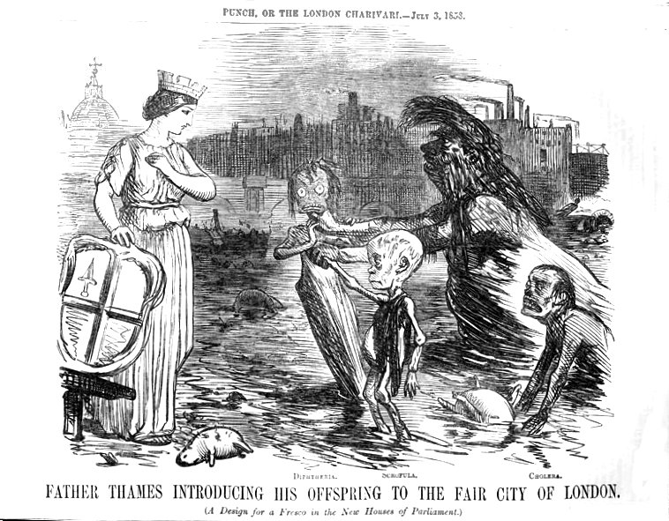  Caricature published in Punch magazine at the time of the "Great Stink.” The River Thames introduces his children – diphtheria, scrofula and cholera – to the city of London.  Source: https://en.wikipedia.org/wiki/File:Father_Thames_introducing_his_offspring_to_the_fair_city_of_London.jpg

Document 6
Due to their newfound wealth, time saving machines and conveniences, and white collar jobs with predictable hours and days off, the middle class in the 19th century enjoyed a luxury that in the past was only available to the rich: money and leisure time (free time). New attractions and activities catering to the middle class drew crowds.
Document 6  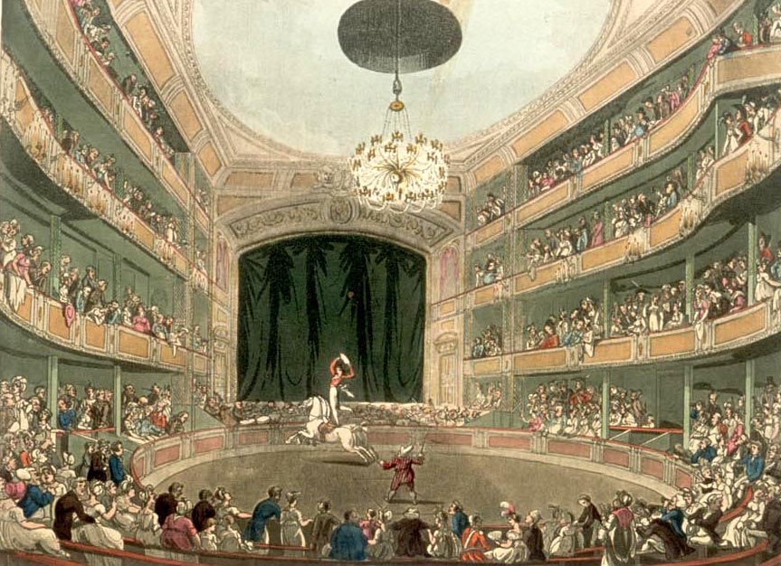  Drawing of Astley’s Amphitheatre in London (1808-1811). Astley’s Amphitheatre is credited as being the first modern circus. | Document 6  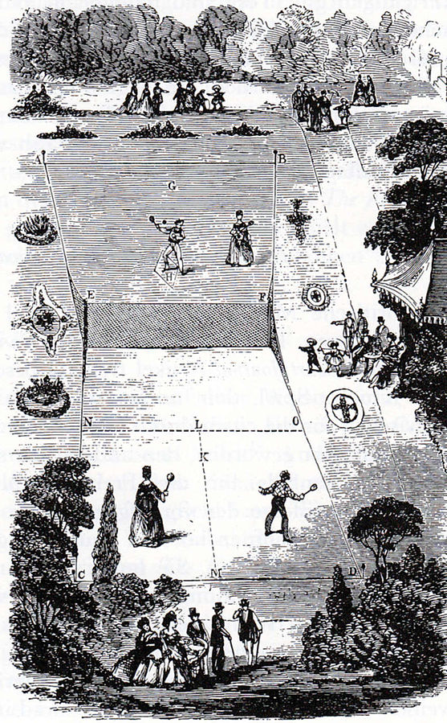  Drawing of a Lawn Tennis court (1874). Tennis, and other sports like cricket became very popular in the 19th century with the middle class.

Document 7
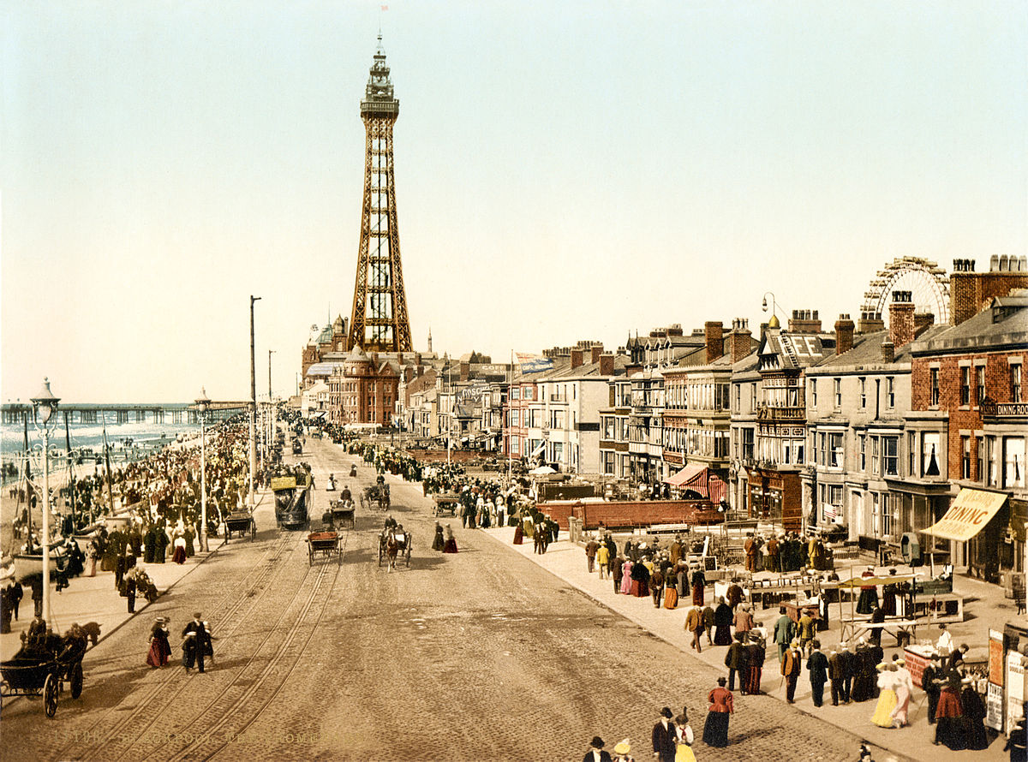
A colored photograph of the Blackpool Promenade (ca. 1890). Blackpool was a popular seaside resort that the middle class used to escape congested and polluted industrial cities if they could afford the train ride.

Document 8
In 1856 Samuel Beeton persuaded his wife, Isabella, to be a joint editor with him in a new publishing venture, a monthly paper called The Englishwoman's Domestic Magazine. This was the first cheap magazine for young middle-class women, and it was an immediate commercial success, with an advertised circulation of 50,000 copies by 1856.

Isabella wrote domestic management [house keeping] material, embroidery patterns, cooking, dressmaking and all the translations of French novels that were serialized in the periodical from 1855 until her early death in 1865. The contents also included a range of serial fiction, biographical sketches, gardening and medical tips (including some useful advice on birth control), and a correspondence page. There was always a strong emphasis on practical instruction and useful knowledge.
Source: http://www.bl.uk/victorian-britain/articles/the-victorian-middle-classes#sthash.7ATm8Gu2.dpuf
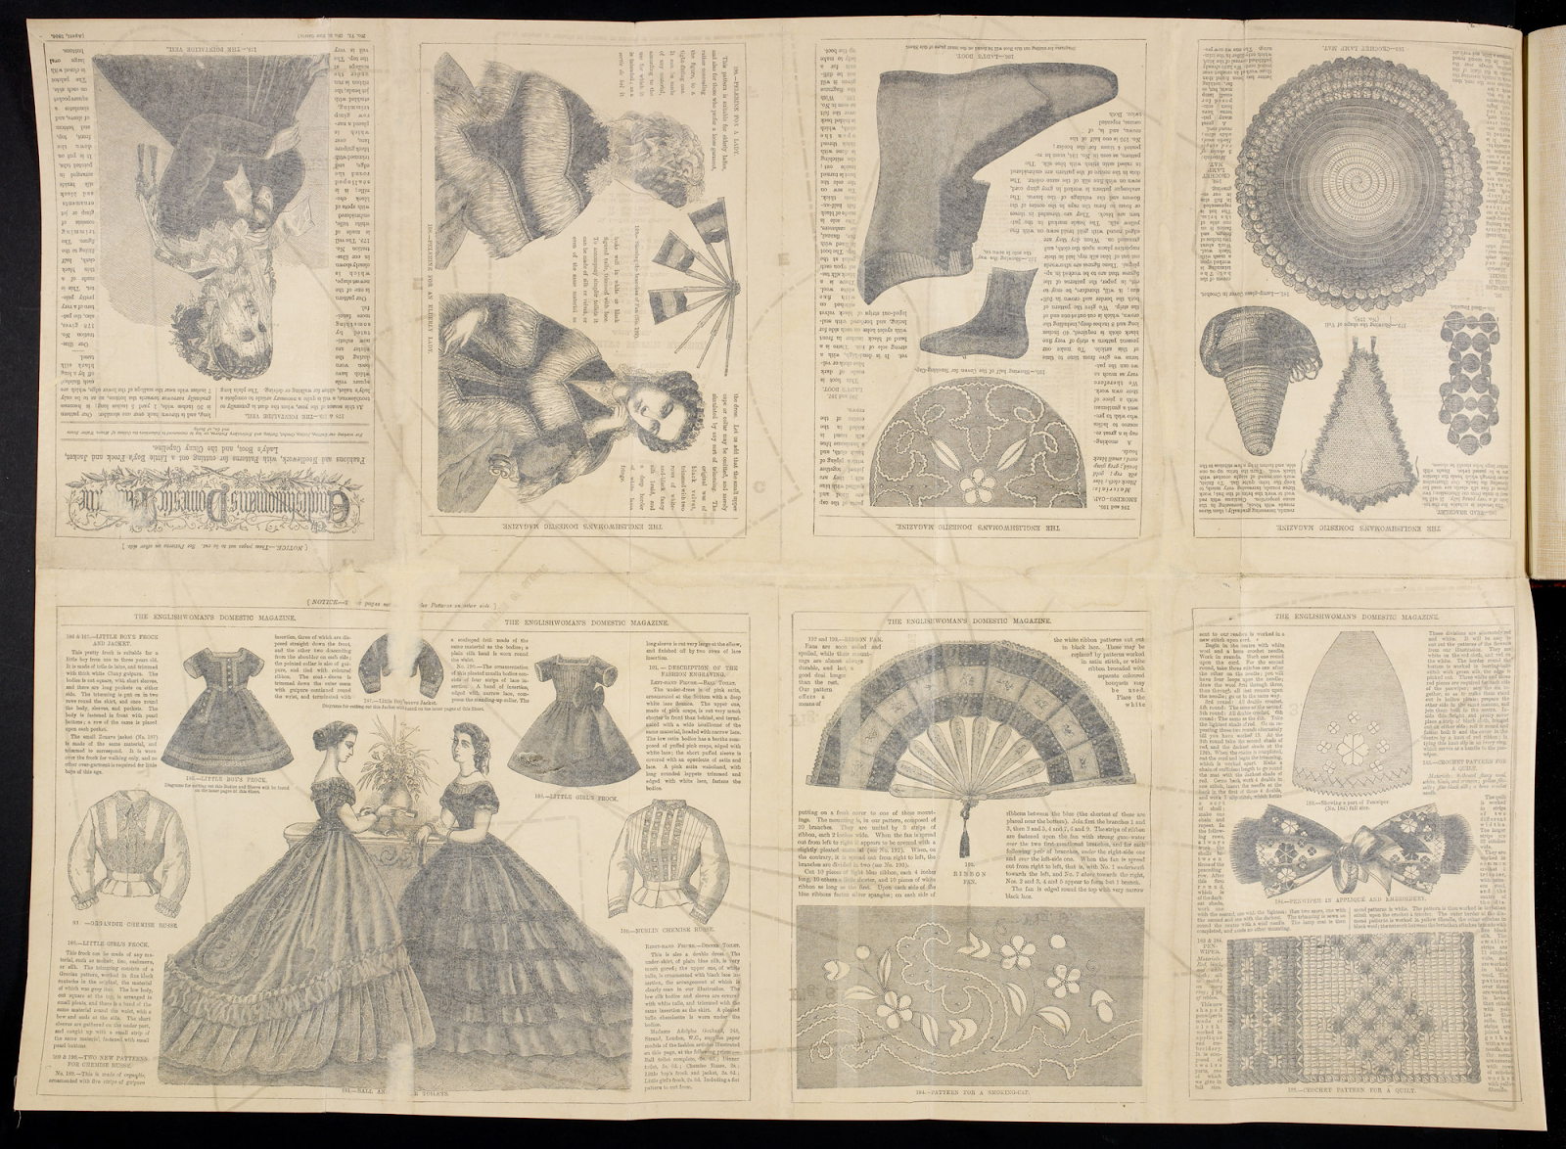
Document 9
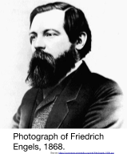
Friedrich Engels (November 28, 1820 – August 5, 1895) was a nineteenth century German political philosopher. He was the son of a textile manufacturer who became a socialist. After observing the appalling situation of British factory laborers while managing a factory in Manchester, England, he wrote his first major work, The Condition of the Working Class in England in 1844 (excerpted below). In 1844, he met Karl Marx in Paris, beginning a lifelong collaboration. He and Marx wrote The Communist Manifesto (1848) and other works.
Source: “Friedrich Engels.” New World Encyclopedia. http://www.newworldencyclopedia.org/entry/Friedrich_Engels
. . . Every great town has one or more slum areas into which the working classes are packed. Sometimes, of course, poverty is to be found hidden away in alleys close to the stately homes of the wealthy. Generally, however, the workers are segregated in separate districts where they struggle through life as best they can out of sight of the more fortunate classes of society. The slums of the English towns have much in common—the worst houses in a town being found in the worst districts. They are generally unplanned wildernesses of one- or two-storied terrace houses built of brick. Wherever possible these have cellars which are also used as dwellings. These little houses of three or four rooms and a kitchen are called cottages, and throughout England, except for some parts of London, are where the working classes normally live. The streets themselves are usually unpaved and full of holes. They are filthy and strewn with animal and vegetable refuse. Since they have neither gutters nor drains the refuse accumulates in stagnant, stinking puddles. Ventilation in the slums is inadequate owing to the hopelessly unplanned nature of these areas. A great many people live huddled together in a very small area, and so it is easy to imagine the nature of the air in these workers’ quarters. However, in fine weather the streets are used for the drying of washing and clothes lines are stretched across the streets from house to house and wet garments are hung out on them. . . .
Source: Friedrich Engels, The Condition of the Working Class in England in 1844, W. O. Henderson and W. H. Chaloner, eds., Stanford University Press from the NYS Global History and Geography Regents Exam, June 2006.

Document 10
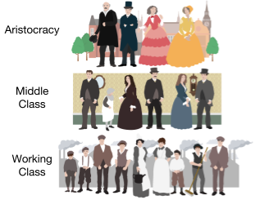

As a result of the Industrial Revolution, a new social class structure emerged, first in Great Britain and later in other industrialized nations. The aristocracy, a group made up of descendants of wealthy landowning families that were the nobles and knights in feudalism, held on to their wealth, but lost power to a new group called the middle class. The middle class (known as the bourgeoisie in French) included business owners (also known as entrepreneurs, industrialists, and capitalists) and other educated professionals that supported business. The lowest class, which was the peasants in the feudal system, was the working class who labored in mines, factories, and the homes of the aristocracy and middle class.

