**Imperialism - India**

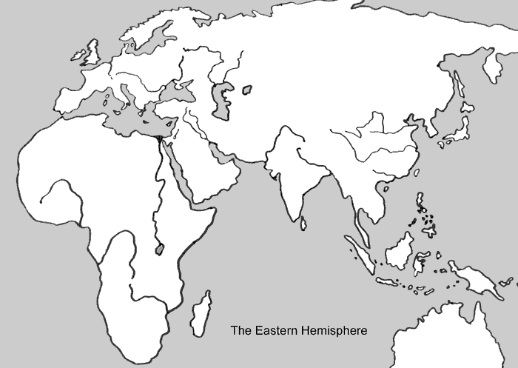

**A. Before Imperialism**

Before the Age of Imperialism, Europeans went to India to get Indian spices and Indian tea, which were very valuable for their rarity. India was referred to as the “Crown Jewel” of the British Empire because of this.

However, Europeans became more interested in India later when they realized that India could be a very effective trading post. Europeans had a lot to trade because of the excess of products they had because of the Industrial Revolution.

*Why was India called “The Crown Jewel” of the British Empire?*

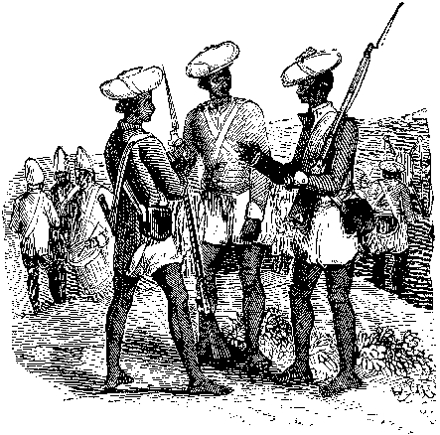**B. Sepoys**

The British controlled more and more territory in India. The British government sent representatives of Britain, called viceroys, to control India. These British viceroys were in charge in India and were free to command the army as they saw fit. British officers were in charge, but the rest of the British army in India consisted of Indian soldiers, known as sepoys.

*What country did the Sepoys fight for?*

*________________________________________________*

*Would you fight for another country if you were forced to? Explain why or why not.*

**C. The Sepoys Are Disrespected!**

The bullet cartridges for the guns that the sepoys had to use were made with beef and pork fat. When it came time to load the gun, the sepoys had to pull the bullet out of its seal using their teeth. The Indian sepoyswere made up of Muslims and Hindus. The problem was that cows are an extremely sacred animal to Hindus and they are not allowed to eat beef. Pigs are considered to be a dirty animal to Muslims and they are not allowed to eat pork. When they realized what was in the cartridges, the Indians were mad. They believed that the British were secretly were trying to convert them to Christianity. (Picture on back of handout).

*Explain how the Sepoys were disrespected by the British.*

______________________________________________________________________________________________________________________________________________________________________________________________________________________________________________________________________________

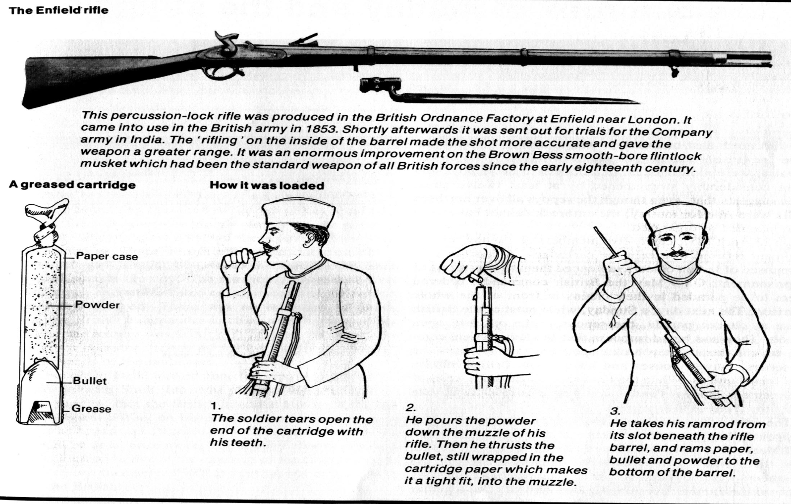

**D. The Sepoy Mutiny (Mutiny = Revolt)**

Fighting took place between the British and Indians in 1857. This was called the Sepoy Mutiny and soon spread across India. Fighting went on for a year and many people on both sides died.

Because of their religious differences, the Hindu Indians could not get along with the Muslim Indians. They could not work together to overpower the British. The British government stopped the rebellion by sending in troops from Britain. The British continued their tyrannical imperialistic rule over the Indians after they crushed the Sepoy Mutiny. The British ruled India until 1947 (another 90 years!).

*Who won this battle? Why were they able to win?*

**E. Vocabulary**

Sepoy

Sepoy Mutiny

Viceroy