**Document #1- Causes for the Partition (Separation) of India**

Muslims speak the same language as other Indians of the same regions, but their customs are very different. For example, Hindus worship the cow and do not eat it, while Muslims eat beef. Hindus eat pork but Muslims consider the pig a dirty animal and it is against their religion to eat pork. Hindus worship many gods, but Muslims worship only one god.

1. “Hindu India must stand together and create one great nation! We should celebrate our great land and culture, with our language, festivals and culture. We must do so until Hindus become one nation, as strong and sharp as steel.” – A Hindu nationalist

2. “Indian Muslims have a separate culture and civilization with our own way of seeing life. The only thing we have in common with the Hindus is that we were slaves to the British.” - A leader of the Indian Muslims

**Document #2- The Partition of India**

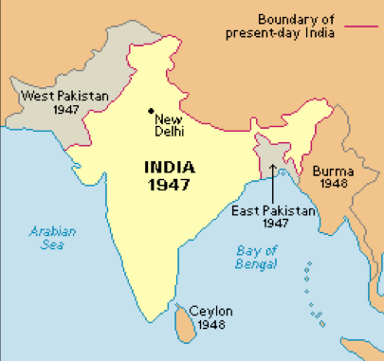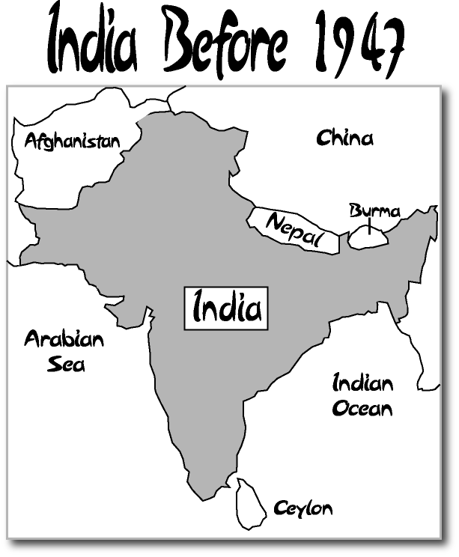India finally gained its freedom in 1947. However, Hindus and Muslims had many disagreements and this made separating from India more difficult. The last British leader of India had to deal with independence while trying to prevent a civil war between Hindus and Muslims. The two main political parties were the Indian National Congress (Jawaharlal Nehru – leader) and the Muslim League. (Muhammad Ali [Jinnah](http://plus.aol.com/aol/redir?src=encyclopedia&requestId=58457113656c318b&userQuery=muslim+league&clickedItemURN=reference%2FJinnah-M/Muhammad_Ali_Jinnah%3FinvocationType%3Dencyclopedia.main&moduleId=encyclopedia.M&clickedItemDescription=Encyclopedia%20Main) – leader). They both wanted separate countries. In 1947, Britain decided to PARTITION (separate) India into TWO INDEPENDENT COUNTRIES, India and Pakistan. East and West Pakistan were far away from each other but they were one country at first. Gandhi did not approve of this partition.

**Document #3- The Great Migration**

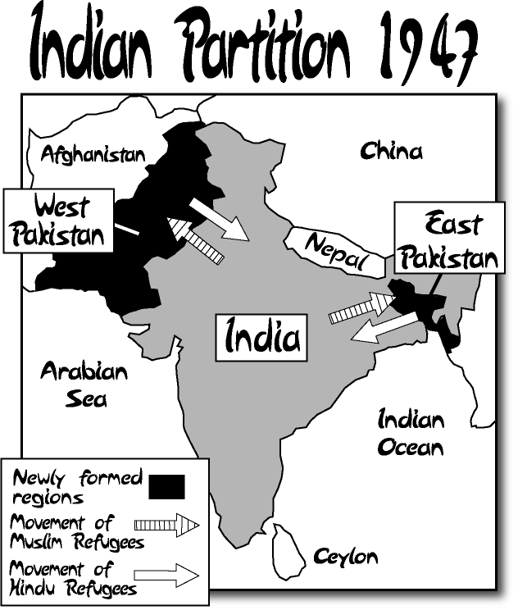As India and Pakistan became separate countries, millions of Hindus living in Pakistan quickly began to move to India. Millions of Muslims who lived in India began to flee (escape) to Pakistan. (see map)

More than 15 million people in total gave up their homes and belongings to move away. During this move, many episodes of violence happened.

**Document #4- Bangladesh**

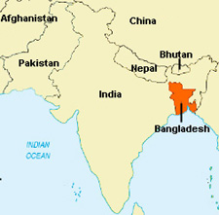The new country of Pakistan had two parts: West Pakistan and East Pakistan (see map). Both had Muslim populations, but their different languages and cultures made them argue over power and jobs. They were also separated by thousands of miles of land. This led to civil war and eventually, East and West Pakistan became two different countries: West Pakistan became =Pakistan. East Pakistan became Bangladesh.

**Formerly called West Pakistan**

**Formerly called East Pakistan**

**Kashmir- *territory fought over by India and Pakistan***

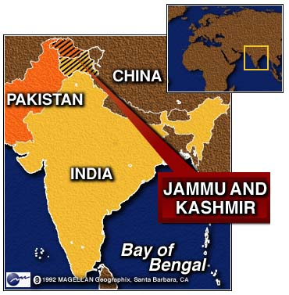

**Document #5- India-Pakistan relations since 1947**

* **1.** **Aug 1947**: India becomes 2 separate countries - Pakistan and India. Many hundreds of thousands are killed in conflicts.

* **2.** **Oct 1947**: Pakistan and India fight over the territory of Kashmir (see map) **See map ⇨**

* **3. Sept 1965**: Pakistan and India fight a second war over Kashmir.

* **4. Dec 2001**: Gunmen attack Indian government. India blames Pakistan. Pakistan denies this. India cuts off Pakistan from being able to fly, drive and use the railroad into their territory.

* **5. Jan 2002**: India sends troops to Pakistan border. Pakistan sends its own troops in response.

* **6. Nov 26, 2008:** Pakistani attackers launch wave of gun and grenade attacks in Mumbai. 120 people are dead.

* **7. 2019:** India and Pakistan are engaged in an ongoing military confrontation in the disputed Kashmir region. The heightened tensions stem from a suicide car bombing that happened on February 14, 2019.

**Document #6- Nuclear Arms Race**

India and Pakistan experience many conflicts and many countries around the world have become concerned because both countries have nuclear weapons and might use them against one another.

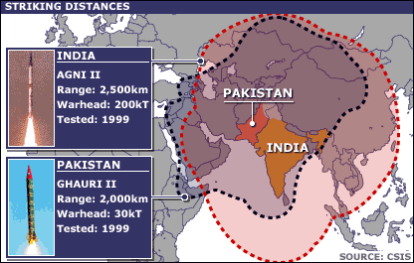

The distance each nation is capable of striking with their nuclear missiles.

Pakistan and India surprised the world by conducting nuclear tests in 1998.

It is estimated, that Pakistan has the capability to produce perhaps 20 nuclear warheads annually and India about five warheads annually. Pakistan is estimated to possess around 120 nuclear weapons against India's 100. Each country has specifically threatened the other country with the use of nuclear weapons.

BONUS: Which two other countries had an arms race as well? Did that arms race heighten or lessen tensions between them?