NAME: ___________________________________________ BAND: ________

Level 2: Enduring Issue TEAL Documents
Directions: Analyze the documents and answer the short-answer questions that follow each document in the space provided.

Document 1
The British presence began in India in the 1700s. At the start of the 18th century, the East India Company's presence in India was one of trade outposts.
Transforming the Face of India
“. . . Failure to answer, nay, refusal to tackle that question has rendered wholly academic the discussion of abandonment. Even were it otherwise we could still look back proudly. British brains, British enterprise, and British capital have, in a material sense, transformed the face of India. Means of communication have been developed: innumerable bridges, over 40,000 miles of railway, 70,000 miles of metalled roads, testify to the skill and industry of British engineers. Irrigation works on a stupendous [huge] scale have brought 30,000,000 acres under cultivation, and thus greatly added to the agricultural wealth of a country which still lives mainly by agriculture. But, on the other hand, the process of industrialization has already begun. The mills of Bombay have become dangerous competitors to Lancashire, and the Indian jute [rope] industry is threatening the prosperity of Dundee. Thanks to improved sanitation (much resented by the more ignorant beneficiaries), to a higher standard of living, to irrigation, to canalization, to the development of transport, and to carefully thought-out schemes for relief work, famines, which by their regular recurrence formerly presented a perennial [continuing] problem to humane administrators, have now virtually disappeared. To have conquered the menace of famine in the face of greater longevity, of diminished death-rate, and the suppression of war, is a remarkable achievement for which India is wholly indebted to British administration.”
Source: Sir John A. R. Marriott, The English in India, Oxford University Press, 1932

What enduring issues do you see in this document? (Circle all that apply)
Power Conflict Globalization Environment Scarcity Migration

Nationalism Response to Change Cultural Diffusion Technology Human Rights Violations

Summarize the document in your own words (no quotes).

What is the historical context of this document?

Document 2
Bishop Desmond Tutu, 1984
Bishop Desmond Tutu is a South African known for his work as an anti-apartheid and human rights activist.

When the missionaries came to Africa they had the Bible and we had the land. They said ‘Let us pray’.
We closed our eyes. When we opened them, we had the Bible and they had the land.
Source: South Africa Sunday Times, November 26, 2000
What enduring issues do you see in this document? (Circle all that apply)
Power Conflict Globalization Environment Scarcity Migration

Nationalism Response to Change Cultural Diffusion Technology Human Rights Violations

Summarize the document in your own words (no quotes).

What is the historical context of this document?

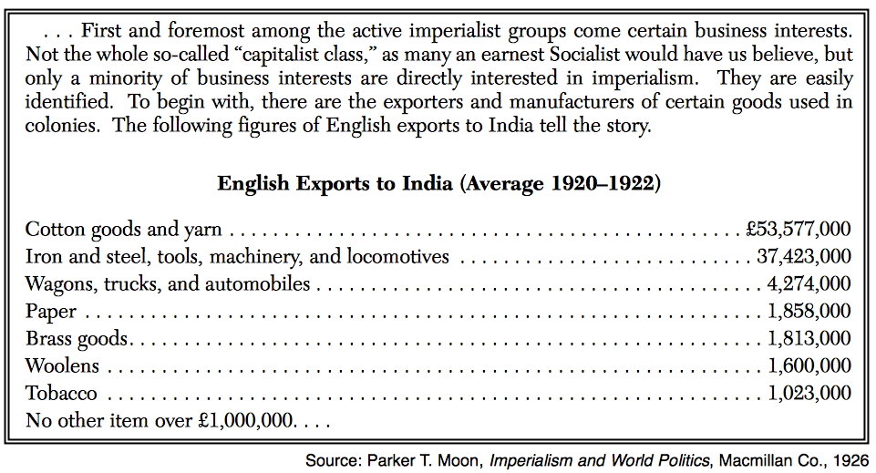
Document 3
Starting in the 1700s, England was a mother country to the colony of India.

What enduring issues do you see in this document? (Circle all that apply)
Power Conflict Globalization Environment Scarcity Migration

Nationalism Response to Change Cultural Diffusion Technology Human Rights Violations

Summarize the document in your own words (no quotes).

What is the historical context of this document?

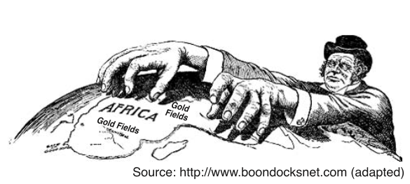
Document 4
By 1900, much of Africa had been colonized by seven European powers: Britain France, Germany, Belgium, Spain and Portugal.

What enduring issues do you see in this document? (Circle all that apply)
Power Conflict
Globalization Environment
Scarcity Migration
Response to Change Nationalism
Cultural Diffusion Technology Human Rights Violations

Summarize the document in your own words (no quotes).

What is the historical context of this document?

Decision Time
What Enduring Issue will you write about? (Circle 1)

Power Conflict Globalization Environment Scarcity Migration

Nationalism Response to Change Cultural Diffusion Technology Human Rights Violation

What documents will you choose?
1.
2.

