Imperialism - China

A. Before the Europeans Took Over
By 1800, China was a rich country with an excellent farming system that produced everything that the Chinese people needed. Because China was so self-sufficient, its emperors did not want to trade with Europeans. The Chinese considered European goods to be very low quality and almost never bought goods from the European merchants.
What is the historical context in China before Imperialism?

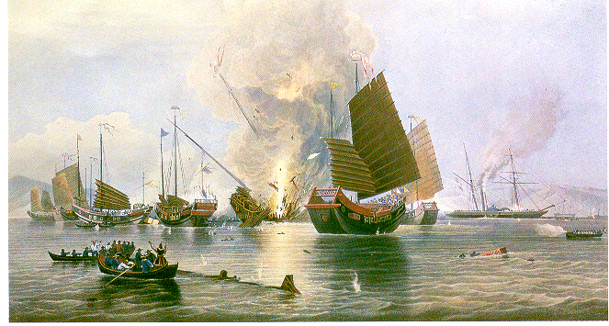
B. Opium Wars
European merchants desperately wanted a good that they could sell to the Chinese. The product they found was called opium. Opium is an addictive drug. The Chinese people loved opium and quickly became addicted to it. The Chinese government tried to stop the opium trade by asking the British king to stop it. He said no and a war between the two countries followed.

Why did the British and the Chinese go to war? Explain in detail.

C. The Nanjing Treaty and Problems Facing China
With superior technology, the British were able to crush the Chinese easily. The Chinese were forced to sign the Treaty of Nanjing. One of the major results of this treaty was that foreigners were allowed to trade freely in many Chinese ports. European countries picked certain parts of China that only those countries could trade in. This divided China into "spheres of influence." Many Chinese hated this new way of life and all of the opium that was being traded into China from the Europeans. Other problems faced China too, such as overpopulation. This, combined with all of the Chinese opium users, made them feel that a big change was needed in China. The Emperor was imprisoned and the again Empres CiXi was put into power. When she died in 1908 her 2-year-old son inherited the throne.

Identify all of the problems facing China at this point in time.

D. The Taiping Rebellion
One Chinese leader named Hong Xiuquan wanted to unite the Chinese people and not under the Empress. His idea was to divide all of China’s wealth equally among its people in order to end poverty. The following passage is taken from the Taiping’s Blueprint for Change, written in 1859:
If China is to survive, she (China) must adopt the technology of the west;
For example China must improve the speed of her communications.
If any Chinese can build a railroad as well as the Europeans make them, able to cover a great distance by day and night, let them do so.
When we Taipings take power, we shall build highways in all 21 provinces, acting as the arteries that will make the country immune from disease.

Result: As a result of the poor leadership of Hong Xiuquan, disagreements between members of the Taiping’s, and the constant attacks by foreigners, the Taiping government fell apart in 1864. By the time the rebellion was over, over 20 million Chinese had died.

Describe the change that the Taipings thought that China needed to make.
______________________________________________________________________________________________________________________________________________________________________________________________________________________________________________________________________________

E. The Boxer Rebellion
After the failed Taiping rebellion, and as the influence of foreigners continued to spread, the Chinese once again tried to make drastic changes to their society including admitting women to school and stressing math and science instead of Confucianism. The Boxers were a secret society in China. The Boxers took control of Beijing for several months during the year 1900. Shouting “Death to the foreign devils”, they murdered European businessmen and Christian missionaries, and burnt churches and foreign businesses.

The following document was written by the Boxer Rebellion:

China faces many problems. Foreign devils have come with their teachings. Many Chinese have converted to Christianity. The foreigners have made the Chinese people their servants. Western railways have been built, foreign guns have been made by Chinese hands... The Boxers ... will burn down houses and bring back our sacred temples. We will destroy every kind of foreign goods and foreign people.

Result: Soon after the Boxers seized Beijing, they were defeated by many countries. Though the Boxer Rebellion failed, many Chinese began feeling a sense of nationalism for the first time.

Explain the goals of the Boxer Rebellion.

F. Vocabulary

Opium Wars:
____________________________________________________________________________________________________________________________________________________________________________________

Taiping Rebellion:
____________________________________________________________________________________________________________________________________________________________________________________

Boxer Rebellion
____________________________________________________________________________________________________________________________________________________________________________________

