Aim: | Date:
Key Words:

1.

2.
Globalization 2 – Environment

A. World Population
Never before in history have there been so many people on Earth as right now. Numbers have skyrocketed from 1 billion in 1800, to 2.3 billion in 1940, 3.7 billion in 1970, and 7.4 billion in 2016. Through globalization the world’s wealth has increased and better healthcare and education in developed has spread to developing countries through technology and international organizations, like the UN.
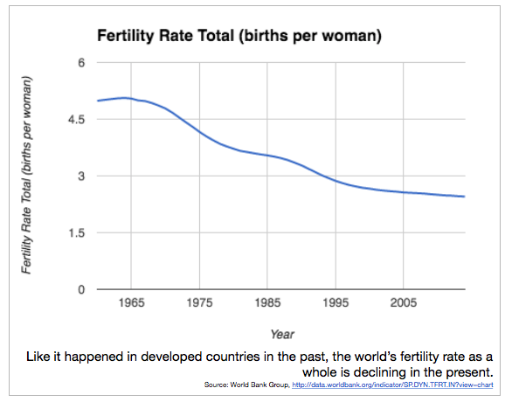

Explain what will most likely happen to the world’s population in the future and the impact on the environment.

Based on the video, why did China create the one-child policy?

Based on the video, why is China changing the policy?

B. Green Revolution
In the 1940s, scientists began to improve seeds, pesticides mechanical equipment and farming methods to improve food production. Today, the world is overpopulated and there is not enough food for everyone. Genetically Modified Organisms (hybrids, or DNA from different plants are combined) are created to make food grow faster and better.

Cons | Pros
- Contributes to food scarcity as staple food crops are being replaced by cash crops to be exported.  - By constantly replanting crops without restoring soil health means that more fertilizer is required to keep the nutrient in the soil and replenish it.  - Cost of industrial farming equipment is expensive for small farmers.  - Has a negative effect on crop production because of soil degradation and the loss in production of fruits, vegetables and pulses. | - Led to the development of intensive agriculture production  - The increase in technology created more job opportunities in the field of agriculture.  - Enabled farmers to obtain increasing produce(profit) from agriculture because of greater utilization of agricultural inputs.  - increased higher adoption of agricultural innovations by the farmers.  - Decreases the amount of human labor.

Has the Green Revolution helped or hurt society more?

C. Technology
Since the establishment of the first civilizations, innovations in communications technology have made it easier and faster for people to communicate over long distances.

Based on the video, what effects can mobile phones have on farmers in Africa?

How might advancement in communication have increased globalization?

D. Climate Change and the Paris Climate Accord
Previously called global warming, climate change refers to the increase of temperature due to human activity such as the burning of fossil fuels. This started in the 1800s due to the Industrial Revolution and the extreme amount of pollution produce by factories. Chemical pesticides and fertilizers produce larger food crops but harm soil and water. Gases from power plants and factories produce acid rain, a form of pollution in which toxic chemicals in the air fall back to Earth as rain or snow. Nations worldwide are starting to cut down the usage of gas emissions and are trying to stop deforestation (cutting down of trees – due for need for more wood or need for farmland or resources especially in Africa, Latin America and Asia) as well as desertification (process by which fertile or semi desert land becomes desert -due to overgrazing and farming is a major problem especially in the Sahel region of Africa.) Nations are also focusing on renewable energy sources such as solar and wind power. The past four years – 2015, 2016, 2017 and 2018 – are the four warmest years since records began in 1850.
“President Trump announced on Thursday that the United States would withdraw from the Paris climate accord… Mr. Trump’s decision to abandon the agreement for environmental action signed by 195 nations is a remarkable rebuke to heads of state, climate activists, corporate executives … The Paris agreement was intended to bind the world community into battling rising temperatures, and the departure of the Earth’s second-largest polluter is a major blow.”
- New York Times (June 2017)

What is the Paris Climate Accord?

How has population growth led to Climate Change?

