**Document #1 - Agricultural/Agrarian Revolution**

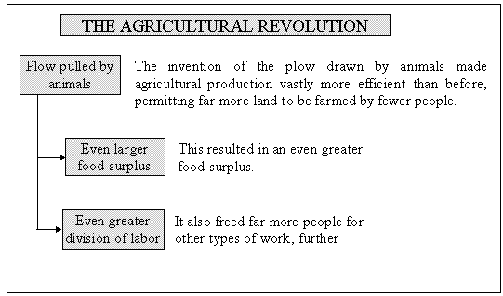The Agricultural/Agrarian Revolution describes a period in England between, which saw an increase in agricultural productivity. Wealthy English landowners would buy many small farms and combine them to make one large farm called an enclosure. A large farm could grow much more food than a bunch of poorly run small farms. On enclosures, landowners experimented with more productive seeding and harvesting methods to boost crop yields (amount).

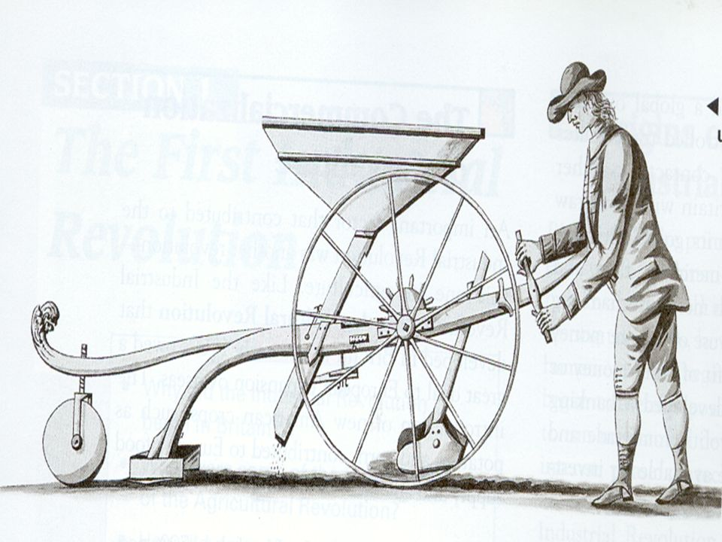

Jethro Tull was one of the first of these scientific farmers. His invention, called the seed drill, allowed farmers to plant seeds in well-spaced rows at specific depths. A larger share of the seeds took root, increasing crop sales. This was more efficient (working in a well-organized and competent way.)

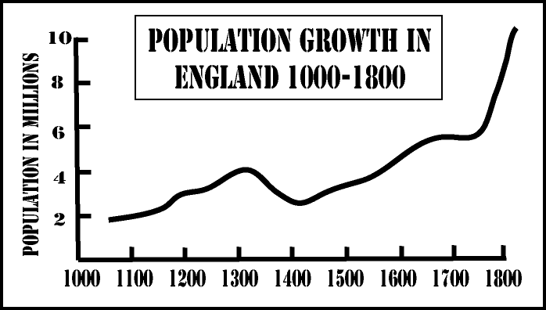This indirectly led to the Great Hunger or the Irish potato famine. The potato became a cash crop that could be sold and eaten. It fed Europe’s rapidly growing populations that developed during the Industrial Revolution. About two-fifths of the population was solely reliant on this cheap crop and when a disease (potato blight) killed most of the crop, approximately one million people died, and millions immigrated causing the population to fall by between 20% and 25%. The British did not try to help the Irish during the famine.

Ultimately, the Agrarian Revolution led to a population increase which meant more people and more food so more people could relax and thing up new ideas.

**Document # 2 – New Technology**

|  |  |  |
| --- | --- | --- |
| **Invention** | **Inventor and Nationality** | **Importance** |
| 1. Flying Shuttle  (1733) | John Kay  *\*English* | Operated by hand, it increased speed of weaving greatly. |
| 2. Spinning jenny (1765) | James Hargreaves \**English* | Spun 8 to 10 threads at one time; could be used at home. |
| 3. Water frame  (1769) | Richard Arkwright \**English* | A spinning machine driven by water, too large for home use; led to building of factories. |
| 4. Spinning mule (1779) | Samuel Crompton \**English* | Combined the jenny and the water frame; could spin fine, strong thread. |
| 5. Power loom  (1785) | Edward Cartwright  \**English* | Wove thread into cloth automatically and quickly; operated by water power. |
| 6. Cotton gin  (1789) | Eli Whitney  *\*American* | Automatically separated seed from raw cotton; increased quantity of cotton available to manufacturers. |

**Document # 3 – The Steam Engine**

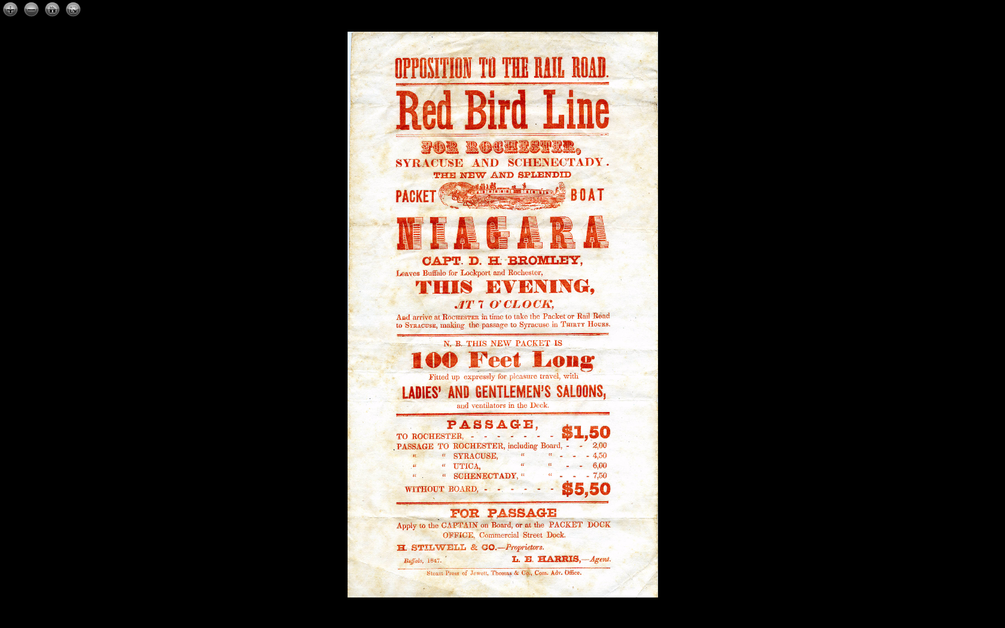

One of the most important inventions of the industrial revolution was a new source of power – the steam engine. Water turns to steam in a boiler. This engine was more dependable and reliable than wind-driven devices, which was at the mercy of changing weather conditions. Steam engines could also be placed wherever they were needed, and not just where wind was readily available.

*"Then I say, such an engine may be made powerful enough to do the work required in employing eight, ten, fifteen, or twenty horses."*

* **Anonymous quote about the Steam Engine**

**Document # 4 – Transportation**

Transportation is the method that is used to move people or goods. At the time of the Industrial Revolution, there were two main methods of transportation: *water and railroads*.

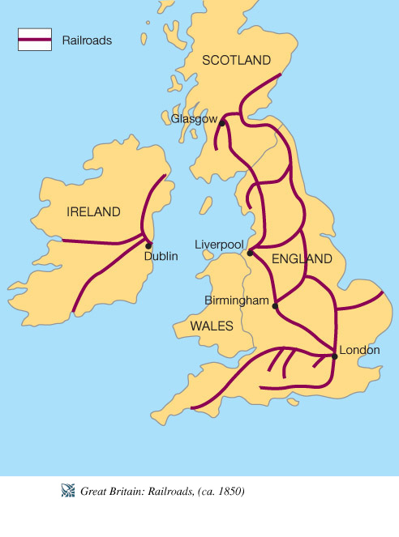

Rivers and Canals played an important role in powering many of the factories and mills. Also, canals were used by ships to move resources and goods that were produced from place to place.

Railroads were another very convenient way of moving goods and resources long distances across land. They moved very quickly and were able to carry huge amounts of goods and materials over a far distance. Building railroads created new jobs for farm laborers and peasants. Less expensive transportation led to lower-priced goods, which meant that more people could buy them. More sales meant more factories and more machinery. Business owners could buy new equipment with all of this new money, adding to the growth of the economy. This type of regular, ongoing economic growth became the foundation for the new industrial economy.

**Document # 5 – Capital (Building of Factories)**



England had plenty of *capital*, or **money**, to invest in the new industrial machines and the factories needed to hold these new machines. Many British people were very wealthy. Some, called entrepreneurs (business people), were interested in finding new business opportunities and new ways to make profits. These very rich entrepreneurs purchased many of these machines and opened factories.

When answering your handout questions, think both about how the wealthy and the poor would be affected by this.

**Document # 6 – Colonial Empire Markets**

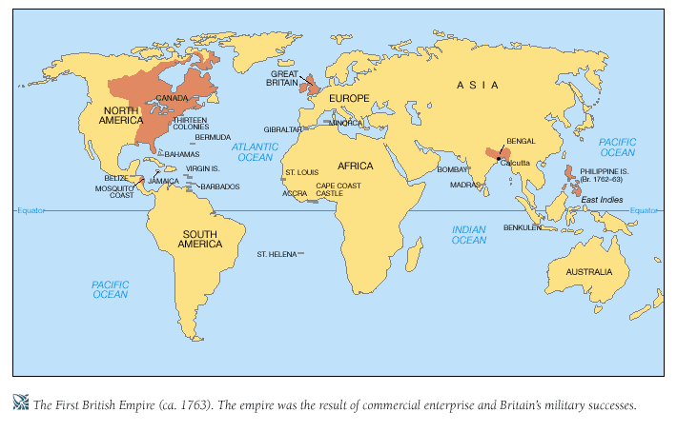Britain had a huge colonial empire, which meant Britain had many colonies to buy manufactured goods from them. Because of this, British ships could transport goods anywhere in the world. A supply of markets gave British manufacturers many places around the world to sell their goods. This colonial empire helped to make Britain the most powerful country in the world.

**Document 7 – Art**

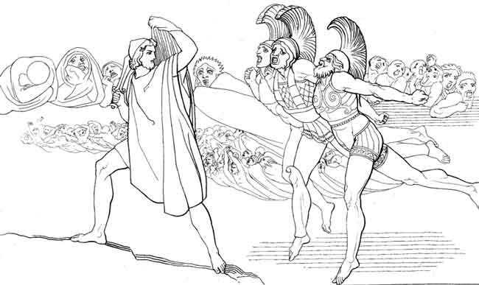

Neo-classicism (1750 to 1820)

The imitation or use primarily of the style and aesthetic principles of ancient Greek and Roman classical art. To the right is a picture of Odysseus in Hades by John Flaxman.

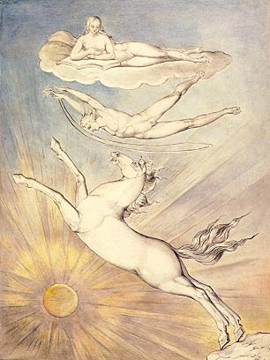

Romanticism (1800 to 1850)

Generally characterized by a highly imaginative and subjective approach, emotional intensity, and a dreamlike or visionary quality. To the left is a picture entitled Pegasus by William Blake.