Name:
Aim: | Date:
Key Words:

1.

2.
Enduring Issues Essay 1: Handout 1
A. The Task
Essay Directions: Write a well-organized enduring issues essay that includes an introduction, several body paragraphs addressing the task below, and a conclusion. An enduring issue is an issue that exists across time. It is one that many societies have attempted to address with varying degrees of success.
In your essay:
- Identify and define an enduring issue raised by this set of documents.
- Using your knowledge of Social Studies and evidence from the documents, argue why the issue you selected is significant and how it has endured across time.
Be sure to
- Identify the issue based on a historically accurate interpretation of three documents.
- Define the issue using evidence from at least three documents
- Argue that this is a significant issue that has endured by showing:
  - How the issue has affected people or been affected by people
  - How the issue has continued to be an issue or changed over time
- Include outside information from your knowledge of social studies and evidence from the documents.

How many body paragraphs do you have to write? | How many paragraphs will you write total?

B. Documents
Directions: Actively read each document and then answer the questions.

Document 1
Excerpt from Second Treatise on Government, written during the Enlightenment
“In the state of nature, all men are equal to one another because they were created as such by God. They are to seek the preservation of mankind and refrain from interfering with other men’s life, liberty, and possessions. Reason is what guides men in this state of nature, for if they comprehend that preserving other men will lead to their own preservation, then the state of nature is ideal. If any violation of this natural law occurs by the government, all men are able to punish the offender because that man is disrupting this state of perfect freedom and is thus violating the rights of all men.”
- John Locke, Second Treatise on Government (1689)

What enduring issues do you see in this document? (Circle all that apply)
Power Conflict Globalization Environment Scarcity Migration

Nationalism Response to Change Cultural Diffusion Technology Human Rights Violations
Summarize the document in your own words (no quotes).

What is the historical context of this document?

Document 2
Social Class Hierarchy in Feudal Japan

Citation: Melissa Schultzel Jamieson, “Social Class Hierarchy: Feudal Japan,” Passport to Social Studies (New York: New
York City Department of Education, 2018).

What enduring issues do you see in this document? (Circle all that apply)
Power Conflict Globalization Environment Scarcity Human Rights

Nationalism Response to Change Cultural Diffusion Technology Migration

Summarize the document in your own words (no quotes).

What is the historical context of this document?

Document 3
The Declaration of the Rights of Man was written during the French Revolution (1789).
Declaration of the Rights of Man
Articles:
1. Men are born free and remain free and equal in rights. Social distinctions can be based only on public utility.
2. The aim of every political association is the preservation of the natural and imprescriptible rights of man. These rights are liberty, property, security, and resistance to oppression.
4. Liberty consists in the power to do anything that does not injure others; accordingly, the exercise of the rights of each man has no limits except those that secure the enjoyment of these same rights to the other members of society. These limits can be determined only by law.
6. Law is the expression of the general will. All citizens have the right to take part personally, or by their representatives, and its formation. It must be the same for all, whether it protects or punishes. All citizens, being equal in its eyes, are equally eligible to all public dignities, places, and employments, according to their capacities, and without other distinction than that of their virtues and talents.
7. No man can be accused, arrested, or detained, except in the cases determined by the law and according to the forms it has prescribed. Those who procure, expedite, execute, or cause arbitrary orders to be executed, ought to be punished: but every citizen summoned were seized in virtue of the law ought to render instant obedience; he makes himself guilty by resistance.
11. The free communication of ideas and opinions is one of the most precious of the rights of man; every citizen can then freely speak, write, and print, subject to responsibility for the abuse of this freedom in the cases is determined by law.
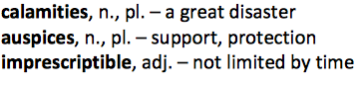
16. Any society in which the guarantee of the rights is not secured, or the separation of powers not determined, has no constitution at all.

- Source: HistoryGuide.org
What enduring issues do you see in this document? (Circle all that apply)
Power Conflict Globalization Environment Scarcity Migration

Nationalism Response to Change Cultural Diffusion Technology Human Rights Violations

Summarize the document in your own words (no quotes).

What is the historical context of this document?

Document 4
The Napoleonic Code was written and implemented while Napoleon was Emperor of France.
The Code of Napoleon (1804) Civil Rights
Article 7. The exercise of civil rights is independent of the quality of citizen, which is only acquired and preserved conformably to the constitutional law.
Article 8. Every Frenchman shall enjoy civil rights
Property [abolishing feudalism]
Article 544. Property is the right of enjoying and disposing of things in the most absolute manner, provided they are not used in a way prohibited by the laws or statutes.
Article 545. No one can be compelled to give up his property, except for the public good, and for a just and previous indemnity.
Article 546. Property in a thing, whether real or personal, confers a right over all which it produces, and over all connected with it by accession, whether naturally or artificially.
- Source: The Napoleon Series

What enduring issues do you see in this document? (Circle all that apply)
Power Conflict Globalization Environment Scarcity Migration

Nationalism Response to Change Cultural Diffusion Technology Human Rights Violations

Summarize the document in your own words (no quotes).

What is the historical context of this document?

Document 5
Map of Latin American during the revolutions
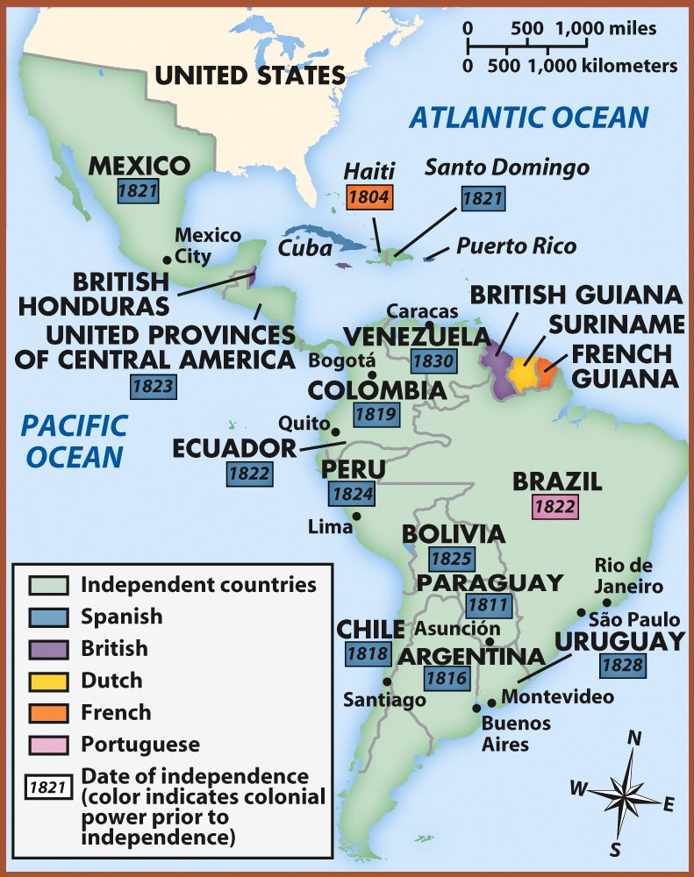
What enduring issues do you see in this document? (Circle all that apply)
Power Conflict
Globalization Environment
Scarcity Migration
Nationalism Response to Change
Cultural Diffusion Technology
Human Rights Violations
Summarize the document in your own words (no quotes).

What is the historical context of this document?

C. Decision Time
What Enduring Issue will you write about? (Circle 1)

Power Conflict Globalization Environment Scarcity Migration
Nationalism Response to Change Cultural Diffusion Technology Human Rights Violation

What documents will you choose?

