Name:
Aim: | Date:
Key Words:

1.

2.
Enduring Issues Essay 1
A. The Task
Essay Directions: Write a well-organized enduring issues essay that includes an introduction, several body paragraphs addressing the task below, and a conclusion. An enduring issue is an issue that exists across time. It is one that many societies have attempted to address with varying degrees of success.
In your essay:
- Identify and define an enduring issue raised by this set of documents.
- Using your knowledge of Social Studies and evidence from the documents, argue why the issue you selected is significant and how it has endured across time.
Be sure to
- Identify the issue based on a historically accurate interpretation of three documents.
- Define the issue using evidence from at least three documents
- Argue that this is a significant issue that has endured by showing:
  - How the issue has affected people or been affected by people
  - How the issue has continued to be an issue or changed over time
- Include outside information from your knowledge of social studies and evidence from the documents.

How many body paragraphs do you have to write? | How many paragraphs will you write total?

B. Documents
Directions: Actively read each document and then answer the questions.

Document 1
Map of the Napoleon Empire in 1810
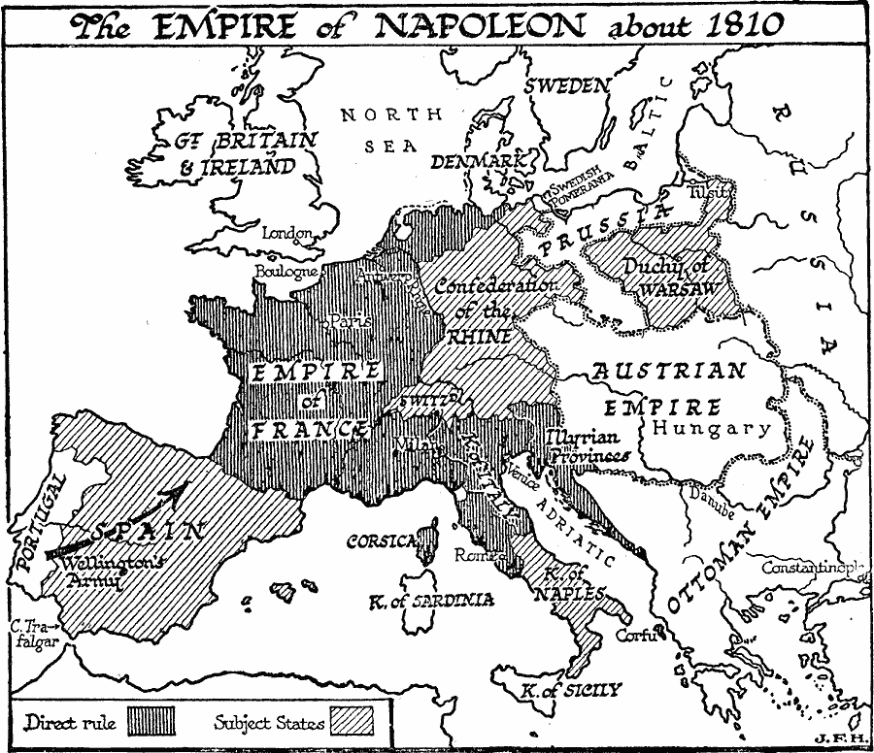
- Source: University of South Florida

What enduring issues do you see in this document? (Circle all that apply)
Power Conflict Globalization Environment Scarcity Human Rights

Nationalism Response to Change Cultural Diffusion Technology Migration
Summarize the document in your own words (no quotes).

What is the historical context of this document?

Document 2

In 1919, the nations involved in WWI met in Versailles to create a peace treaty, entitled the Treaty of Versailles
Article 42: Germany is forbidden to maintain or construct any fortifications either on the left or right bank of the Rhineland.
Article 119: Germany renounces in favor of the principle Allied Powers (France and Britain) all of her rights and titles over her overseas possessions.
Article 160: By March 31, 1920, the German army must not comprise more than seven divisions of infantry and three divisions of cavalry (100,000 men)
Article 181: The German naval forces in commission must not exceed six battleships, six light cruisers, 12 destroyers, 12 torpedo boats, or an equal number of ships constructed to replace them. No submarines are to be included. All other warships, except where there is provision to the contrary in the present Treaty, must be placed in reserve or devoted to commercial purposes.
Article 198: The armed forces of Germany must not include any military or naval air forces.
Article 231: The Allied Powers affirm, and Germany accepts responsibility of German and her all for causing all the loss and damage to which the Allies have been subjected to as a consequence of the war imposed upon them by the aggression of Germany and her allies.
Article 231-247: Due to her responsibility for the war, Germany will pay 132 billion gold marks or 33 billion dollars for damages and lives lost.
- Source: The Treaty of Versailles (1919)
What enduring issues do you see in this document? (Circle all that apply)
Power Conflict Globalization Environment Scarcity Human Rights

Nationalism Response to Change Cultural Diffusion Technology Migration

Summarize the document in your own words (no quotes).

What is the historical context of this document?

Document 3

Political Cartoon of Vladimir Lenin from approximately 1918
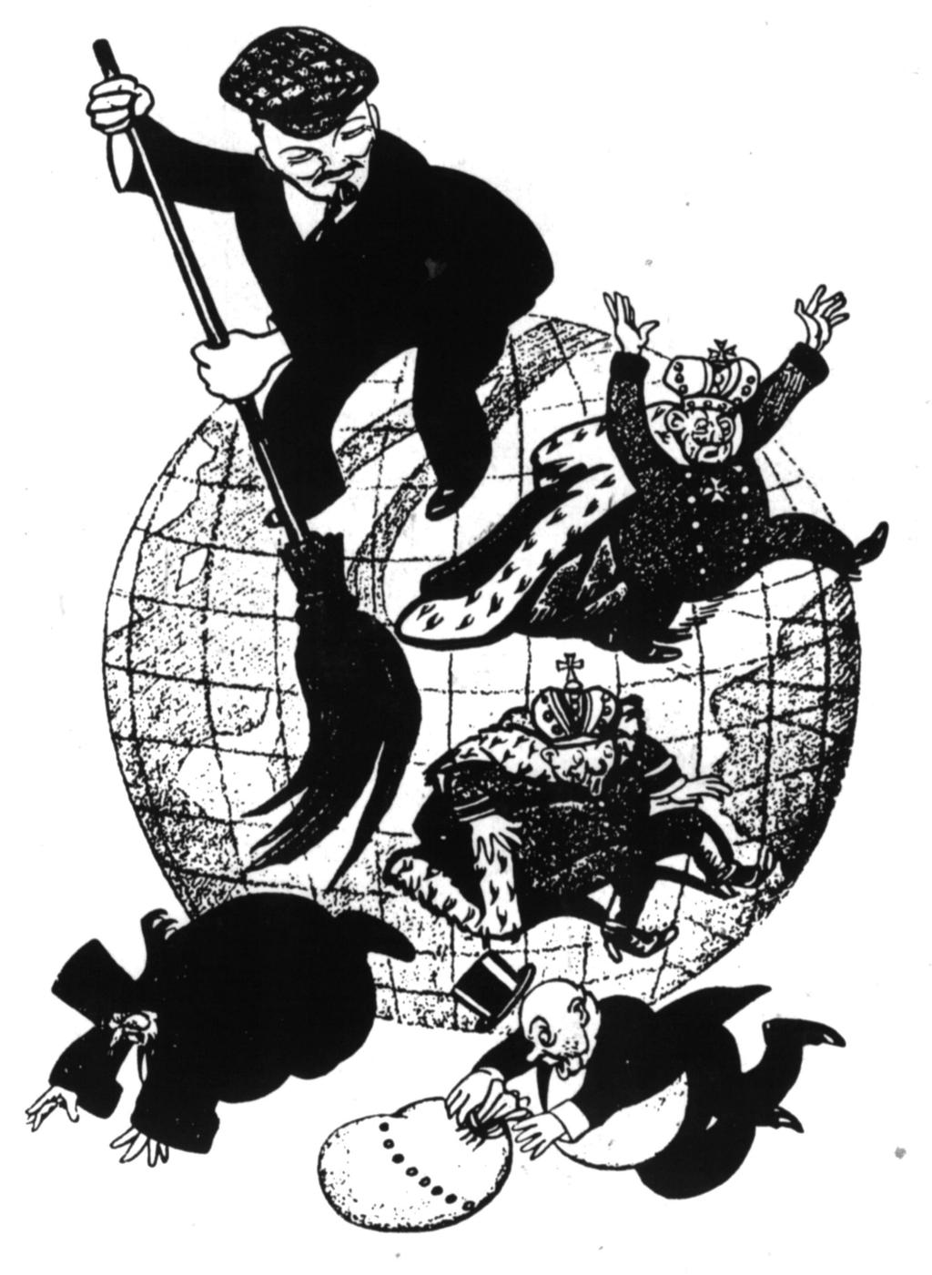
- Source: New Politics

What enduring issues do you see in this document? (Circle all that apply)
Power Conflict Globalization Environment Scarcity Human Rights

Nationalism Response to Change Cultural Diffusion Technology Migration

Summarize the document in your own words (no quotes).

What is the historical context of this document?

Document 4
Collection of speeches given by Benito Mussolini, leader of Italy, 1935
The glory of the state is an absolute necessity. All individuals or groups are only seen in terms of their relationship and importance to the states. Fascists do not believe in the idea of lasting peace … we think of life as duty, struggle, and conquest… Fascism does not agree with ideas of communism. It supports the unchangeable and beneficial inequality of all men. Fascism fights against communism because it is against the nation… Fascism denies that the majority, by the simple fact that it is the majority will make decisions that are best for the nation. Human society should be directed toward the lory of the state, not the individual.
- Source: Fordham University

What enduring issues do you see in this document? (Circle all that apply)
Power Conflict Globalization Environment Scarcity Human Rights

Nationalism Response to Change Cultural Diffusion Technology Migration

Summarize the document in your own words (no quotes).

What is the historical context of this document?

Document 5
The Prime Minister of England, Neville Chamberlain, “In Defense of Appeasement”, 1939
How horrible it would be digging trenches and trying on gas masks here because of a quarrel in a far away country between people of whom we know nothing. IT seems even more impossible that such a quarrel should be the subject of war. We had no treaty obligations and no legal obligations to Czechoslovakia and if we do aid them in war, we would have no support from British citizens. Therefore, I think the government deserves approval for their conduct of the affairs in which we saved Czechoslovakia and the rest of Europe from Armageddon. Does the experience of the Great War and of the years that followed give us reasonable hope that if some new war started that war would end any better that the last one did?
- Source: History Guide

What enduring issues do you see in this document? (Circle all that apply)
Power Conflict Globalization Environment Scarcity Human Rights

Nationalism Response to Change Cultural Diffusion Technology Migration

Summarize the document in your own words (no quotes).

What is the historical context of this document?

