**Document 1: The Intermediate-Range Nuclear Forces (INF) Treaty**

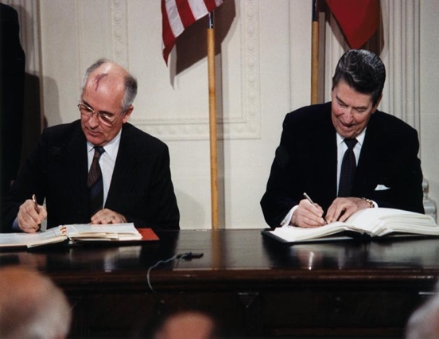

In the late 1970s, the Soviet Union was spending a lot of money on developing their nuclear missile and nuclear bomb programs. Because most of their money was spent on national defense, the people of the Soviet Union suffered. People were starving and the Soviet government did not seem to be showing any interest in helping its people.

However, in the mid-1980s a major treaty was signed between the Soviets and the U.S. The 1987 Intermediate-Range Nuclear Forces (INF) Treaty required the United States and the Soviet Union to get rid of most of their nuclear weapons. The treaty marked the first time the superpowers had agreed to reduce their nuclear weapons. As a result of the INF Treaty, the United States and the Soviet Union destroyed a total of 2,692 nuclear missiles, and neither country built anymore of these kinds of nuclear weapons again.

**Document 2 - Mikhail Gorbachev and his Policies (Glasnost and Perestroika)**

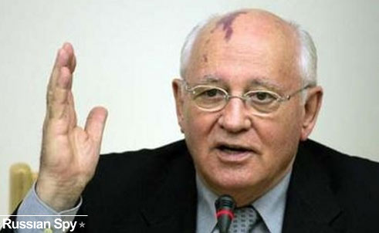

Mikhail Gorbachev was a Russian politician who was the last head of state of the Soviet Union serving from 1988 until its collapse in 1991. He established close relationships with several Western leaders, such as West German Chancellor Helmut Kohl, U.S. President Ronald Reagan, and British Prime Minister Margaret Thatcher.

Perestroika:

"I am starting a new economic policy called 'perestroika.' Our economy is having many problems. Our factories are not producing goods, workers do not want to work, and management cannot keep business together. Under 'perestroika' business will change. Workers will be given more money to work harder…and farmers can sell extra crops and keep their profits."

-Mikhail Gorbachev (1987)

Glasnost:

“Glasnost means ‘openness.’ To give glasnost is to allow people to speak openly and freely. Gorbachev’s policy of glasnost let people speak out for the first time and has had a great effect. Books that have never been allowed by the government before will be published. On television, we saw a reporter give a good review of McDonald’s restaurants, which the Soviet Union had never seen before until recently.”

- *New York Times* (November 1986)

**Document 3 - Eastern Europe**

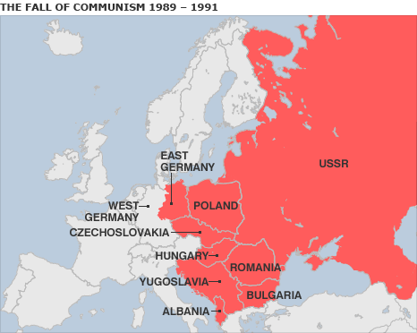

Other Communist Nations in Eastern Europe (not part of the Soviet Union)

After World War II, Eastern Europe fell under Soviet control.

Gorbachev was a leader who allowed his people freedom for the first time in the history of the Soviet Union. With Gorbachev in power, the other Communist countries in Europe wanted more freedom too and got rid of their totalitarian rulers.

Hungarian Revolt (1956)

The revolt began as a student demonstration, which attracted thousands as they marched through capital and were fired upon by the police. One student died and this was the start of the revolution. As the news spread, disorder and violence spread throughout the country. Over 2,500 Hungarians and 700 Soviet troops were killed in the conflict, and 200,000 Hungarians fled as refugees. Mass arrests and denunciations continued for months thereafter. By January 1957, the new Soviet-installed government had suppressed all opposition.

Solidarity

Solidarity was a non-violent, anti-communist social movement that led by activist Lech Walesa in Poland in 1980. The people wanted to improve working conditions and to push for political freedom. The Poles (who are very religious Catholics) also protested the religious policies of Communism (which outlawed religion). Even though the protests led to thousands of activists being jailed or killed, the Solidarity movement eventually won. Lech Walesa became the first president of free Poland in 1990.

Ethnic Wars

By the end of 1989 other Communist nations such as Czechoslovakia, East Germany, Romania, and eventually Bulgaria changed to a democratic government. Several of these countries broke out into civil wars because of the diverse groups of people (Orthodox Christians, Roman Catholics, Muslims, etc.) In April 1992, Bosnia-Herzegovina declared its independence from Yugoslavia. Over the next several years, led by Slobodan Milošević, Bosnian Serb forces targeted Bosnian Muslims and Croatian civilians resulting in the deaths of some 100,000 people by 1995. It was the worst act of genocide since the Nazi regime’s destruction of some 6 million European Jews during World War II. U.N. judges sentenced former Bosnian Serb military chief to life in jail after finding him guilty of genocide during the 1990s fighting.

**Document 4 - Germany**

Willy Brandt and Ostpolitik:

In 1969, West German chancellor Willy Brandt tried to ease tensions between communist and capitalists. He called his policy of easing tensions Ostpolitik. Brandt kept close ties to the West, but signed treaties with the Soviet Union and Poland. He established economic ties to Eastern Europe and signed a treaty of mutual recognition with East Germany.

The Fall of the Berlin Wall (November 9, 2009):

“November 9, 1989, will be remembered as one of the great moments of German history. On that day, the dreadful Berlin Wall…cutting through the heart of the old capital city, was opened … In joyful disbelief, Germans from both sides climbed up on the Wall… They embraced each other and sang and danced in the streets. Some began chiseling away chips of the Wall as if to have a personal hand in tearing it down… East Germans immediately began pouring into West Germany. Within a few days, over 1 million persons per day had .. the chance to see their western neighbor firsthand.”

- Area Handbook of the US Library of Congress

On March 18, 1990 East Germany held its first free elections. The Soviet Union, under Mikhail Gorbachev allowed these elections. Once these elections were official, both East and West Germany began work on a Unification Treaty. German Reunification took place on October 3, 1990, when the areas of the former German Democratic Republic were incorporated into the Federal Republic of Germany

**Document 5 - Collapse of Soviet Union**

Gorbachev did not mean to end Communism. He wanted to reform it (make it better). However, people liked the idea of freedom so much, that they wanted freedom from the Soviet Union and wanted to rule themselves.

As a result, territory after territory began to declare independence from the Soviet Union. As of December of 1991, the Soviet Union was no more and Boris Yeltsin became the first elected leader.

Eastern Europe after the Soviet breakup. These republics used to be part of the Soviet Union but are now free countries. **⇩**

