Name:

Cuba – Constructed-Response Questions

Directions: For constructed-response questions, you will need to answer a total of four questions. Answer each question in at least 3 sentences using both document information and prior knowledge.

Document #1
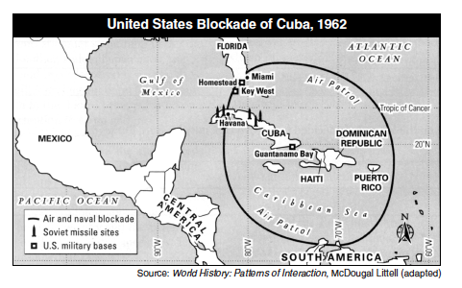
QUESTION 1 – You must answer this question!

Geographic Context—where this historical development is taking place, and why it is taking place there.

1. Using document 1, explain how the geographic context affected the placement of Soviet Union missiles in Cuba.

Document #2
President Kennedy was President of the United States during the Cuban Missile Crisis.
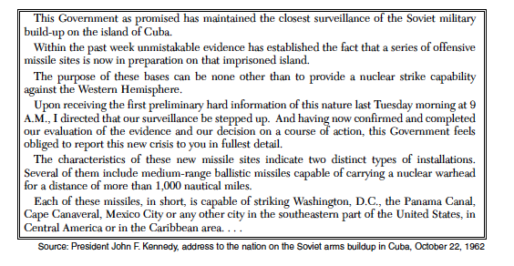

QUESTION 2 – You must answer this question!

2. Using document 2, identify the purpose of creating this document.

Document 1 Document 2

QUESTION 3 – You must answer both questions!
A turning point is a significant event, idea, or historical event that brings about change. It can be local, regional, national or global.

3a. Identify a turning point associated with the historical development and events related to both documents 1 and 2. (Only one sentence needed here)

3b. Explain why the historical developments and events associated with these documents are considered a turning point. Be sure to use evidence from both documents 1 and 2 in your response.

Unsatisfactory (0) | Needs Improvement (5) | Satisfactory (10)
Either no attempt was made to answer the question, or an attempt was made that did not address the question properly. | A valid attempt to answer the question was made. However, there may be factual inaccuracies, vagueness, or missing relevant analysis. | The question was answered in a satisfactory manner. The appropriate evidence, analysis, and outside information was used.

Q1: Q2: Q3: Q4:

