NAME: ___________________________________________ BAND: ________

Level 2: Enduring Issue TEAL Documents
Directions: Analyze the documents and answer the short-answer questions that follow each document in the space provided.
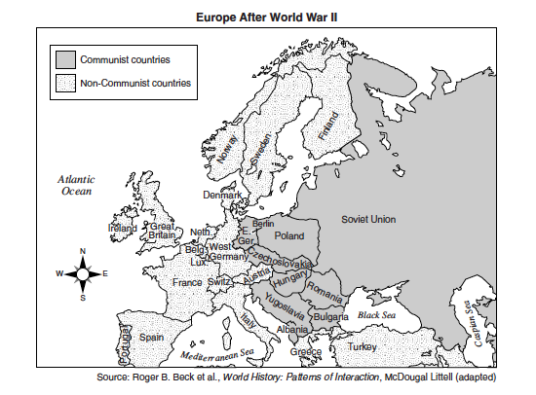
Document 1

What enduring issues do you see in this document? (Circle all that apply)
Power Conflict
Globalization Environment
Scarcity Migration
Nationalism Technology
Response to Change
Cultural Diffusion
Human Rights Violations

Summarize the document in your own words (no quotes).

What is the historical context of this document?

Document 2 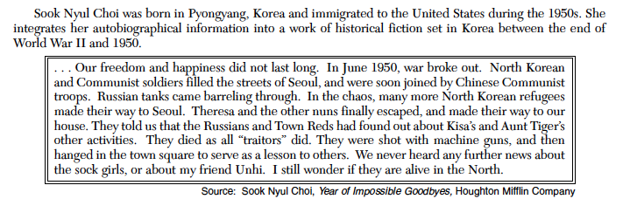

What enduring issues do you see in this document? (Circle all that apply)
Power Conflict Globalization Environment Scarcity Human Rights

Nationalism Response to Change Cultural Diffusion Technology Migration

Summarize the document in your own words (no quotes).

What is the historical context of this document?

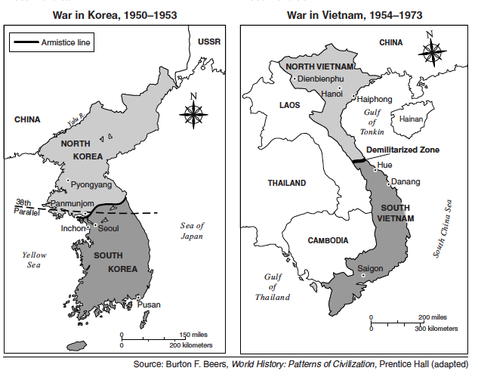
Document 3

What enduring issues do you see in this document? (Circle all that apply)
Power Conflict
Globalization Environment
Scarcity Migration
Nationalism Technology
Response to Change
Cultural Diffusion
Human Rights Violations

Summarize the document in your own words (no quotes).

What is the historical context of this document?

Document 4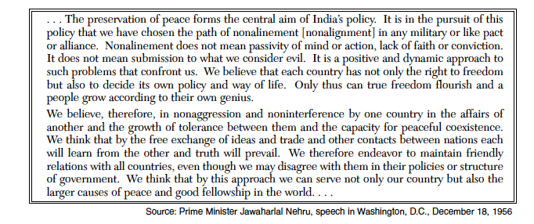

What enduring issues do you see in this document? (Circle all that apply)
Power Conflict Globalization Environment Scarcity Migration

Nationalism Response to Change Cultural Diffusion Technology Human Rights Violations

Summarize the document in your own words (no quotes).

What is the historical context of this document?

Which Enduring Issue will you write about? (Circle 1)

Power Conflict Globalization Environment Scarcity Migration

Nationalism Response to Change Cultural Diffusion Technology Human Rights Violations

What documents will you write about? (Two)

