**China 3 – Deng Xiaoping**

|  |  |
| --- | --- |
| **Aim:** | **Date:** |
| **Key Words:**  **1.**  **2.** |  |

**A. Four Modernizations – Economic Changes**

Mao Zedong died in 1976, and afterwards, a moderate Communist named Deng Xiaoping took control of the Communist Party in China. Though he was also one of the original Communist Party members like Mao, Deng took a very different approach to governing China. The result of Deng’s influence over Chinese policy resulted in the economic strong China we see today.

**Four Modernizations**

* He eliminated Mao’s communes and created a system where farmers would deliver a certain amount of food to the government and be able to sell the rest for profit, so people were not starving.
* He gave more freedom to the mangers of state owned businesses.
* He even allowed for the creation of private businesses.
* He encouraged foreign (other countries) investment and technology

*How are Deng’s economic policies different from Mao’s?*

*Which above change do you believe will have the biggest effect upon China? Why?*

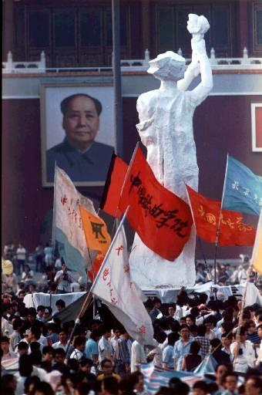**B. The Tiananmen Square**

Deng’s economic changes had an unexpected effect. Many Chinese people’s incomes increased, allowing them access to foreign/Western goods such as televisions, appliances, music, and clothing. Many Chinese even began to travel abroad to study. While living abroad, Chinese students learned about democracy and began to question China’s lack of freedom and rights. In 1989, 100,000 students gathered in a large public space known as Tiananmen Square, in the city of Beijing. They planned a “hunger strike” until their demands were met. The students built a 33 foot statue called the “Goddess of Democracy” which was a cross between a Chinese god of mercy and the American Statue of Liberty.

“Democracy is supposed to be the highest of human aspirations (goals) and freedom, a sacred human right, granted at birth… We request 1. An immediate dialogue (discussion) between the government and the students on important topics with equal status. 2. An acknowledgment (acceptance) by the government of the legitimacy (right) of the student democratic movement.”

*Why do you think democracy is so important to these students?*

*How do you think the government is going to respond to their demands?*

**C. Deng Responds**

Deng declared *martial law* (temporary government control by military authorities). Deng ordered more than 250,000 troops to surround the square. Tanks destroyed the Goddess of Democracy. Soldiers shot into the crowds of students. Soldiers also attacked protesters in other areas of the city. The assault killed hundreds and wounded thousands. The police arrested approximately 10,000.

*How did Deng respond to the protest?*

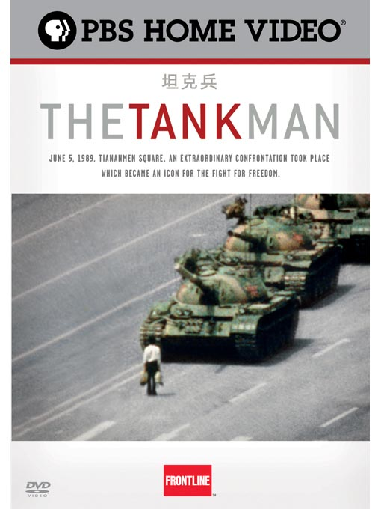**D. Tank Man**

After the Tiananmen Protests were crushed on June 4th, 1989, a young man walked out onto the street to try and stop a convoy of 59 army tanks. By this time, the Chinese Army was in total control of Beijing. People watched in horror believing that this unknown man would soon be crushed by the tanks.

*What would motivate this man to do this?*

*In your opinion, is Tank Man a hero or a fool?*

**E. Result of the Protest**

There was no meaningful democratic change in China and witnesses say that anywhere between 500-1,000 student protestors were killed because of the massacre at Tiananmen Square. To this day, the Chinese government maintains that no-one died in Tiananmen Square. The Chinese government has blocked all searches of anything Tiananmen Square-related on Google in China.

*Based on the video, from the POV of a Chinese person, how do the regulations impact your life?*