China 1 - Civil War
Aim: | Date:
Key Words:

1.

2.

A. Sun Yat-Sen
Sun Yat-Sen was a Christian, western-educated medical doctor. He lived and traveled in the United States and dreamed of establishing a modern democratic form of government in China. Sun Yat-Sen created the Kuomintang or Nationalist Party, and in 1911 succeeded in overthrowing the last emperor of the Qing dynasty, which had ruled China since 1644. Sun Yat-Sen wanted to create a Chinese government based on what he called “The Three Principles of the People”.

“Three Principles of the People”
1. Nationalism – The government of china should be in the hands of the Chinese. After driving out the foreign rulers we must restore our national state
2. Democracy – Our revolution is based on equality. All people are equal and enjoy political rights. The people will choose the president. A constitution of the Chinese Republic will be written and every person must follow its laws.
3. People’s Livelihood – The good fortune of civilization is to be shared equally by all the people of that nation. After the revolution, all property shall belong to the state, to be shared by all people in order to create a socialist (not communist) state. Then each family within the empire can be well supported, each person satisfied and no one fail to gain a job.

How will China change under Sun Yat Sen’s rule?

What would have to change in order for this to happen?

B. Chiang Kai-Shek
After Sun Yat-Sen’s death in 1925, Chiang Kai-Shek took over the Kuomintang (Nationalist Party). Many rich businessmen and bankers supported Chiang Kai-Shek. He promised a democracy and political rights for all Chinese, but his government became less and less democratic. Over time his government became corrupt and many Chinese lost faith in the Nationalist Party.
My fellow peasants are dying. They were lying in the roads, in the mountains, by the railroad stations, in mud huts, in the fields. And as they died, the government continued to collect taxes. The government in each part of China was demanding more grain than any farmer could grow on his land. No excuses were allowed. Many peasants starved to death. We never did see the land and supplies that the Nationalists promised us. Chiang was supposed to create the democracy Sun Yat-Sen had wanted, but all the people in China had gotten was grief from the new government,
- Peasant Living Under Chiang Kai-Shek
Claim: Under the leadership of Chiang Kai-Shek and the Nationalist government, China faced numerous social, political and economic problems.
Social (Evidence: data that supports claim) | Political (Evidence: data that supports claim) | Economic (Evidence: data that supports claim)

C. Chinese Communist Party (The CCP) vs. Kuomintang (Nationalists)
Because of the problems under Chiang Kai-Shek’s rule, there was a Communist movement going on peasants in the Chinese countryside largely supported that led by Mao Zedong. These Communists wanted to create a society similar to the one in the Soviet Union. As a supporter of business and private ownership, Chiang Kai-Shek was naturally threatened by the desire of the Communists to divide China’s wealth among the people. The division of these two groups: the Nationalists led by Chiang Kai-Shek, and the Communists, led by Mao Zedong, and marked the start of China’s bloody civil war (1927).

Describe Mao’s leadership skills.

Why did the peasants support Mao Zedong (Claim and Evidence (data)

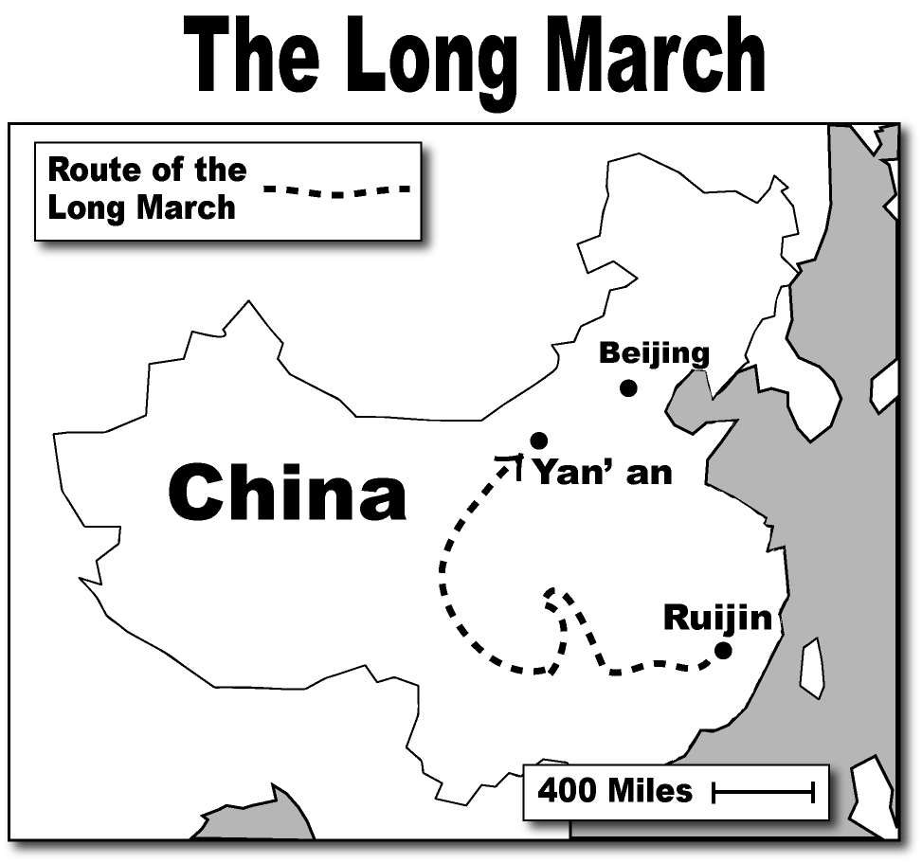
D. The Chinese Civil War
In response to the Communist uprising, Chiang Kai-Shek launched a variety of attacks against the Communists. Though he killed many Communist leaders he failed to wipe them out. Chiang had gathered an army of over 700,000 soldiers and surrounded the Communists in their mountain hideout. Knowing that they faced certain defeat, the 100,000 Communists fled. Incredibly, they would be chased by Chiang’s forces over 6,000 miles, in a journey by foot known as the Long March (1934-1935). Thousands would die from starvation, fighting, and sickness. By marching throughout the country, Mao gained lots of supporters and by 1949, Mao and the Communists had taken complete control of China. The remaining Nationalist forces of Chiang Kai-Shek had fled south to Taiwan. Taiwan is still independent from China today.

Based on the video and document, was the Long March a success? (claim and evidence)

