The End of the Ottoman Empire
Aim: | Date:
Key Words:

1.

2.
A. Armenian Genocide
Because of its location, in 1914, the Ottoman Empire entered World War I on the side of the Central Powers (Germany). As the Russians advanced into the Ottoman Empire during the war many Armenians joined or helped the Russian army (The Allies). Armenians were Christians and therefore a minority in the Ottoman Empire so they did not have the same rights. This cooperation was used as a reason by the Ottoman government to deport the entire Armenian population to Syria and Mesopotamia. During the deportation, between 600,000 and 1.5 million Armenians died. Many were killed by planned massacres, others starved as they were forced to walk without food. After the end of the war, the empire was called the Sick Man of Europe and nationalistic movements started to spread. The Ottoman Empire became a British protectorate.

Describe the Ottoman Empire towards the end of World War I.

How did the historical context of WWI lead to the Armenian Genocide?

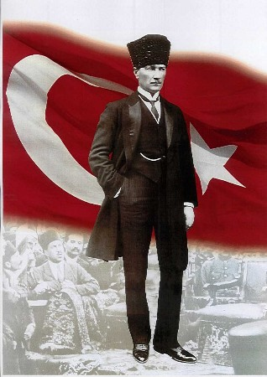
B. Mustafa Kemal Atatürk (1881-1938)
Mustafa Kemal Atatürk was the founder of the Republic of Turkey as well as the first Turkish President and absolute ruler (dictator). Atatürk was a military officer during World War I. Following the defeat of the Ottoman Empire in WWI, he led the Turkish national movement (Young Turk) in the Turkish War of Independence and in 1922 the Republic of Turkey was formed.

“There was only one decision to make in this situation and that was to establish a new Turkish State based on national sovereignty (control over your own country) without any restrictions and without any conditions! ... The Turkish nation should live in honor and dignity. Such a condition could only be attained by complete independence. To request the protectorate (another country protects you but also controls you) of a foreign power is to admit to a lack of all human qualities; it is to admit to weakness and incapacity. Indeed, it is unthinkable that any group of people should ever voluntarily accept the humiliation of being ruled by a foreign master.”

Explain the extent to which this quote is a reliable source on Atatürk’s plan for Turkey. (Reliable, somewhat reliable, or unreliable)

After WWI, should Turkey be a protectorate or a sovereign nation?

C. Religion
“In virtue of these laws the Grand National Assembly of Turkey and the Government formed by it is authorized to give legal form to the stipulations (conditions) which are in force in the Turkish Republic with reference to public affairs and to carry through their application … The Ministry for Religious affairs has been suppressed (abolished)… All scientific and educational institutions on Turkish territory are to be given utmost importance … The Caliph (Turkish Religious leader) is removed from his position and the dignity abolished. All members of the fallen Ottoman dynasty are forever forbidden to reside within the frontiers of the territory of the Turkish Republic…”
- Atatürk

Marriage and divorce became civil rather than religious and polygamy was abolished. Essentially Turkey went from a religious to secular society.

How did Turkey change from a religious to secular society? (Give 3 examples)

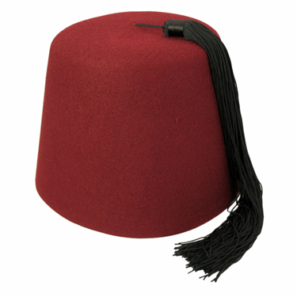
D. Dress
Atatürk embarked on a campaign against the traditional headgear, in particular women’s veils, the turban and the fez. Although the caliphate had been dissolved with hardly a murmur, the sartorial laws outlawing the turban and fez, and requiring the wearing of the hated European hat, were met with stiff resistance; dress for the Ottoman had always served as a vital indicator of rank.

“Gentlemen, it was necessary to abolish the fez, which sat on our heads as a sign of ignorance, of fanaticism, of hatred to process and civilization, and to adopt in its place the hat, the customary headdress of the whole civilized world thus showing, among other things, that no difference existed in the manner of thought between the Turkish nation and the whole family of civilized mankind.”

Why was it “necessary” to abolish the fez?

E. Laws
In 1926, The Gregorian calendar (Christian) replaced the Muslim lunar calendar for official use. Islamic law code was replaced with Western European versions. Jewish, Armenian and Greek were to be judged by the same legal system as Muslims. By 1930, women were given the vote. Turkey had used the Arabic alphabet, but in 1928, Turkey transitioned to the Roman alphabet.

What laws did Atatürk change?

