Imperialism - Africa

A. Africa Before the Europeans Took Over
There are hundreds of different tribes in Africa, and an African’s feels loyalty his tribe (tribalism) more than his country. Due to this, there were various cultures and governments with 100s of languages spoken. During the 300 years of the slave trade, the Europeans traveled all over the coasts of Africa, but very rarely through the large, middle parts of Africa. There were very dangerous waterways in Africa that the Europeans were unable to travel through. Therefore, there was minimal contact with Europeans and Europeans only knew of Africa’s coast. The invention of the steam engine (Industrial Revolution) made it possible for Europeans to move through Africa more easily. Africa had been very valuable because there were so many slaves there who could be captured by the Europeans, but since industrialization occurred, the need for workers decreased as the use of machines increased. Africa then became valuable for its natural resources. Furthermore, Europeans believed in the idea of White Man’s Burden and Social Darwinism.

Describe the relationship between the Europeans and Africa.

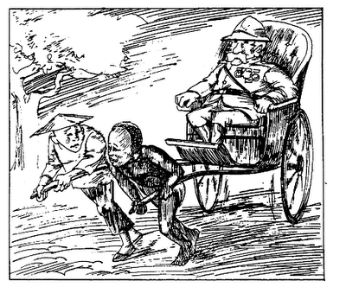
B. King Leopold II in The Congo
King Leopold II of Belgium became interested in the areas of the Congo. In 1879, Leopold hired Henry Stanley to help him get land there. In 1882, Leopold got agreements from local chiefs of the Congo that gave Belgium control of that land. Publicly, Leopold said that he wanted to “civilize the Africans, because they have been living in an uncivilized state for so long.”

Cartoon Title – “Learning to be civilized is hard work”

Compare and contrast King Leopold’s message on the left with the cartoon.

C. The Berlin Conference, 1884-1885
So many countries wanted a piece of Africa so badly that European countries feared war among themselves. To prevent fighting, 14 European nations met at the Berlin Conference in 1884-1885 to make rules for dividing up Africa. They agreed that any European country could control land in Africa by telling other countries of their control. (basically by “calling it”) The Europeans nations divided the rest of Africa with no concern to where African tribes or different language groups were living.

Why was the Berlin Conference necessary?
______________________________________________________________________________________________________________________________________________________________________________________________________________________________________________________________________________
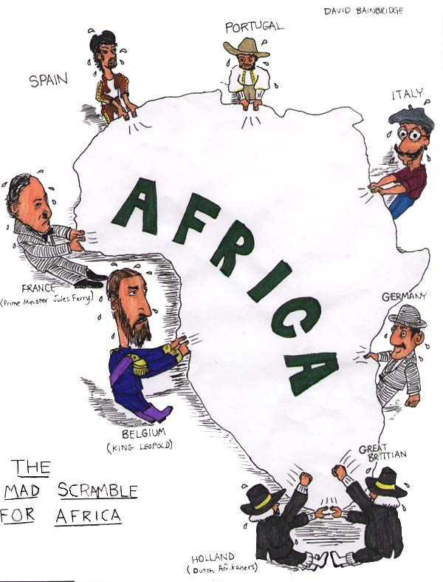
D. The Scramble For Africa
The Scramble for Africa (1880-1900) was a period of rapid colonization of the African continent by European powers. All of Africa was divided up among the countries of Europe.

Why was this period in time called “The Scramble for Africa”?

E. African Resistance

The Boer Wars were fought from 1899 to 1902 between an alliance of different tribe and Great Britain over power in what is now South Africa. The war ended with British victory. The British were able to win due to superior numbers and weaponry (such as bolt action rifles which allowed them to reload quickly.) Africans had weaponry dating back two generations. Only one country was able to resist imperialism in Africa – Ethiopia.

How would you describe African Resistance?
______________________________________________________________________________________________________________________________________________________________________________________________________________________________________________________________________________

F. Vocabulary
Tribalism
____________________________________________________________________________________________________________________________________________________________________________________

The Berlin Conference
____________________________________________________________________________________________________________________________________________________________________________________

Scramble for Africa
____________________________________________________________________________________________________________________________________________________________________________________

