Unit 3 Handout 8: Practice EOC B Writing

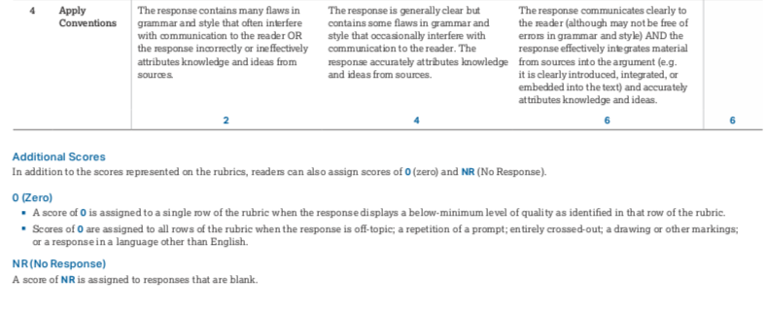
A. Rubric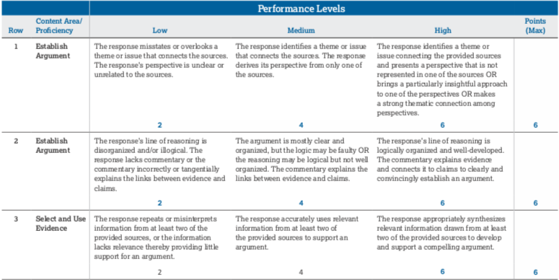

B. Writing
Directions:
Read the four sources carefully, focusing on a theme or issue that connects them and the different perspective each represents. Then, write a logically organized, well-reasoned, and well-written argument that presents your own perspective on the theme or issue you identified. You must incorporate at least two of the sources provided and link the claims in your argument to supporting evidence. You may also use the other provided sources or draw upon your own knowledge. In your response, refer to the provided sources as Source A, Source B, Source C, or Source D, or by the author’s name.
Suggested time — 1 hour and 30 minutes

