Unit 7 Handout 9: IMP
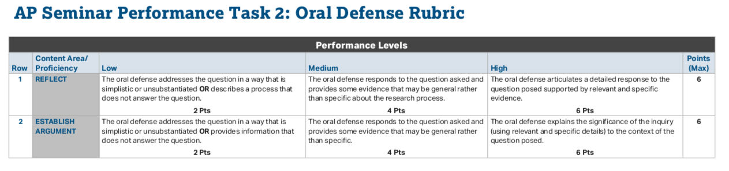
A. Individual Multimedia Presentation (6–8 minutes)
- Deliver a 6–8minute multimedia presentation in which you:
- Contextualize and identify the importance of your research question.
- Explain the connection between your research and your analysis of the stimulus materials.
- Deliver an argument that connects claims and evidence.
- Incorporate, synthesize and interpret evidence from various perspectives.
- Offer resolutions, conclusions, and/or solutions based on evidence and consider the implications of any suggested solutions.
- Engage the audience with an effective and clearly organized presentation design.
- Engage the audience with effective techniques of delivery and performance.
- Persuasive PowerPoint Tips: https://business.tutsplus.com/tutorials/how-to-make-a-persuasive-powerpoint-presentation--cms-25459
- YOU MUST MEMORIZE YOUR PRESENTATION.
- Look at the camera
- Change your tone of voice and feel free to point to the PowerPoint.

B. IMP Slide Organization
Overall: Your slides should have bullet points with key ideas. You can use images to explain your point, but you must have a title above your image that semi explains the connection.
- Title: Name and Research Question
- Argument
  - Problem and solution
- Stimulus Materials
  - Show theme between two materials
  - Connect to problem (This document connects to my research because….)
- Context
  - Explain why your problem is a problem (shows relevance of research)
- Lens 1/Perspectives 1
  - Show how they view the problem
  - Show link to argument (This shows how _____ is a problem and why a solution is necessary)
- Lens 2/ Perspectives 2
  - Show how they view the problem
  - Show link to argument (This shows how _____ is a problem and why a solution is necessary)
- Lens 3/ Perspectives 3
  - Show how they view the problem
  - Show link to argument (This shows how _____ is a problem and why a solution is necessary)
- Solution
  - MUST BE SPECIFIC. Bad example: Video games about climate change can solve the problem. Good example: A video game about climate change can solve the problem. The game should be about…. This would show children how to end climate change because….
- Limitations
  - Reasons why your solution might not work
- Alternatives
  - Why these alternatives would not work

C. Individual Oral Defense (two questions)
- Defend your research process, use of evidence, and conclusion(s), solution(s), or recommendation(s) through oral responses to two questions asked by your teacher. Be prepared to describe and reflect on your process as well as defend and extend your written work and oral presentation.

Sample Oral Defense Questions:
There will be one question that relates to each of the following two categories.

1. Reflection on Research Process
- What information did you need before you began your research, and how did that information shape your research?
- What evidence did you gather that you didn’t use? Why did you choose not to use it?
- How valid and reliable are the sources you used? How do you know? Which sources didn’t work?
- How did you select the strategies you used to gather information or conduct research? Were they effective?
- How did your research question evolve as you moved through the research process? Did your research go in a different direction than you originally planned/hypothesized?
- What information did you need that you weren’t able to find or locate? How did you go about trying to find that information?
- How did you handle the differing perspectives in order to reach a conclusion?

2. Extending argumentation through effective questioning and inquiry
- What additional questions emerged from your research? Why are these questions important?
- What advice would you have for other researchers who consider this topic?
- What might be the real-world implications or consequences (influence on others’ behaviors or decision-making processes) of your findings? What are the implications to your community?
- If you had more time, what additional research would you conduct related to this issue?
- Explain the level of certainty you have about your conclusion, solution, or recommendation.
- How does your conclusion respond to any of the other research or sources you examined?
- How did you use the conclusions and questions of others to advance your own research?

