Unit 7 Handout 7: IWA Writing Tips

A. Capstone Writing Tips
“Like” versus “Such as”
- Many instances like these occurred over a 10-year period.
- Many instances such as these occurred over a 10-year period.

Watch overuse of “leads to”
- The rise in blah blah blah led to this, which in turn led to this. This led to the rise of blah blah, which led to…

Make sure to draw conclusions as you go. Too much overwhelming data without your FREQUENT insight is confusing. Help the reader along.

Other informal words:
- “Pretty” (as in “she gives a pretty basic overview of…”)
- “Not a bad thing” (as in “Mrs. Minich will judge you if you say ‘not a bad thing’”)
- “Now,” (as in “Now, this may seem like a bad thing, but if you look closer, it’s a pretty good thing”)

Make sure credibility is specific, not vague (and use active voice)
- “In a report on criminal activity, it was found that…”
- “In a report compiled by the University of Virginia School of Criminology, 28% of felons typically…”

Absolutely no 2nd person. None. Ever. (you, your, you’re, youz guyz, ya’ll)
If you’re a “many” offender, look for instances and find some synonyms to break that up: Multiple / Myriad (“there were myriad examples of this in the late 1990s”)

And still more tips:
Strong verbs: Avoid the following –
- Get (or any form of it)
- Has/ had/ have (when not accompanied by an action verb)
- Done (instead, say conducted)

Meaningless Adverbs:
- Really
- Very
- Extremely

Conjunctive Adverbs: How to punctuate –
Although, after, while, however, because, since, if, etc.
“She enjoyed prom; however, she wished she’d gone with someone who liked to dance.”

B. Top Tips
- Must include a stimulus material in the argument (either as context or evidence)
- Titles are important: here were a few really great ones:
  - Financial Literacy and the Debt Crisis in America
  - The Effects of cDNA Patents on Agriculture
  - Effects of Gentrification on Low Income Residents
  - A Cost-Benefit Analysis of the Implementation of Autonomous Vehicles
  - Broken English: An Analysis of Accent Discrimination in the Workplace
  - Increasing the Representation of Black Students in Gifted and Talented Programs
  - Mens Rea Standards and Over-criminalization in America
- Words matter: Avoid these illegal words:
  - Get (as in “pollution gets worse every year” and “when refugees got out of Syria…”)
  - Thing
  - Done (as in “a study done by the University of Minnesota)
- The way you say it matters, too: It’s critical that writing maintain formality and sophistication while still being clear and not wordy/ overly complicated.
- Remember your audience: Educated non-experts. This means you don’t need to (and shouldn’t) define things that most educated adults who watch the news and went to college would know. However, if your topic is technical, you need to help readers out and define key terms, as well as tread gingerly through complex content.
- Remember that a high-scoring IWA is essentially, a really compelling argument. A compelling argument looks at all sides of an issue (all relevant counter-arguments), concedes valid claims, and delves into the specifics as opposed to skimming the surface.
- Limitations and implications are most effective when woven into subtopic sections as opposed to a dedicated “limitations and implications” section (which can feel forced/ contrived)
- Don’t forget source credibility! (this applies to all entities not well known) – Some strong examples: Dianne Markely (2002), a director of cooperative education at the University of North Texas… According to the Colombia Law Review, the strictness of these laws varies…
- A thesis statement/ assertion/ or research question is critical and should conclude your context section. Some good examples: This paper serves to offer solutions to the legal and ethical problems at hand while demonstrating the health and economic benefits of the implementation of AV technology. This abuse of power needs to be restricted, and this can be accomplished by implementing tighter legal restrictions and platforms for victims to speak out against offenders without feeling afraid of the consequences.
- End paragraphs with substantive commentary where you draw conclusions for the reader, never quotes or evidence.

C. Strong Verbs
affirm | ascertain | assert
cite | claim | clarify
communicate | concur | contribute
convey | debate | defend
define | detail | determine
develop | differ | discover
discuss | dispute | dissect
document | elaborate | emphasize
employ | engage | enhance
establish | estimate | evaluate
examine | explore | express
find | focus | highlight
hold | hypothesize | identify
illuminate | illustrate | imply
incorporate | infer | inquire
invest | investigate | involve
judge | justify | Value / undervalue
observe | ponder | Predict
proclaim | proffer | Promote
provide | question | Realize
recap | reconcile | Refer
reflect | regard | Relate
relay | remark | Report
resolve | respond | Reveal
review | sanction | Seek
show | simplify | Speculate
submit | support | Surmise
survey | tangle | Test
theorize | Total / verity | Transpose/ Validate
underestimate | Underline / Undertake | Underscore

D. Before You Upload
- Make sure your name, my name, and Lassiter are all removed from your paper
- Include word count, AP Seminar 2018, and your title on your title page
- Make sure your title is engaging and specific
- Triple-check internal citations
- Make sure to edit references
- Check font on running head / header and make sure it's consistent with text font
- Run your paper through Grammarly
- If you have time, read it out-loud to yourself; you'll catch confusing / unclear phrasing

E. Checklist
Connection to Theme of Two Stimulus Materials:
- Does your paper specifically reference TWO stimulus materials in the context section, drawing out a common theme?
OR
Does your paper explicitly discuss change/progress/need for change as part of your context? (This is the broader theme the class decided on.)
- If so, do you feel the discussion is significant enough not to be considered off-topic?
Row 1: Understand and Analyze Context
- Do you specifically cite one of the stimulus materials in your paper, using in-text citation?
- Do you use the source for context or evidence?
- Do you have a detailed explanation of how this stimulus piece connects to either your context or your solution?
  - Could you delete the reference with little to no effect on your paper?
  - Is it just a perfunctory reference, with no discussion?
  - Is it tangential, with only a slight connection? (i.e., MLK also advocated for change in his letter from the Birmingham Jail. Margaret Thatcher also talked about the environment in her address to the UN.)
  - Do you rely on a quotation to do your work for you? Or are you drawing out the connection?
- Does your discussion of the stimulus material show that you accurately understand it?
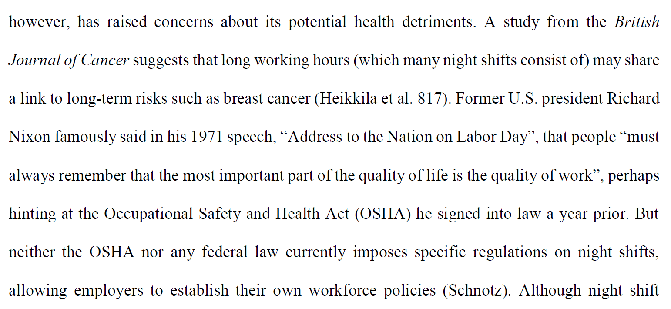
- Could the information you discuss about the stimulus material be found in a general resource like a dictionary or an encyclopedia? (i.e., “climate change is defined as…”). If so, re-write it to make a stronger connection to your topic.
Elaboration/ commentary on Nixon stimulus material.
Reference to two stimulus materials to show theme.

Row 2: Understand and Analyze Context
- Does your context section show why it is important to answer your research question? Do you use research evidence (data, etc.) to show how important it is?
- Does the context provide necessary information on the what, who, when and where type of details necessary to show why this topic is important? Do you say who the major stakeholders are, for example.
- Have you eliminated any broad or vague statements such as “this is important”, or “climate change is a big problem today”, or “there are many reasons why we should…”?
- Are there direct connections between your discussion of context and your research question?
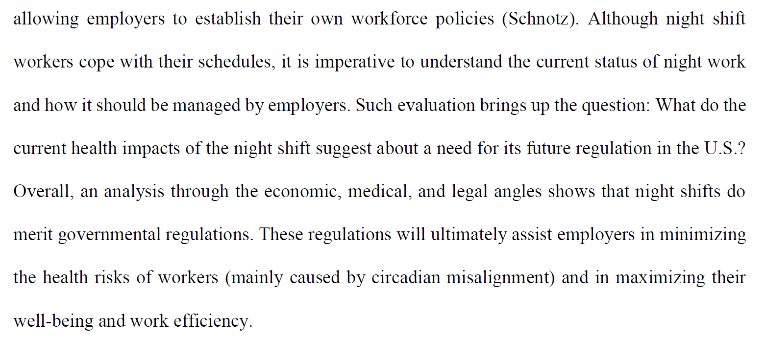
- Is your research question clearly stated in your context?
More complex than just “need more regulations”.
Clear research question, followed by three perspectives.
- While you are working on your research question, check your paper’s title. Is it clearly connected to the problem you are addressing? Is the title phrased as a statement?
- Double-check the quality of your research question.
  - Have you narrowed your focus to a reasonable level?
  - Does the evidence you have researched match the research question? (i.e., you’re focusing on the United States, but your evidence comes from Asia)?
  - Will your research question lead to a COMPLEX conclusion/resolution/solution? Think of complex as requiring a two or three-part conclusion/resolution/solution, not something simple like “climate change is bad”.

Row 3: Understand and Analyze Perspective
- Do you have more than one perspective? Do you oversimplify a perspective by treating many stakeholders as one? If so, you need to bring in more perspectives and evidence.
- Do you have more than two perspectives? Is this sufficient? Are you over-simplifying their perspectives?
- Do you have enough evidence to show the complexity of a perspective?
- The difference between medium and high related to having multiple perspectives is where you simply describe the perspectives or whether you evaluate the perspectives. When you discuss a perspective, are you making a point to EVALUATE it as opposed to just describing it?
- Do you only show how the perspectives agree with each other (medium level), or do you break down that agreement/disagreement into specifics? (i.e., while ___ agrees with ___ on this aspect, they disagree on this aspect because…)
- Do you bring out strengths and weaknesses of different perspectives?
- Do you discuss objections, implications and limitations of every perspective?
- Look for words like juxtaposes, however, alternately, in contrast, also, agree, disagree, question, recommend.
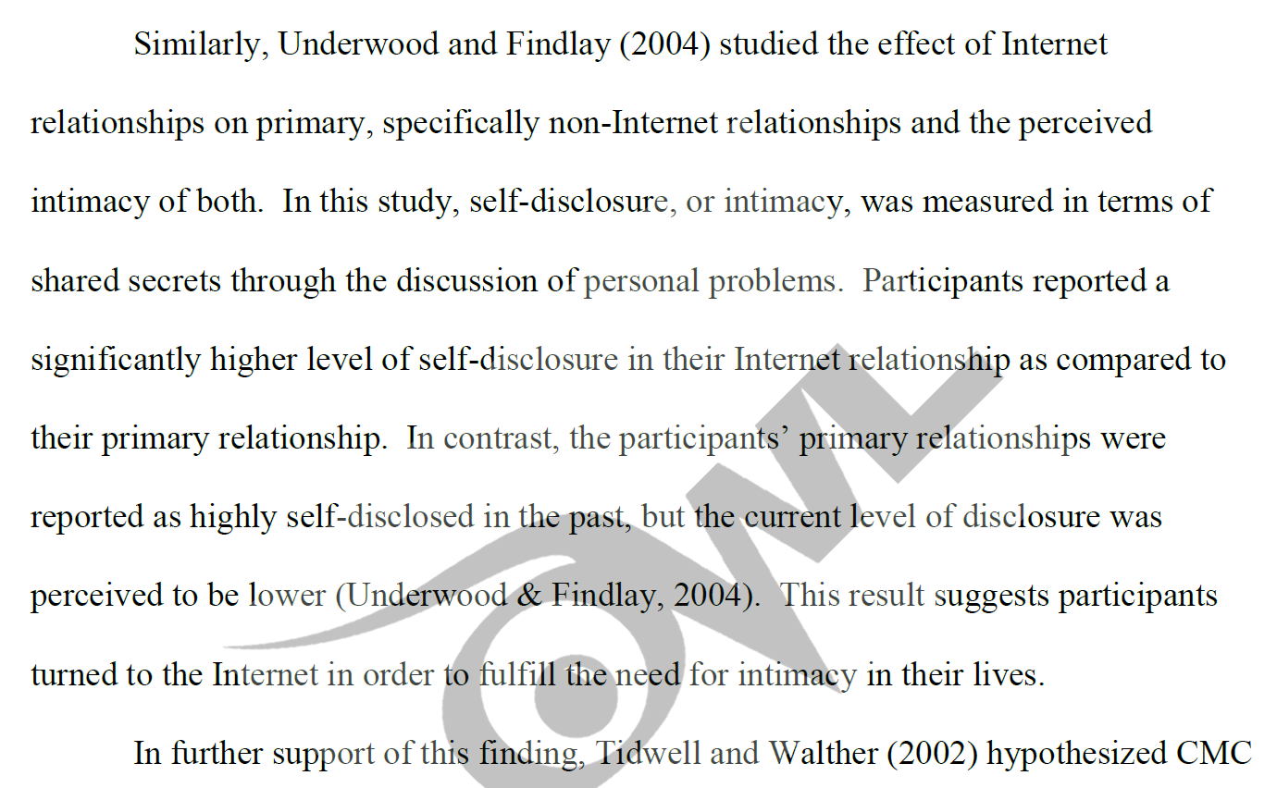
The highlighted portions show how the author reflects on similarities and differences in studies.
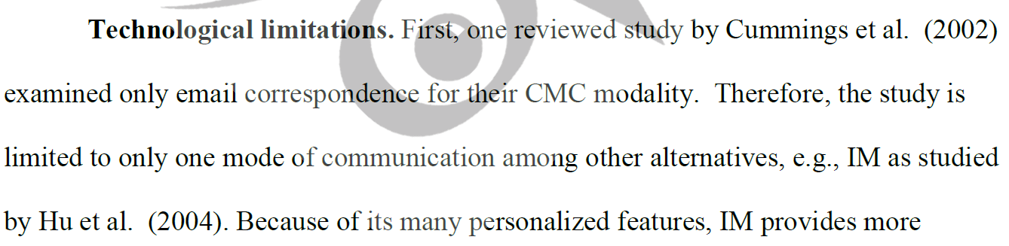
This example points out limitations of a study.
Row 4: Establish Argument
- This is the most significant part of the paper! It focuses on evidence to prove an argument, and the organization of that evidence.
  - The paper will score low if your argument just gives an opinion, just summarizes information (rather than evaluating it), or lacks a conclusion.
  - The paper will score medium if you have reasonable evidence, but don’t effectively connect it to your argument. It could also score medium if you have some evidence, but not enough convincing evidence.
- Do you make any statements of opinion without evidence to back it up?
  - Remember what you learned in the Part B practice—this is your argument. So make sure you are arguing for a solution/ conclusion/ resolution, but use lots of evidence to back it up.
- Do you “signpost” your argument? In other words, do you use sentences and phrases to guide the reader through the steps of your argument? Go through your paper and highlight key signpost phrasing in yellow.
- Is your argument logically organized with topic sentences and transitional phrases? Return to the They Say I Say phrases we studied, or check out the Online Writing Lab’s suggestions or MLA’s suggestions. Highlight the topic sentence of each paragraph in yellow. Is it accomplishing what you need?
- Are you making sure you adequately discuss counter-arguments to yours?
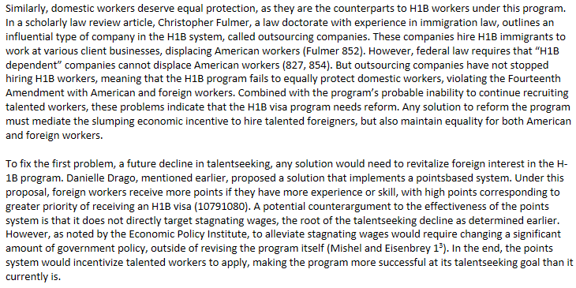
Exploring counter-argument
Sign-posting
Topic sentence
Argumentative commentary

Row 5: Select and Use Evidence
Evidence and evaluation of evidence
- Do you have sufficient evidence? Check the high-scoring sample below for comparison. Please note that general references (dictionaries and
encyclopedias) do not fill the requirement for scholarly evidence.
More evidence
More evidence
- Are you constantly evaluating the evidence, not just summarizing it? In other words, are you explaining how it supports your argument?
- Does your report draw on a wide variety of sources? Can you determine the different types based on the Works Cited page?
  - How many sources are on the Works Cited page? __________
  - How many sources are from the stimulus packet? __________
  - How many sources are academic/scholarly (academic sources, peer-reviewed journals, primary sources, etc.)? __________
  - How many sources are journalistic (newspapers, magazines, written by journalists)? __________
  - How many are not very credible sources (blogs, Tweets, etc.)? ________________
- Highlight any cited source material (direct quotations, paraphrases) in blue.
  - How many direct quotations are cited in the paper? __________
  - How many pieces of paraphrased evidence are cited in the paper? __________
- Highlight sentences that directly explain specific information in orange.
- Highlight sentences in which the writer demonstrates understand through explicit explanation of reasoning and conclusions in orange.
- Do you use the phrases “this proves that” or “this shows that” instead of just proving it or showing it?
- Highlight sentence in which the writer explains why sources are relevant and credible to support the research question/argument I orange.
- Do you go beyond mere description in the attribution to show analysis? Underline areas where the writer has provided analysis (not just a summary) of evidence and write “analysis” in the margin.
- What percentage of the paper is highlighted in orange? At least 50%? __________
- Highlight words that show how the evidence is well-connected to the claims (because, for example, explains, in other words, therefore, supports, since, though, thus) in purple.

Row 6: Apply Conventions (Citations)
- This section is all about consistent use of a style sheet. So keep your APA stylesheet handy as you work through this.
- Read through the References page. Do they include all of the major elements for the type of source (author, title, date, page number, DOI or Permalink, date of access, etc.)?
- Does every citation include a date?
- Cross-check ALL internal citations with the References page to ensure that everything on the References page was used in the paper, and everything cited in the paper is included in the References page. Use a red pen to circle every in-text citation in your paper and make a check mark on the References page as you identify each citation. When you finish, see if you have additional references in your list that are not checked off. Do they need to be cited in the paper? Were they used for background information?
- Check the following reminders:
  - Do you have a properly formatted title page?
  - Have you removed your name and school?
  - Is the correct word count on the title page?
  - Is the paper in Times New Roman size 12, including the header?
  - Is the References on a separate page at the end?
  - Have you removed the annotations on your References list?

Row 7: Apply Conventions (Grammar and Style)
- Do a search in Word for the following words to make sure you are avoiding first person, second person, and vague or meaningless words:
  - You, your
  - I, me, we (it’s possible to use these, but if so, make sure it’s essential!)
  - Things, very
- Your paper has been peer-edited multiple times, but consider having one or two other people read it over for grammatical, spelling and punctuation errors, inconsistencies in style, or poor word choice.
- Read your paper over yourself looking for poor capitalization.

