Unit 6 Handout 6: Performance Task 1 IRR Credibility

A. How To Write Content That People Actually Trust

1. Link to credible outside sources
I can't tell you how important it includes outbound links in your content. While you'll obviously include few (or even no) links in sales-related content, your blog posts absolutely must link out to credible outside sources.
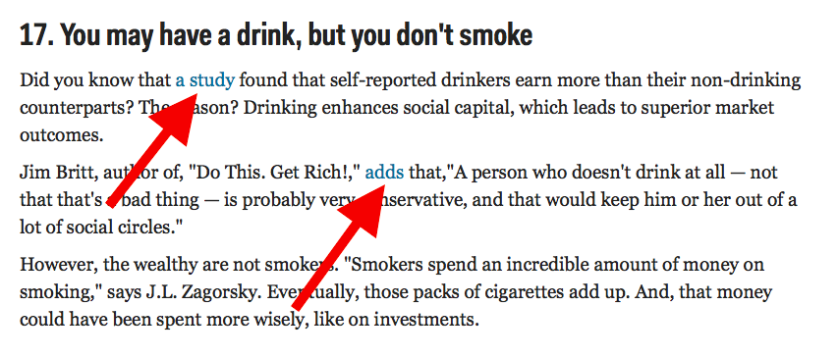
Not only are outbound links important for helping to establish trust, they're great for user experience and rankings. Some general tips for using outbound links in your content include:
- Only link to sources that Google and your users would deem credible. This means not linking out to "bad neighborhoods", outdated sources or irrelevant content.
- Use anchor text that will make sense to Google and to your readers. Overusing anchor text just to get rankings can destroy trust and even get you a manual action.
- Google used to recommend keeping external links to 100 or less per page, however, this is no longer the case. Instead of obsessing over how many links you're using, use just enough to prove that your content is comprehensively covering your topic.

2. Include common questions and objections
Whether they're reading a blog post or sales copy, your readers will invariably have an internal dialogue going on as they read.
Sometimes this will simply be questions that naturally emerge as they read; for instance, "I wonder what the most popular breed of dog is?". Other times, they'll have actual objections to what they're reading, like "How can he say labs are the most popular type of dog without giving any proof?".
When writing your content, try to put yourself in the minds of your readers. What questions would you be asking? What objections might you have? What type of evidence or proof would help to satisfy these objections?
One way that I've found that works very well to appease both crowds is to make prediction posts. Prediction posts allow you to answer common questions that most people have while predicting the future.

3. Include testimonials or other types of social proof
If you're writing any type of sales copy, using testimonials will go a long way to providing social proof. And even if you're not trying to sell anything, reader comments or questions can help boost the relatability of your content.

Some ways you can do this include:
- Using testimonials or customer reviews in your sales copy
- Including social media counters on posts so readers know how many times they were liked, tweeted and shared

4. Use your voice carefully
Your voice is the distinct personality or point of view you convey in your writing. Everyone's voice will be slightly different, and expressing this voice is what will help people trust what you've written.
While it's vital that you are authentic in your writing style (and this means using your own voice, not someone else's), you also need to consider what type of voice your audience needs to hear.
For instance, if I'm writing for a publication that's targeted at academics, I'll use a more formal and polished voice. If I'm writing for small business owners, I'll usually use a more casual voice that will help them feel comfortable and at ease.
The important thing is that is that no matter which voice you use, you're still true to yourself. Your readers will know the difference!

5. Avoid grammatical errors and typos
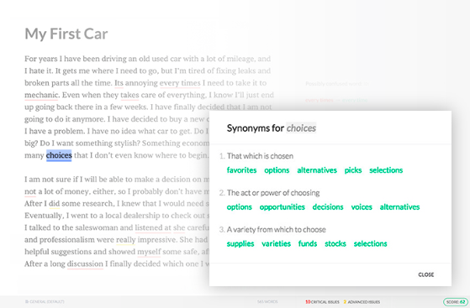
When I encounter an article with obvious grammatical errors or typos, this immediately suggests to me that the content was created in a rush and/or that the writer couldn't be bothered to check it over. Both of these lower the credibility of the content and of the writer.
I understand that not everyone can afford to hire a professional editor, but there are free or low-cost ways you can ensure your content doesn't contain obvious mistakes. These include:
- Using Grammarly to correct grammar mistakes and spelling errors
- Checking the accessibility of your content using a tool like Readability Score
- Using a WordPress plugin like Yoast SEO to monitor the readability of your posts
- Spending time editing your own content. Here's a pretty comprehensive checklist you can use when editing your work.

6. Avoid generic statements
Using broad, unsubstantiated statements can hurt your credibility more than you know. Whenever possible, use specific and concrete examples to back up your points.
This doesn't mean you need to have research or statistics to back up every point you make. Using personal examples or anecdotes can bolster your content, as can fictitious examples that help to illustrate your point.
For instance, rather than writing, "Facebook is the most popular social networking site for business owners", you could boost credibility by citing a statistic or even stating anecdotal evidence for your statement (e.g., "Many business owners have told me Facebook is their favorite social networking site.")
- Forbes (February 2017)

B. Sample Credibility Terms
- Journalists and Newspapers: “Pulitzer Prize winner, The New York Times …” (Name Awards)
- Name Credentials: “Erin Rubin, PHD in AP Seminar (from Harvard University)”
- Survey Info: “A recent survey, conducted in 2018, amongst a large sample group, including people specifically related to …”
- Professionals: “John Doe, who has owned a successful business in this field for over 10 years…” or “Doctor Whoever, who graduated from Princeton, and has practice medicine in this field for over 10 years”
- Journal Articles: “Science, a peer-reviewed publication, led by Dr. Rush D. Holt (who holds a M.A. and Ph.D. degrees in physics from New York University and holds honorary degrees from Monmouth University, Rider University, and Thomas Edison State College) published …..)

