Unit 2 Handout 5: Grammar and Keyboard

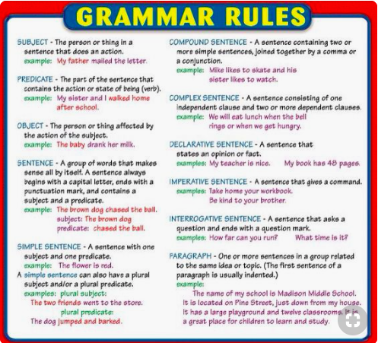
A. Grammar Rules

B. Keyboard
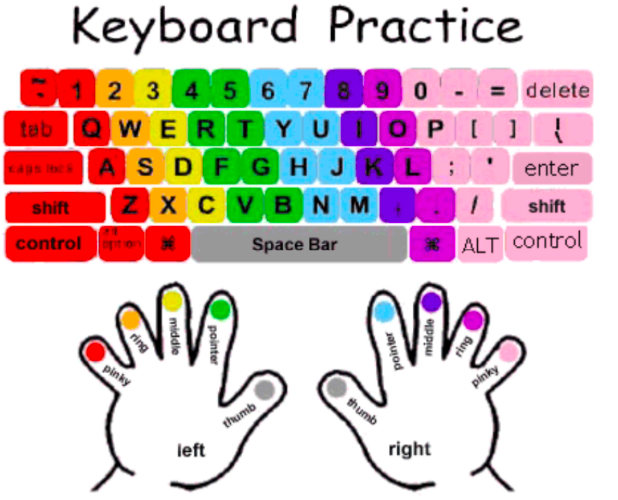

C. Microsoft Work Shortcut

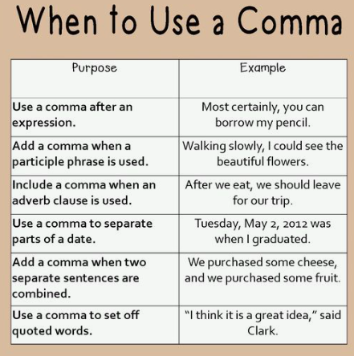
D. Comma Use

