Name:

Unit 5 Handout 3: Practice Performance Task 1 Delay a Grade

A. Grade Yourself
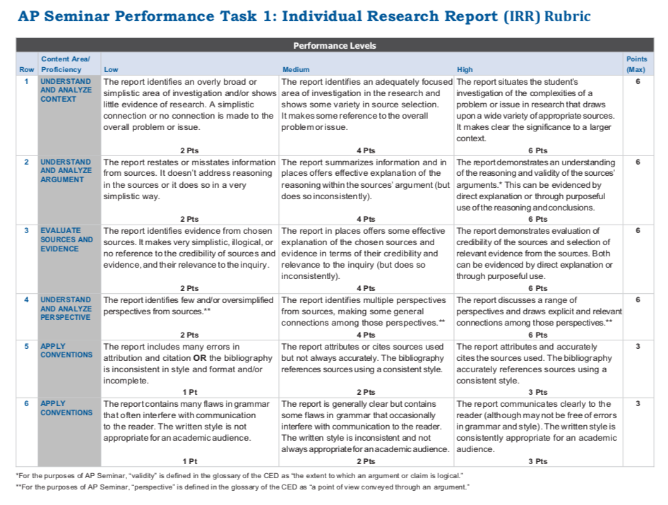
Using the rubric below grade yourself based on my comments.

B. Comments
Write three observations about your work based on my feedback
Write two questions about your work based on my feedback.

C. Performance Task 1
I will give you an index card. Based on your practice PT1 write:

Your name on top
1 person you want to work with
1 person you don’t want to work with

