Plagiarism and Annotated Bibliography

A. Plagiarism
Please read the information on plagiarism from at least two of the sites below (must read first one) and copy/paste the most important tips until you have your own list of helpful hints.
http://www.indiana.edu/~wts/pamphlets/plagiarism.shtml (MUST READ THIS ONE)
https://owl.english.purdue.edu/owl/resource/589/01/
http://www.hamilton.edu/style/avoiding-plagiarism
https://www.princeton.edu/pr/pub/integrity/pages/plagiarism/

Answer the following:
What is a paraphrase?
How is it different from a direct quotation? A summary?
How is it done properly?
What is plagiarism and how could it happen accidentally if you are not careful?
How is plagiarism different from paraphrasing?
How can plagiarism be avoided in the reading/note-taking and summary steps of the research process?

Go to the class website and under the website tab explore the different APA formatting websites.
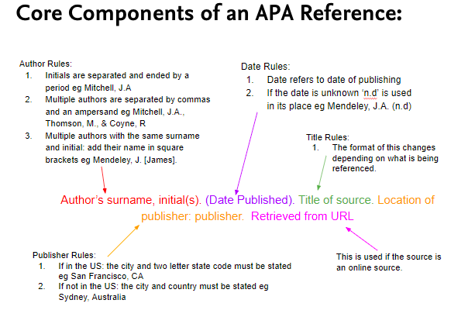
B. Citations and Reference Pages
Difference between MLA and APA:
MLA – cares about author; therefore, you give author and page/paragraph/section citation –
Whereas…
APA—cares about when the research was done as well as author; therefore, you give author/date
We are all about APA in Tech Writing, and here are our mandated rules of the road:
- Name-date works two ways: (1) both together at the end of the citation, or (2) date after author’s name – i.e. (Rubin, 2017) OR As Rubin (2017) brilliantly stated…
- Cite by last name only (Bowra, not Henry M. Bowra)
- For 3-5 authors, name all when you first mention the research team, then cite by the first author and et al. in subsequent references (Bowra, Lemmings, Manchester and Chiu first mention; Bowra et al. afterwards)

B. What is an Annotated Bibliography?
A bibliography is a complete list of the sources that were used to complete a research paper or project. Depending on the style guide you follow. In APA it is called a Reference Page. Each listed source, shares information about the author, title, publishing year, and other details that serve to credit the original authors whose work informed your research. These details also help other students and researchers find and read the source materials. Although annotations can be descriptive, they also include distinctive features about an item. Annotations can be evaluative and critical and state how they can be used in your research. Therefore, you should summarize the source as well as explain how the source applies to your research.
Watch this video for help writing an annotated bibliography in APA format: https://www.youtube.com/watch?v=lPhWhRlEWtI
C. Practice Annotated Bibliography
Read the following article and write an annotated bibliography for it. Your APA annotated bibliography should only be 5 sentences for such a short article. Although you may not be able to use this source in your research paper, you should include information as to what research topics this could be used for.

Last month, an outrageous phrase, "Hang the Whites", was trending on French Twitter. What brought this horrendous exclamation under the national spotlight was a provocative song named PLB (the French acronym for "Hang the Whites") by Nick Conrad, a black rapper that no one had heard of before. In the equally provocative video clip for the song, posted briefly on Youtube and taken down after widespread outcry, Conrad and an associate abduct, chase, torture and violently kill a white man. The song's shocking lyrics appear to advocate for the "killing of white babies" and "hanging of their parents". The video clip quickly set the French political landscape on fire. In response to Conrad's video, Marine Le Pen, leader of France's far-rightRassemblement National Party (National Rally) criticised what she called "an anti-white racism that no self-proclaimed expert or media person speaks of". Minister of Interior Gerard Collomb also tweeted that he "condemned without reservation these abject remarks and ignominious attacks". On September 27, Paris prosecutor's office announced that it launched an investigation to determine whether Conrad's video constitutes an incitement to a crime…Nick Conrad gave an interview to RTL on September 26 and explained that his song was not a "call for hate" but a "fictional" re-telling of the horrors experienced by black people in real life, in which the races were reversed for impact. He said that the scene in the video clip in which he tortures and kills a white man was a re-enactment of a scene from the 1998 Hollywood movie, American History X, in which a black man was killed by Neo-Nazis in a similar way. He even referenced the movie in the lyrics, saying "Black History X, it is the beginning." Several people also came to Conrad's defence on Twitter, and argued that this was not a "racist" song calling for murder, but instead an artist's provocative attempt to attract attention to the very real racism black people have long been facing…Conrad was not a superstar, or even a well-known public figure before this controversy, and it was obvious that his music would have next to no influence in France or anywhere else. So why on Earth would so many pre-eminent political figures give so much exposure to an unknown rapper who had no more than a couple of hundred followers on social media?... The most concerning reaction to Conrad's music video came from the International League against Racism and Antisemitism (LICRA), an anti-racism organisation close to the French government. They declared, "The LICRA did not wait for #NickConrad to denounce and prosecute the anti-white racism. The law does not make any distinction according to the colour of the perpetrator and the victim." That lack of understanding of racism, from an association that is supposed to support the victims of racism, says a lot about the confusion that revolves around the subject of race in France. The irony is that the controversy occurs in a country where race is still a taboo, where there are no data about race in the census or in any official document.
Published by: Country Coordinator Belgium Authors: Al Jazeera Date: October 10, 2018

D. Annotated Bibliography
Once you finish your practice annotated bibliography, use the remainder of the class to work on your annotated bibliography for your discrimination paper.

