**Enduring Issues Essay 1**

|  |  |
| --- | --- |
| **Aim:** | **Date:** |
| **Key Words:**  **1.**  **2.** |  |

**A. The Task**

Essay Directions: Write a well-organized enduring issues essay that includes an introduction, several body paragraphs addressing the task below, and a conclusion. An enduring issue is an issue that exists across time. It is one that many societies have attempted to address with varying degrees of success.

|  |
| --- |
| In your essay:   * *Identify and define an enduring issue raised by this set of documents.* * *Using your knowledge of Social Studies and evidence from the documents, argue why the issue you selected is significant and how it has endured across time.*   Be sure to:   * Identify the issue based on a historically accurate interpretation of three documents. * Define the issue using evidence from *at least* ***three*** documents * Argue that this is a significant issue that has endured by showing:   + How the issue has affected people or been affected by people   + How the issue has continued to be an issue or changed over time * Include outside information from your knowledge of social studies and evidence from the documents. |

|  |  |
| --- | --- |
| *How many body paragraphs do you have to write?* | *How many paragraphs will you write total?* |
|  |  |

**B. Documents**

Directions: Actively read each document and then answer the questions.

Document 1

***Political Cartoon from the French Revolution (1789)***

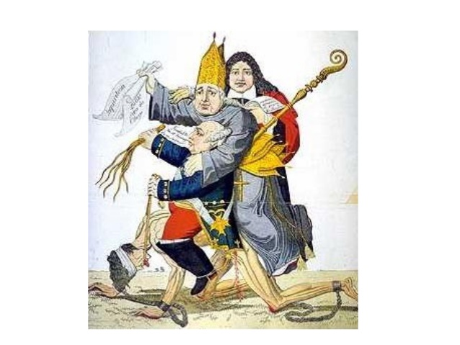

*What enduring issues do you see in this document? (Circle all that apply)*

Power Conflict Globalization Environment Scarcity

Nationalism Response to Change Cultural Diffusion Technology Migration

*Summarize the document.*

*What is the historical context of this document?*

Document 2

***The Sadler Commission Questions Factory Workers during the Industrial Revolution (1832)***

Elizabeth Bentley, called in; and Examined.

What age are you? — Twenty-three.

What time did you begin to work at a factory? — When I was six years old.

What kind of mill is it? — Flax-mill.

What were your hours of labour in that mill? — From 5 in the morning till 9 at night, when they were thronged.

What time was allowed for your meals? — Forty minutes at noon.

Had you any time to get your breakfast or drinking? — No, we got it as we could.

Explain what it is you had to do. — When the frames are full, they have to stop the frames, and take the flyers off, and take the full bobbins off, and carry them to the roller; and then put empty ones on, and set the frame going again.

Does that keep you constantly on your feet? — Yes, there are so many frames, and they run so quick.

Your labour is very excessive? — Yes; you have not time for anything.

Suppose you flagged a little, or were too late, what would they do? — Strap (whip) us.

Are they in the habit of strapping? — Yes.

Girls as well as boys? — Yes.

Have you ever been strapped severely? — Yes.

*What enduring issues do you see in this document? (Circle all that apply)*

Power Conflict Globalization Environment Scarcity

Nationalism Response to Change Cultural Diffusion Technology Migration

*Summarize the document.*

*What is the historical context of this document?*

THIS AREA WAS INTENTIONALLY LEFT BLANK.

TURN TO THE NEXT PAGE FOR THE NEXT DOCUMENT.

Document 3

***Map of German Reunification (1871)***

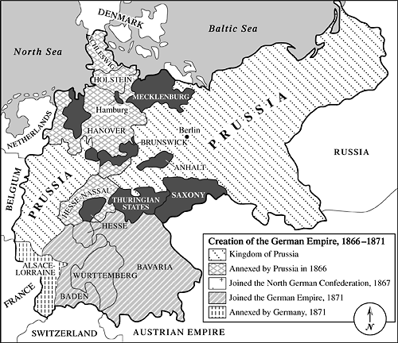



*What enduring issues do you see in this document? (Circle all that apply)*

Power Conflict Globalization Environment Scarcity

Nationalism Response to Change Cultural Diffusion Technology Migration

*Summarize the document.*

*What is the historical context of this document?*

Document 4

***Fei Ch'i-hao, a Chinese Christian, recounts the activities of the Boxers in the Boxer Rebellion of 1900.***

“From this time, we had no communication with Tientsin or Peking. All travelers were searched, and if discovered bearing foreign letters they were killed. So, though several times messengers were started out to carry our letters to the coast, they were turned back by the Boxers before they had gone far. It was not long before the Boxers, like a pestilence, had spread all over Shansi. School had not closed yet in Fen Chou Fu, but as the feeling of alarm deepened, fathers came to take their boys home, and school was dismissed before the wicked Governor, Yü Hsien, proclamations were broadcast. These stated that the foreign religions overthrew morality and inflamed men to do evil, so now gods and men were stirred up against them, and Heaven's legions had been sent to exterminate the foreign devils. Moreover, there were the Boxers, faithful to their sovereign, loyal to their country, determined to unite in wiping out the foreign religion. He also offered a reward to all who killed foreigners, either titles or office or money. When the highest official in the province took such a stand in favor of the Boxers, what could inferior officials do? People and officials bowed to his will, and all who enlisted as Boxers were in high favor. It was a time of license and anarchy, when not only Christians were killed, but hundreds of others against whom individual Boxers had a grudge the end of June.”

*What enduring issues do you see in this document? (Circle all that apply)*

Power Conflict Globalization Environment Scarcity

Nationalism Response to Change Cultural Diffusion Technology Migration

*Summarize the document.*

*What is the historical context of this document?*

Document 5

***An excerpt from All Quiet on the Western Front by Erich Maria Remarque, a German veteran of World War I.***

We have become wild beasts. We do not fight, we defend ourselves against annihilation. It is not against men that we fling our bombs, what do we know of men in this moment when Death is hunting us down—now, for the first time in three days we can see his face, now for the first time in three days we can oppose him; we feel a mad anger. No longer do we lie helpless, waiting on the scaffold, we can destroy and kill, to save ourselves, to save ourselves and to be revenged. We crouch behind every corner, behind every barrier of barbed wire, and hurl heaps of explosives at the feet of the advancing enemy before we run. The blast of the hand-grenades impinges powerfully on our arms and legs; crouching like cats we run on, overwhelmed by this wave that bears us along, that fills us with ferocity, turns us into thugs, into murderers, into God only knows what devils; this wave that multiplies our strength with fear and madness and greed of life, seeking and fighting for nothing but our deliverance.”

*What enduring issues do you see in this document? (Circle all that apply)*

Power Conflict Globalization Environment Scarcity

Nationalism Response to Change Cultural Diffusion Technology Migration

*Summarize the document.*

*What is the historical context of this document?*