Unit 3 Handout 2: Annotate a Text
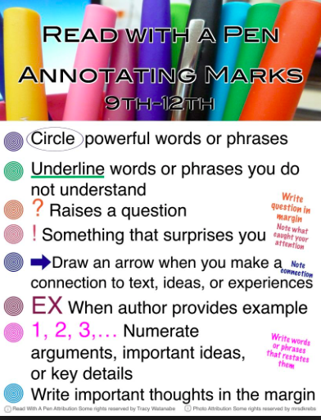
A. How To Annotate
Annotating is any action that deliberately interacts with a text to enhance the reader's understanding of, recall of, and reaction to the text. Sometimes called "close reading," annotating usually involves highlighting or underlining key pieces of text and making notes in the margins of the text.

B. Annotation Practice
Read the following speech (Hillary Clinton’s Remarks to the U.N. 4th World Conference on Women Plenary Session, September 5, 1995) and annotate it.

“I would like to thank the Secretary General for inviting me to be part of this important United Nations Fourth World Conference on Women. This is truly a celebration, a celebration of the contributions women make in every aspect of life: in the home, on the job, in the community, as mothers, wives, sisters, daughters, learners, workers, citizens, and leaders…. By gathering in Beijing, we are focusing world attention on issues that matter most in our lives -- the lives of women and their families: access to education, health care, jobs and credit, the chance to enjoy basic legal and human rights and to participate fully in the political life of our countries. There are some who question the reason for this conference. Let them listen to the voices of women in their homes, neighborhoods, and workplaces. There are some who wonder whether the lives of women and girls matter to economic and political progress around the globe… It is conferences like this that compel governments and peoples everywhere to listen, look, and face the world’s most pressing problems. Wasn’t it after all -- after the women’s conference in Nairobi ten years ago that the world focused for the first time on the crisis of domestic violence?... …The great challenge of this conference is to give voice to women everywhere whose experiences go unnoticed, whose words go unheard. Women comprise more than half the world’s population, 70% of the world’s poor, and two-thirds of those who are not taught to read and write. We are the primary caretakers for most of the world’s children and elderly. Yet much of the work we do is not valued -- not by economists, not by historians, not by popular culture, not by government leaders. …Our goals for this conference, to strengthen families and societies by empowering women to take greater control over their own destinies, cannot be fully achieved unless all governments -- here and around the world -- accept their responsibility to protect and promote internationally recognized human rights. The -- The international community has long acknowledged and recently reaffirmed at Vienna that both women and men are entitled to a range of protections and personal freedoms, from the right of personal security to the right to determine freely the number and spacing of the children they bear. No one -- No one should be forced to remain silent for fear of religious or political persecution, arrest, abuse, or torture. Tragically, women are most often the ones whose human rights are violated. Even now, in the late 20th century, the rape of women continues to be used as an instrument of armed conflict. Women and children make up a large majority of the world’s refugees. And when women are excluded from the political process, they become even more vulnerable to abuse. I believe that now, on the eve of a new millennium, it is time to break the silence. It is time for us to say here in Beijing, and for the world to hear, that it is no longer acceptable to discuss women’s rights as separate from human rights. These abuses have continued because, for too long, the history of women has been a history of silence. Even today, there are those who are trying to silence our words. But the voices of this conference and of the women at Huairou must be heard loudly and clearly: It is a violation of human rights when babies are denied food, or drowned, or suffocated, or their spines broken, simply because they are born girls.It is a violation of human rights when women and girls are sold into the slavery of prostitution for human greed -- and the kinds of reasons that are used to justify this practice should no longer be tolerated. It is a violation of human rights when women are doused with gasoline, set on fire, and burned to death because their marriage dowries are deemed too small. It is a violation of human rights when individual women are raped in their own communities and when thousands of women are subjected to rape as a tactic or prize of war. It is a violation of human rights when a leading cause of death worldwide among women ages 14 to 44 is the violence they are subjected to in their own homes by their own relatives. It is a violation of human rights when young girls are brutalized by the painful and degrading practice of genital mutilation. It is a violation of human rights when women are denied the right to plan their own families, and that includes being forced to have abortions or being sterilized against their will. If there is one message that echoes forth from this conference, let it be that human rights are women’s rights and women’s rights are human rights once and for all. Let us not forget that among those rights are the right to speak freely -- and the right to be heard. Women must enjoy the rights to participate fully in the social and political lives of their countries, if we want freedom and democracy to thrive and endure. It is indefensible that many women in nongovernmental organizations who wished to participate in this conference have not been able to attend -- or have been prohibited from fully taking part… Let -- Let this conference be our -- and the world’s -- call to action. Let us heed that call so we can create a world in which every woman is treated with respect and dignity, every boy and girl is loved and cared for equally, and every family has the hope of a strong and stable future. That is the work before you. That is the work before all of us who have a vision of the world we want to see -- for our children and our grandchildren. The time is now. We must move beyond rhetoric. We must move beyond recognition of problems to working together, to have the comment efforts to build that common ground we hope to see. God's blessing on you, your work, and all who will benefit from it. Godspeed and thank you very much.”

