Unit 5 Handout 1: Practice Performance Task 1 Rubric

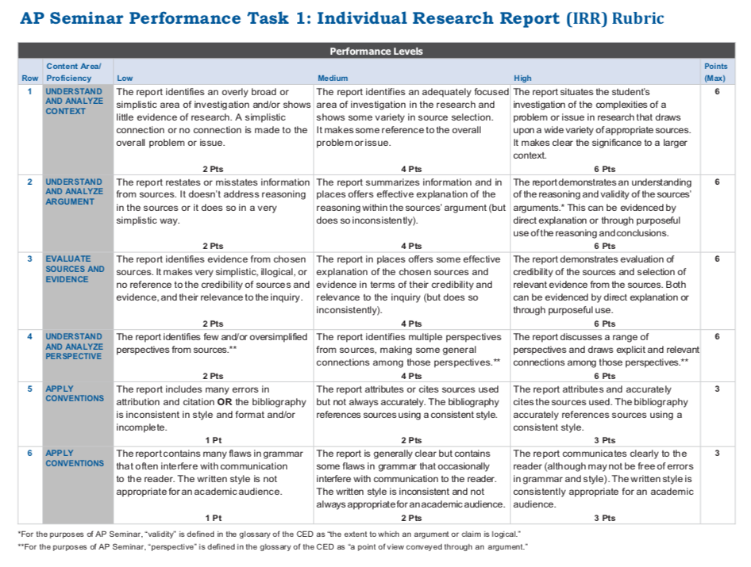
A. IRR Rubric
Row | Content Area | Low | Medium | High
1 | Understand and analyze content
2 | Understand and analyze argument
3 | Evaluate sources and evidence
4 | Understand and analyze
5 | Apply Conventions
6 | Apply Conventions
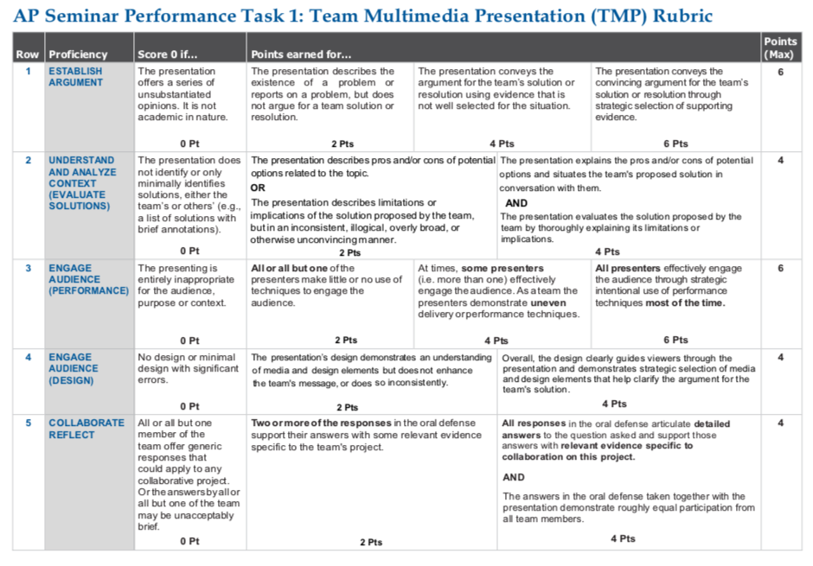
B. TMP Rubric
Row | Content Area | Low | Medium | High
1 | Establish Argument
2 | Understand and analyze content
3 | Engage audience (performance)
4 | Engage audience (design)
5 | Collaborate Reflect

Out of both parts, which item do you think will be the most challenging for you? Why?

