Unit 2 Handout 1: Lens and Perspectives

A. Lenses
Within the AP Seminar course, you can make cross-curricular connections within a theme by looking at the theme through different lenses.
There are eight lenses identified in the course and exam description:
- Environmental
- Scientific
- Economic
- Political and Historical
- Artistic and Philosophical
- Cultural and Social (culture consists of the beliefs, behaviors, objects, and other characteristics common to the members. Through culture, people and groups define themselves and then conform to society's shared values and contribute to society.)
- Futuristic
- Ethical
When you are working in you teams for Part I, each member of the team will look at the topic through a different lens.

Which lens do you think you will prefer to research? Explain.

B. Lens Graphic Organizer Example
Cultural & Social  How does a democratic society explain the inequity of social classes?  How do different cultural understand the meaning of democracy? | Theme: Democracy | Futuristic  Does democracy have a future?
Artistic & Philosophical  How has democracy shaped the modern understanding of civic virtue and aspiration?  How have representations of democracy change over time? |  | Environmental  Does a democratic system inevitably mean that the environment is a lesser priority?  Should other species on the planet have representation?
Ethical  Is democracy equally fair to all citizens?  Is it possible to have a truly democratic system of government? |  | Economic  What is the relationship between capitalism and democracy?  Should there be a limit on financial contributions to political parties?
Political & Historical  What is democracy?  How has democracy changed over thousands of years? |  | Scientific  Should governments have a role in stopping controversial practices, such as stem cell research?

C. Lens Graphic Organizer
With a group you will create questions for each lens.

Cultural & Social | Racial Discrimination | Futuristic
Artistic & Philosophical |  | Environmental
Ethical |  | Economic
Political & Historical |  | Scientific

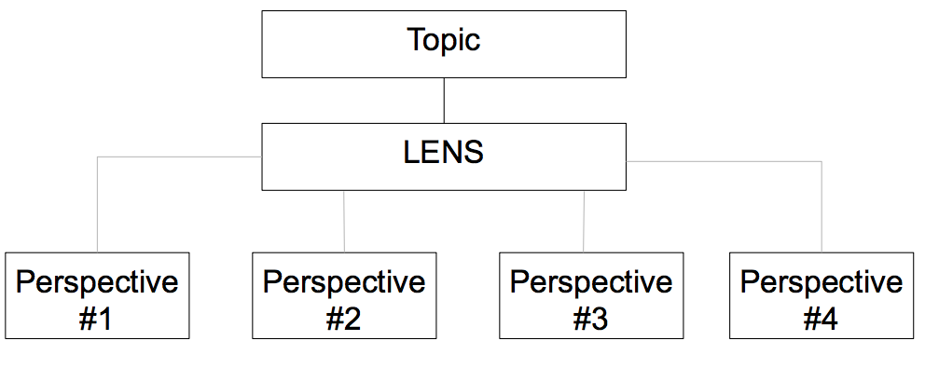
D. Perspectives
Multiple Perspectives can be better understood if you think about a conversation at a dinner party. In order to have a successful dinner party you need to be selective about your guests.
- Who are they?
- What contribution would this person bring to the table that another guest does not already represent?

