**DOCUMENT # 1 – The Devilfish in Egyptian Waters**

The picture was created by an American and was published in Punch, a British magazine in 1888. It depicts John Bull (an imaginary figure who represents England, similar to the American 'Uncle Sam') as an imperialist octopus.

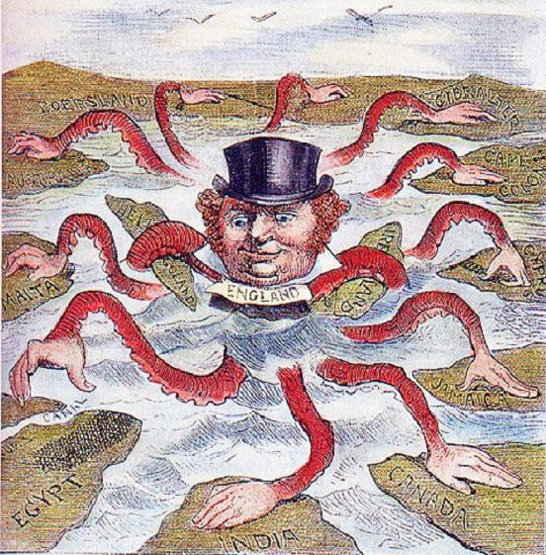

**DOCUMENT # 2: “The White Man’s Burden” Poem by Rudyard Kipling**

He was an English author who was born in India, which inspired much of his work.

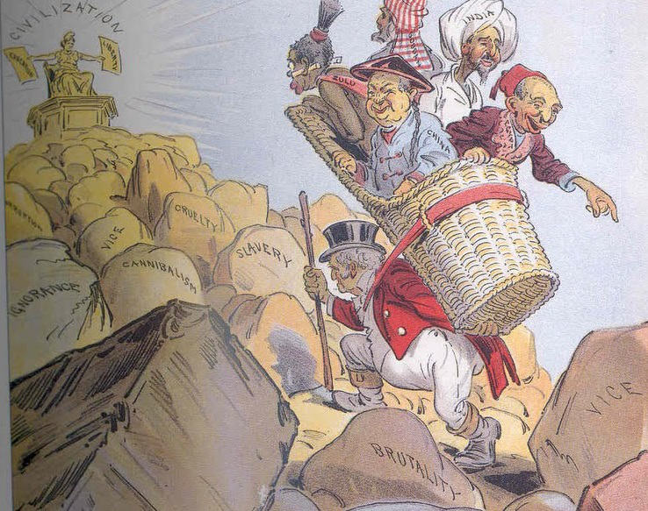

“Take up the White Man’s burden, Send forth the best…Go send your sons to exile To serve your captives' need … Your new-caught, sullen peoples, Half devil and half child.”

**DOCUMENT # 3 – French Poster**

Created by Eric Castel, a French artist, for the French government in 1941.

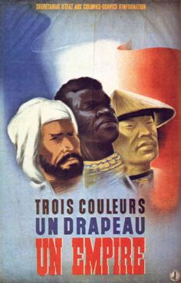

“Three colors

One flag

One empire”

**DOCUMENT # 4: Role of Britain**

Quote from Cecil Rhodes, 1877 (British businessman and politician in southern Africa)

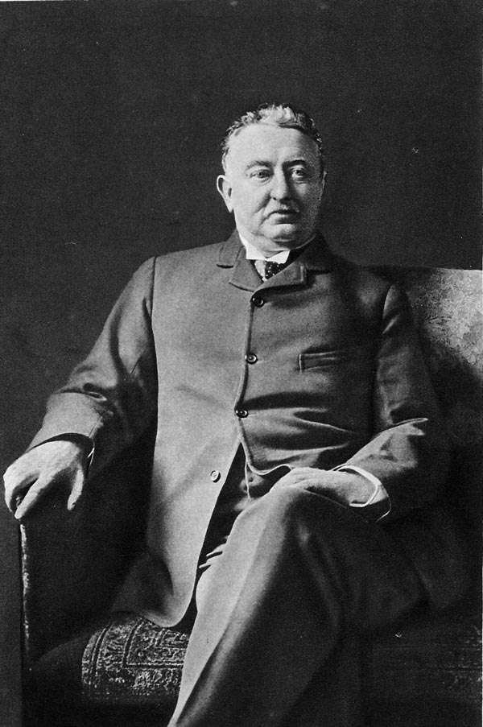 “The British are the finest group of people in the world. The more of this world we take over, the better it is for the human race.

It is our duty as the best race in the world to take every chance to get more territory. If we have more territory, there will be more room for the British – the best, the most human, most honorable race in the world.”

**DOCUMENT # 5: Capitalism and the IR**

Newspaper article from a British journalist during the Industrial Revolution

“Those who own factories and make goods out of cotton and iron are very interested in imperialism.

These business owners make more goods than they can sell in their native countries. So they need new markets and new customers for their goods. England needs colonies. How do we make this happen? Imperialism, of course! These business owners also own giant industries which need raw materials (natural resources). How will they get their raw materials? Imperialism, of course!”

**DOCUMENT # 6: William McKinley’s View**

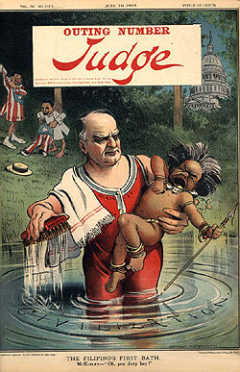American president William McKinley (1897-1901) said this about the native people of the Philippines:

“We could not leave them on their own. They cannot take care of themselves and rule themselves. We (the Americans) had no choice but to take them over and civilize them. Now we can educate them and make them Christians.”

**DOCUMENT # 7: The Jungle Book**

Song written by the Sherman Brothers who were an American songwriting duo that specialized in musical films. The movie is based on a book by Rudyard Kipling who was an English author who was born in India, which inspired much of his work.)

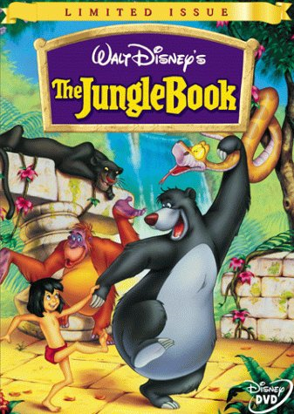Now I'm the king of the swingers Oh, the jungle VIP I've reached the top and had to stop And that's what botherin' me I wanna be a man, mancub And stroll right into town And be just like the other men I'm tired of monkeyin' around! Oh, oobee doo I wanna be like you I wanna walk like you Talk like you, too You'll see it's true An ape like me Can learn to be human too ( Gee, cousin Louie You're doin' real good Now here's your part of the deal, cuz Lay the secret on me of man's red fire But I don't know how to make fire ) Now don't try to kid me, mancub I made a deal with you What I desire is man's red fire To make my dream come true Give me the secret, mancub Clue me what to do Give me the power of man's red flower So I can be like you You! I wanna be like you I wanna talk like you Walk like you, too You'll see it's true Someone like me Can learn to be Like someone like me Can learn to be Like someone like you Can learn to be Like someone like me!