Unit 7 Handout 13:IWA Plagiarism Checklist

Plagiarism Check:
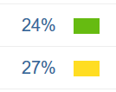
Go to your draft on Turnitin.com. Click on the similarity #. Look at EVERY example that Turnitin flags and make sure that it is properly cited and attributed.
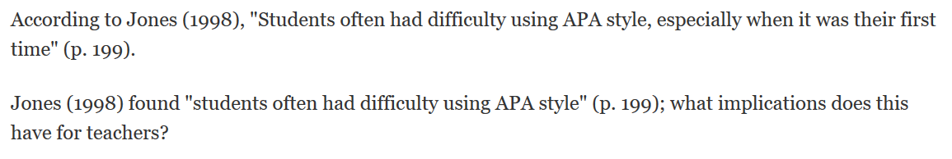
- If it is a quotation, make sure it is in quotation marks and cited appropriately.
- If it is a paraphrase, make sure the source is in proper in-text citation format.
- If the overall percentage of quoted material is OVER 30%, shorten some of your quotations, or expand your commentary.

Sign here that you completed this step for your IWA! _____________________________

Now find another person to quickly check over your IWA.

Have them sign here that they reviewed your papers! ____________________________

