Unit 6 Handout 10: TMP Notes
Task Score Breakdown:
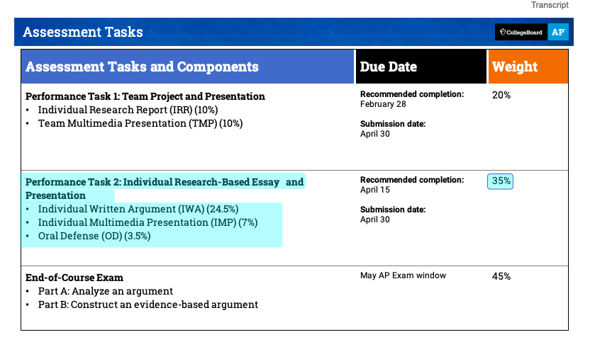

Bad TMP Slide:
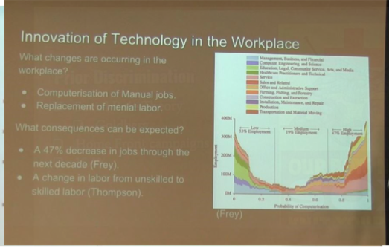

What you need to cite:
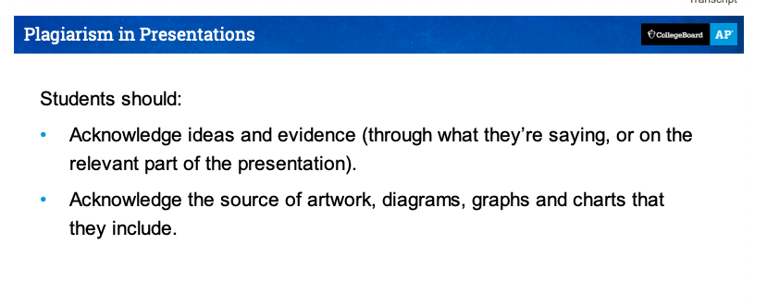

Other notes: Each student must answer one question and I will decide who answers what questions. The questions are there to show group collaboration - you should be able to answer questions about other group members research. Follow up questions are frowned upon.

