Unit 3 Handout 9: EOC B Debrief

A. They Say I Say Template
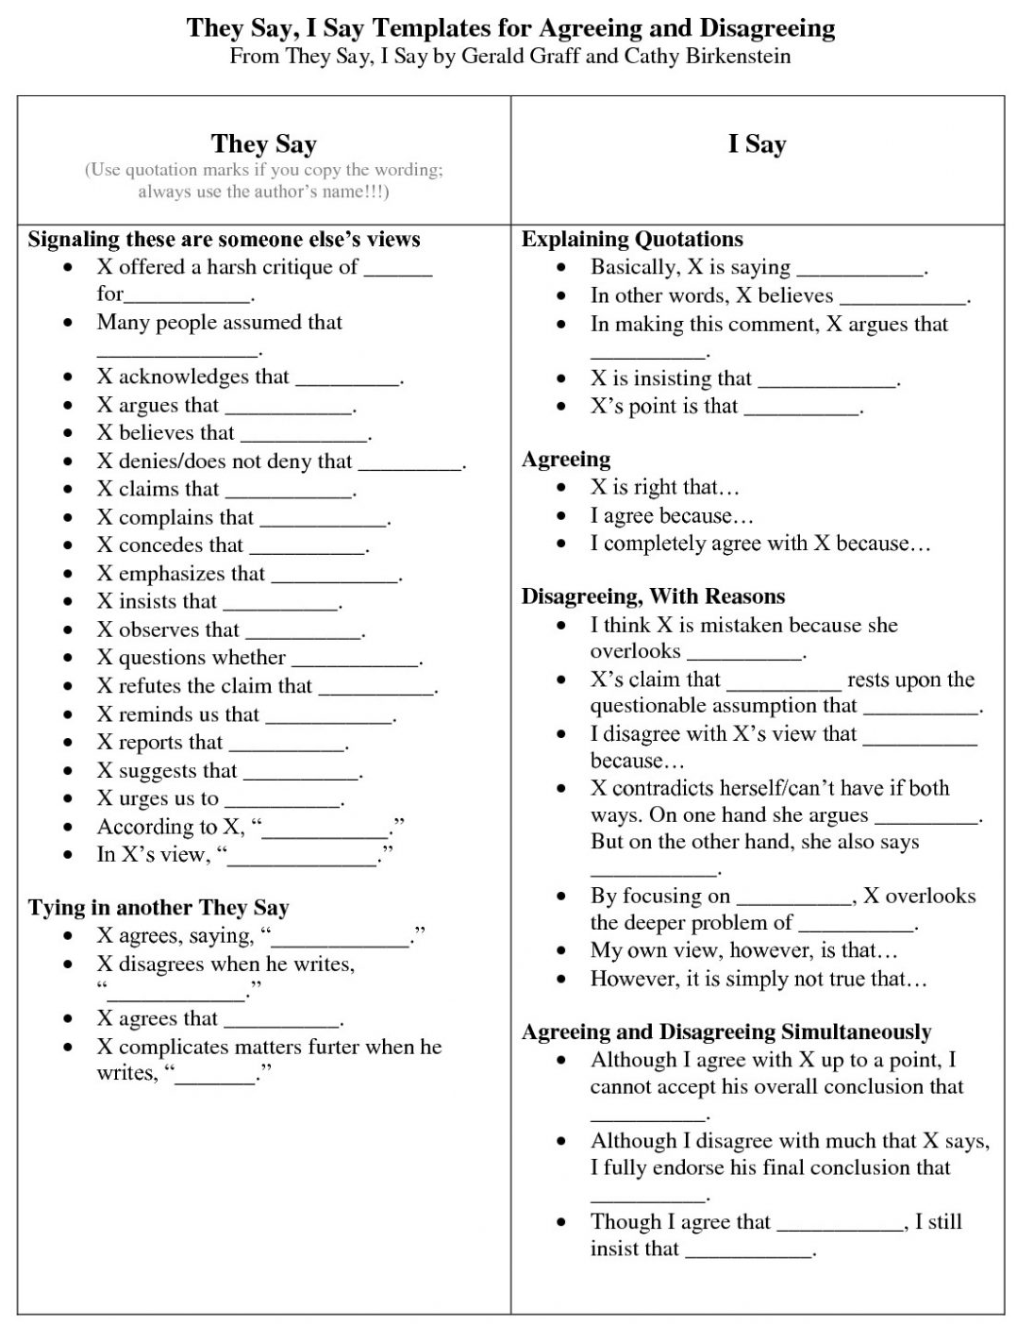

B. Introduction
The connecting theme amongst the documents is
This theme is important in society because
Unique thesis

C. Body Paragraphs

Source #  _____ | Topic Sentence: Source ___ shows the theme of ____ with _____....
 | Source Information (evidence) Aim for 3 | Outside Information (evidence)
 | Analysis (Compare, Contrast, Connect or Point Out)
 | Link (*Close off your paragraph with a summary statement of all your points.)
Source #  _____ | Topic Sentence: Source ___ shows the theme of ____ with _____....
 | Source Information (evidence) | Outside Information (evidence)
 | Analysis (Compare, Contrast, Connect or Point Out)
 | Link (*Close off your paragraph with a summary statement of all your points.)
Source #  _____ | Topic Sentence: Source ___ shows the theme of ____ with _____....
 | Source Information (evidence) | Outside Information (evidence)
 | Analysis (Compare, Contrast, Connect or Point Out)
 | Link (*Close off your paragraph with a summary statement of all your points.)

D. Conclusion
The requirements are very similar to the introduction. Your conclusion should be a summation of what you just wrote in your essay.
Things to remember:
- You MUST restate your thesis in your conclusion.
- You MUST restate the theme and why the them is important in society.
- Never say “As you can see…” – As a matter of fact, never say “you” in an essay.

Conclusion Paragraph:

B. EOC B Sample Response 